

Creating a rubik’s cube scrambler and solver

Hana Ahmed-Mahmoud

nea a-level

Candidate number: 1001

CENTRE NUMBER: 26218



Table of Contents

Analysis 4

Project background 4

Research/ investigation into the problem 4

History 4

How many possible combinations? 4

Terminology: 4

The problems that arise with this extremely enormous number 5

How does a human solve a Rubik’s cube? 5

Current system/ investigation into similar systems 14

User investigation 18

Summarising findings and further research 20

Possible users 21

Proposed Solution 21

Limitations: 21

Data Volumes: 22

Hardware and software: 22

Objectives 22

References 23

Information References 23

Picture References 24

Documented Design 25

Overview 25

Mini Project- Tic-Tac-Toe 25

Web Hierarchy 26

GUI Design 27

System Hierarchy/ DFD diagram 29

Object-Oriented Design 30

Overview 30

Cubies 31

Class Diagram 32

Enumerations 36

Pseudocodes 38

Validation 38

IsCubePossible() 38

EdgesPossible() 39

CornersPossible() 41

EdgesPossible() 41

Use of Sets- ValidColour() 43

Rotating the Cube 45

FaceVerticalSwap() 50

GetRightColoum() 50

UpdateVertical() 50

FaceBeingPermutated() 51

MatrixTransformation() 52

Rotation [Move] () 52

Algorithms () 56

RightAlgorithm() 56

LeftAlgorithm() 56

Data structures 57

Overview and examples: 57

Dynamic implantation of stacks and queues 58

Queues 58

InsturctionToBePerformed Class 59

PriorityQueue Class 60

Enqueue () 60

Dequeue () 62

Stacks 62

Stack Class 62

Instruction Class 63

[Push() 63](https://kggs-my.sharepoint.com/personal/hahmedmahmoud16_kestevengrantham_lincs_sch_uk/Documents/NEA-%20A%20level/NEA%20A-Level.docx#_Toc132701714)

Pop () 64

Using all techniques 64

Dictionaries 65

sequenceForRotationDictionary() 65

faceAndOrientationDictionary() 66

Seeing the different face- an alternative method 67

DisplayAfterSeeingAdjacentFaces() 68

First method of solving 69

FirstLayerSolved() 69

SecondLayerSolved() 69

BottomLayerSolved() 70

Prototyping Cubie Input in Blazor for First Layer: 70

Attempts at pseudocode 75

CheckForCross() 77

IsCubeSolved() 78

Solve () 78

The problem with the first method: 79

Solving- Alternative method 79

Scrambling Algorithm 79

Investigating recursion 79

Solving Instructions 81

PoppingOffAListOfInstructions 82

Data Dictionary 82

Cube Class 82

Face class 88

Instruction class 90

Prototyping Rotations in Blazor 92

Technical Solution 99

Skills dictionary 99

Cube Class 100

Face Class 121

Instruction Class 127

CSS StyleSheet 130

HTML format for Rubik’s Solving page 138

HTML for the home page 146

Blazor File Structure and Navigation Page 146

Development and Testing 148

Different approaches to display the cube 148

2D approach 148

2D design with grid spacing 149

A flat cube net 150

The decision 155

Testing for the final CSS 3D cube rendering 156

Testing evidence 161

1.1 161

1.2 162

1.3.1 163

1.3.2 165

1.4 167

2.1 169

2.2 170

2.3 179

2.4 180

2.5 187

2.6 190

2.7 195

2.8 198

2.9 199

3.1 205

3.2 206

3.3 207

3.4 207

3.5 208

3.6 208

3.7 208

4.1 209

4.2 212

4.3 212

4.4 213

4.5 214

5.1 219

5.1.2 220

5.1.3 220

Final Project Screenshots: 223

Evaluation 236

Comparison of project against original objectives 236

User feedback 238

Possible extensions to my project 239

Improvements that could be made 239

Project Log 240

# Analysis

## Project background

I am an A-level computer science student at KGGS and have always been fascinated by the mathematics behind every day puzzles. That is why I have chosen to do an investigation into the Rubik cube and its algorithms by developing a software to scramble and solve a cube whilst designing a suitable user interface to display instructions for humans to solve a cube.

## Research/ investigation into the problem

### History

Founded by Erno Rubik in 1974, the cube was initially intended to illustrate spatial relationships in 3D to his students. He quickly realised that the cube itself was much harder to solve than predicted, and it took him one month to create a method to solve it. He then patented his cube and started selling it as a children’s toy, which has now been sold 350 million times under his official name. The market for Rubik’s cubes is still growing, but there seems to be a lack in easy-to-access software to learn how to solve one and to increase the scrambling difficulty of the cube to make it more interactive. In this project my aim is to create a well-designed solution to this problem.

### How many possible combinations?

Firstly, we must consider how a Rubik’s cube is organised and become familiar with the terminology typically used when discussing these.

#### Terminology:

* Cubie- One of the 26 mini cube that makes up the entire cube
  + Centre- A static single-coloured cubie in the centre of a face (6 in total)
  + Edge- A cubie with 2 colours (12 of these in total)
  + Corner- A cubie with 3 colours (8 of these in total)
* Face- A side of a Rubik’s cube made up of 9 cubie: 1 centre, 4 edges, 4 corners
  + There are 6 faces, front, back, left, right, up and down
* Twist- a 90 or 180 degrees turn of one of the six faces. These can be turned clockwise or anticlockwise (commonly referred to as ‘prime’). There are in total 18 possible twists.

When assembling a cube, when fixing an edge, you have one less possible space to put it each time, thus the number of possibilities being:

12 x 11 x 10 x 9 x 8 x 7 x 6 x 5 x 4 x 3 x 2 x 1 = 12! = 479001600

It is the same idea for the corner pieces, so:

8 x 7 x 6 x 5 x 4 x 3 x 2 x1 = 8! = 40320

The total positions so far:

12! X 8! = 19,313,344,512,000

Which is already too many possibilities to brute force a solution. I also haven’t considered the orientation of the edge pieces. Each piece has two distinct colours, so there are two diverse ways to position this in the cube (i.e., red on top yellow on bottom, and yellow on top and red on bottom). Therefore, the edge flips:

212 = 4096

And for the corners:

38 = 6561

So, the new total:

12! X 8! X 212 x 38 = 519,024,039,293,878,272,000

However, we know that the true value of possibilities must be less than this. By assembling a cube in this way, some positions may become unsolvable. You may have run into this problem if you ever replaced the stickers when trying to solve. Some unsolvable positions hold single corner twists, single edge twists and 2 pieces being swapped. Considering these, our new numbers are:

37 = 2187 (So the last corner piece is untwisted)  
211 = 2048 (So the last edge piece is unflipped)

8 x 7 x 6 x 5 x 4 x 3 = 20160 (so 2 of the corner pieces are in the correct positions)

So, the final total number of ways to scramble a cube is:

12! X 20160 x 2040 x 2187 = 43,252,003,274,489,856,000

#### The problems that arise with this extremely enormous number

A classical computer would take an unreasonable amount of time to solve, and I would class this problem as being intractable. Therefore, when implementing ways to solve a cube, a heuristic approach should be used. By doing this, the solution may not be perfectly exact or complete, but good enough for our project. Machine learning would thrive in these conditions and would be beneficial to produce optimal solutions to the cube. However, the implementation of such learning may be difficult to achieve in the timeframe given for this project, so I will class this as a desirable feature (not a necessary).

### How does a human solve a Rubik’s cube?

Following my research, I found that notations are commonly used to describe movement on a cube, the formula of a move consists of:

* Picking a side, you would like to move
  + Up = U
  + Down = D
  + Right = R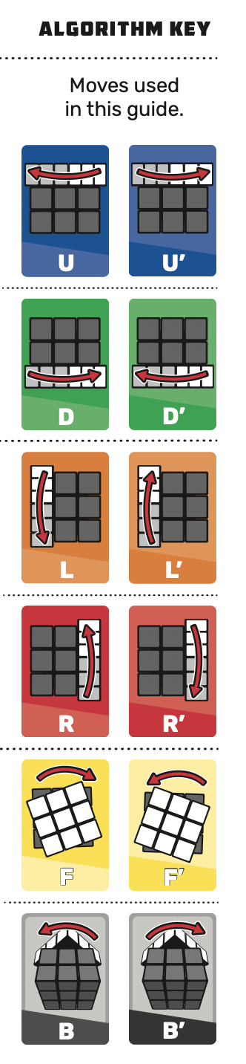
  + Left = L
  + Front = F
  + Back = B
* Decide which way it needs to be turned:
  + If clockwise, do not add an apostrophe
  + If anti-clockwise, add an apostrophe (i.e., U’ means turn the upwards facing face anticlockwise by 90 degrees)
* 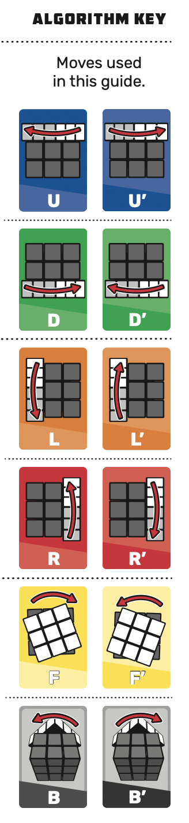Decide the number of times the face is turned
  + If the number of times being turned is 1, write as normal (i.e., U)
  + If the number of times being turned is 2, add a 2 after the letter. (i.e., U2 or U2’)

Human way to solve a cube:

* Creating a Daisy
  + Holding the Rubik’s cube with the middle yellow tile up, find an edge piece that has a white tile on the first layer. Then look at the second layer, move an edge piece from the middle to the top by a U move.
  + Looking at the bottom layer, move the edge piece that have a white sticker on them to the top layer
    - Being careful not to bump out the white edges on the daisy, always move the up face
    - If a piece needs to be flipped, So the algorithm R’ U F’
* Creating a white cross
  + With the daisy facing up, see if the top layer middle edge pieces match with the second layer middle piece
    - If they don’t match Turn U until it does
  + Turn F2 so that the white tile is on the D face
  + Repeat this action with each white edge
  + After this, if you flip over your Rubik’s cube, you should see a white cross with matching tiles (as seen in the picture)
* Solving the white corners
  + The correct placement of a corner is sandwiched between centre pieces with the same colour
  + Locate a white sticker on the bottom layer
    - Rotate D until the corner is between two matching coloured centre tiles
    - Keeping the white cross on the U face, hold the cube so the white tile is on the front face
      * If not on the front face, Hold the cube with the corner on the ride and do the algorithm F D’ F’ D2

Figure 4- Moves

* + - If the corner is on the left
      * Perform the algorithm D L D’ L’
    - If the corner is on the right
      * Perform the algorithm D’ R’ D R
  + If the sticker isn’t on the bottom, perform the algorithm R’ D’ R to get it there and continue through the steps above until all 4 white corners are correctly places.
* Solving middle layer
  + Orientate the cube so the yellow centre piece is on the top and the white face is down
  + Choosing a Front face, Rotate U to create a vertical line with matching middle pieces.
    - If you want to move the piece to the left (commonly known as a ‘Left algorithm’), perform the algorithm U’ L’ U L followed by U F U’ F’
    - If you want to move the piece to the right (commonly known as a ‘Right algorithm’), perform the algorithm U R U’ R’ followed by U’ F’ U F
  + If you can’t make a vertical line, you will need to swap an edge from the up face
    - Look in the middle layer to find a mismatched edge that doesn’t have a yellow tile
    - Hold your Rubik’s cube so the mismatched edge on the middle layer is on the right face
    - Complete a ‘Right algorithm’ and continue the steps above until the middle layer is solved. – U R U’ R’ U’ F’ U F
* Solving the final layer
  + Holding the white face down, there are three possible ways for your cube to look:
    - Your cube has a singular yellow piece in the centre
    - Your cube has a horizontal line of yellow pieces
    - Your cube has an L shape of yellow pieces
  + Follow the algorithm F U R U’ R’ F’ until a yellow cross is formed
  + To solve the corners:
    - If one corner piece is yellow on the up face, hold the cube so the corner piece is next to your left hand
    - If there are no yellow corner pieces on the up face, hold your cube so the corner pieces with yellow on the left face is next to your left hand
    - If there are two corner pieces that are yellow on the up face, hold the cube so that you can put your left thumb on the front face
  + Follow the algorithm R U R’ U R U2 R’
    - If the whole of the upside face is not yellow, repeat the algorithm analysing the position of the yellow stickers until it is.
  + To position the yellow corners correctly,
    - Move the Up face until two corresponding corners are in the correct location or opposite each other
      * Repeat the algorithm R’ F R’ B2 followed by R F’ R’ B2 then R2 U’ until the centre pieces are in the correct position
  + To solve the cube
    - Hold the cube so a solved face is on the back face
      * If the cube has no solved faces, you can do this from anywhere
    - Complete the algorithm up to 3 times to move the unsolved edges to the left: F2 U L R’ followed by F2 L’ R U F2

Flow chart of the above:

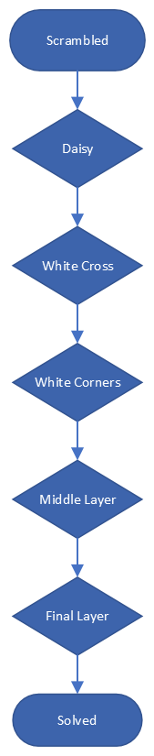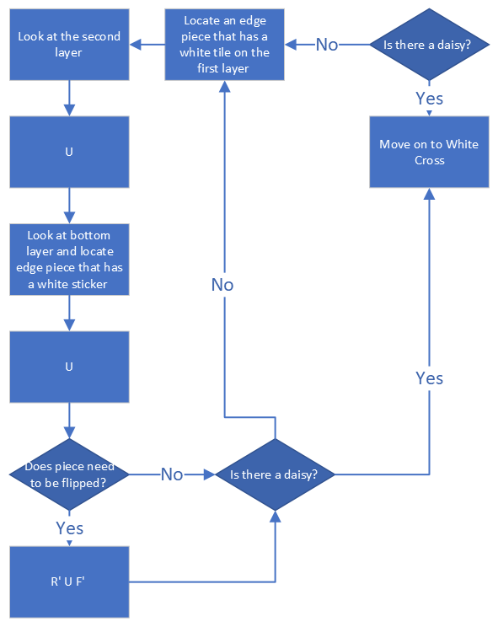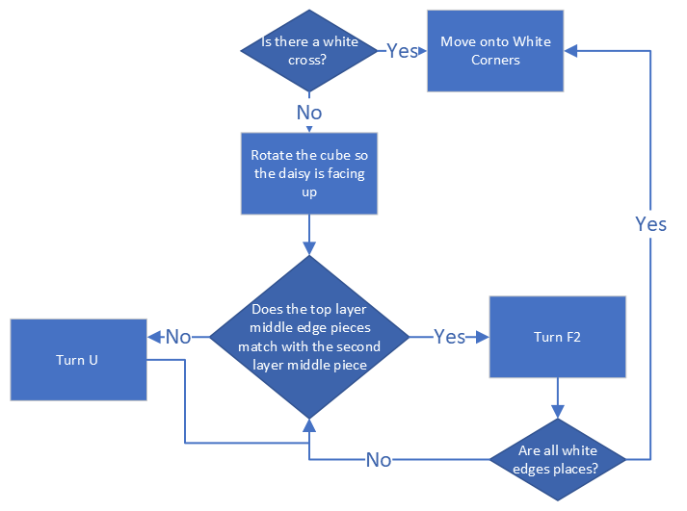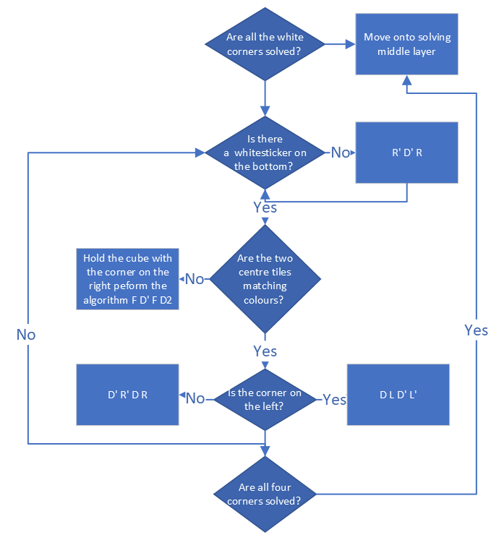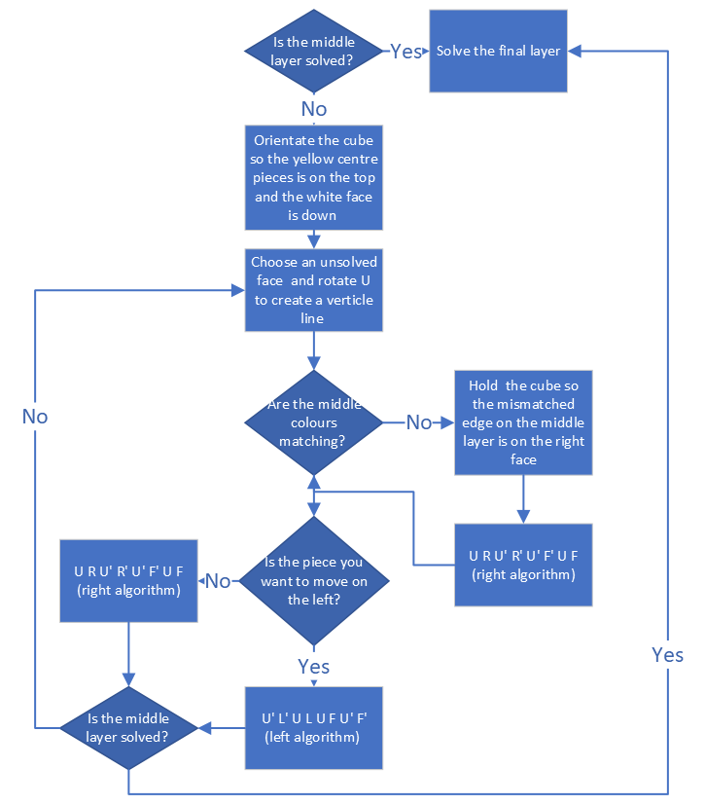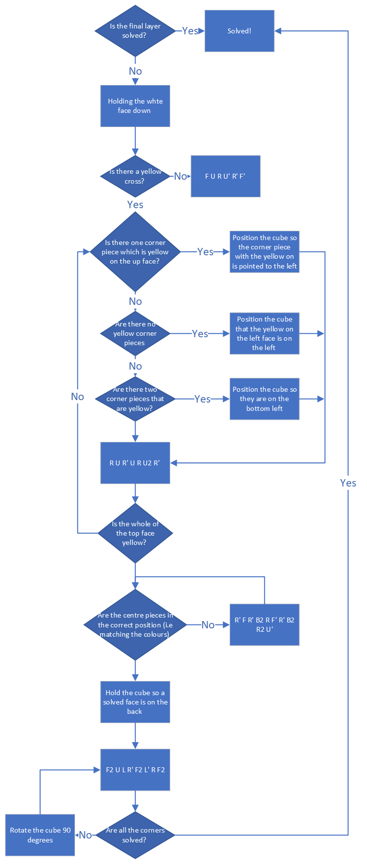

## Current system/ investigation into similar systems

There are many Rubik’s cube tutorials and solvers that already exist on the web, all with a variety of helpful features I would love to include in my project! I decided to explore the top results on the internet and the apple app store to investigate what I should implement.

* 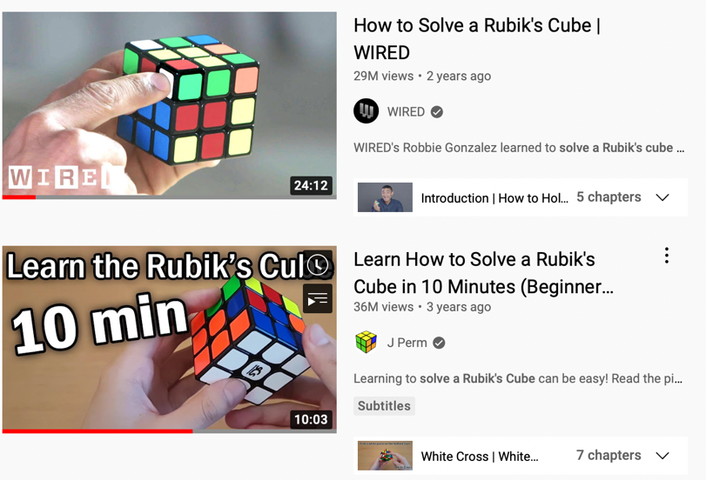I started by following tutorials on YouTube and worksheets online but found this was time-consuming and frustrating. The Rubik notation was hard to follow as a complete beginner and felt there was an imbalance of pace in different videos. I also found some of the moves they were describing were confusing and I did not know where to start; I sensed that a visual aid may be helpful. Eventually, I managed to solve my cube but feel there are much better methods of learning.

Figure 1- Top results after searching “How to solve a Rubik’s cube” into YouTube

* Grubiks is an online puzzle site that offers the chance of inputting your own cube positions into a 3D platform and gives a step- by- step solution on how to solve it. A feature I particularly liked on Grubiks is the built-in validation to ensure that the user enters proper values (encase of swapped stickers) and the easy-to-follow animations. However, after scrambling my cube, inputting 54 assorted colours felt like a chore and was surprisingly difficult, which took away the enjoyment I get from solving a cube. Furthermore, even though it took me through all the steps of solving, I still felt like I was ‘cheating’ and did not truly solve it for myself.

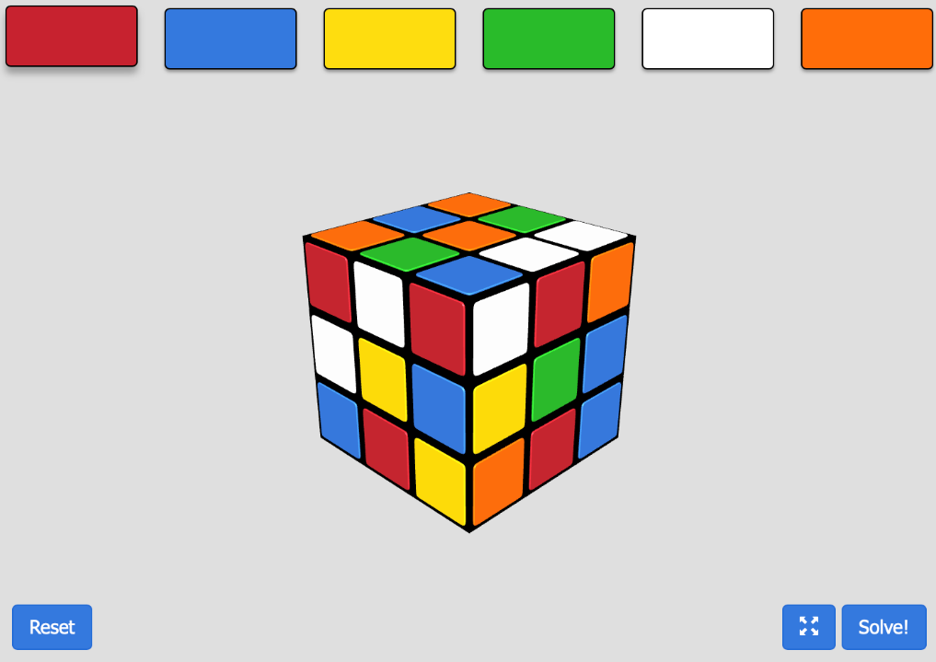

Figure 2- snippets from Grubiks show an invalid input and its exception handling

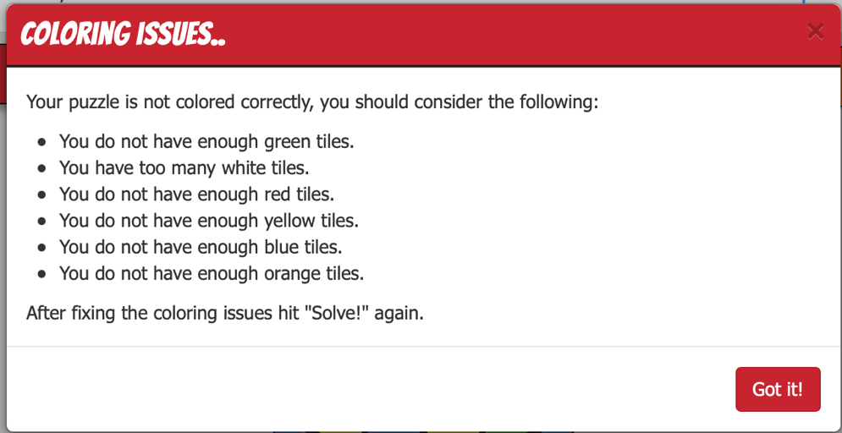

* I created flow chart to investigate into how the program works to help me deeper decompose the site and help me think of how my own program will be structured:

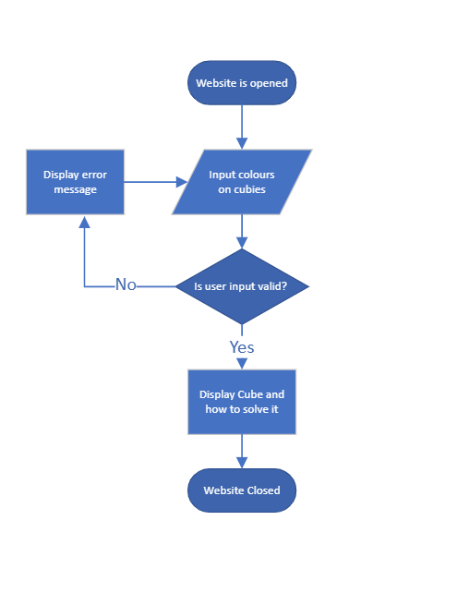

* CubeSolver is a mobile app which enables users to take a picture of their scrambled cube and renders a 3D image it. A step-by-step animation is then shown on the screen in timed intervals giving the user time to solve their own cube, as well as the option to go back a step if you were lost. After following all the steps, a well-done message is displayed on the screen which feels gratifying and gives the user satisfaction! Furthermore, I thought the user interface was aesthetically pleasing and easy to understand. On the contrary, I found the camera input to be haphazard, but eventually it did register all the distinct colours on the cube.

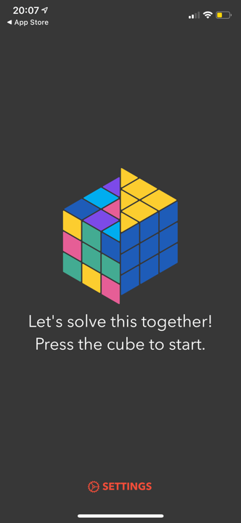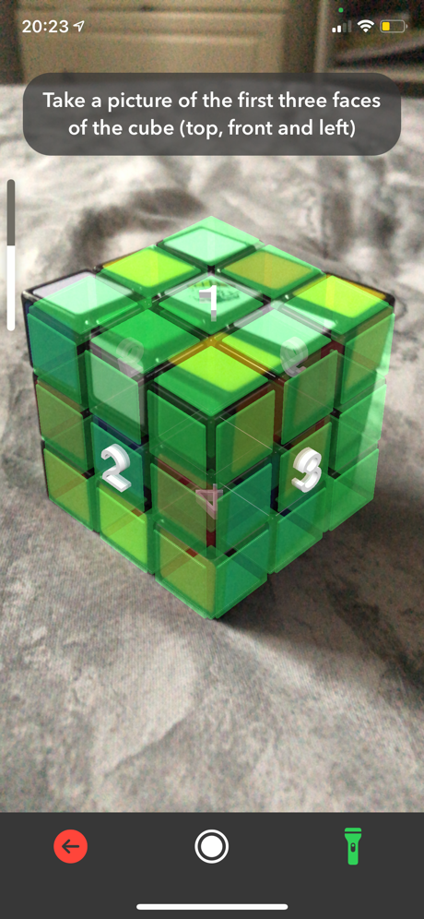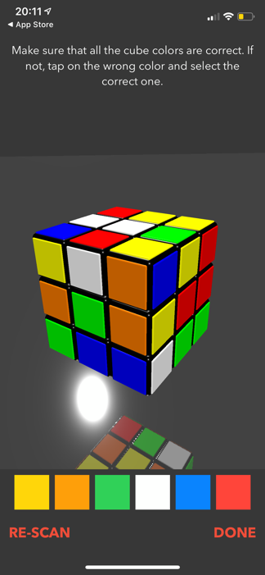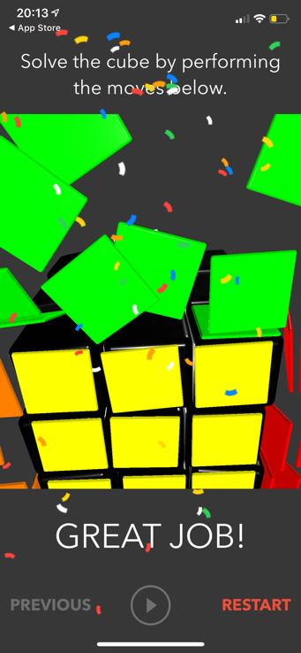

Figure 3- snippets from the mobile app CubeSolver

Below I created another flow chat to investigate how this program works:

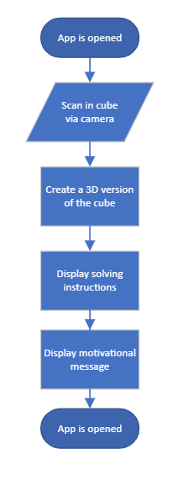

Even though this is similar to the other flow chart, the lack of validation in this program is a disadvantage and could end up in errors in the program’s solver.

## User investigation

To investigate into a target audience, I sent an electronic questionnaire to my fellow classmates and interviewed some teachers who have had experience with solving Rubik’s cubes and gathered information about the target demographic. The following questions in the questionnaire were asked along with their responses:

How did you learn how to solve a Rubik’s cube?

The general answers for this question I received was:

* By YouTube videos
* Family members
* Websites
* Trial and error

Have you ever used software/hardware to help you solve a cube? If so, please describe what it did.

Most people who had answered this question answered that they had not ever used any websites or apps to help them solve a cube. When prompted with what features they thought would be beneficial in such software, a variety of answers were given including:

* Formula being written out
* Being able to retrace your steps as many times as you wanted
* Shown pictures of how it’s meant to look after each step

Do you value efficiency in solving or a standard step-by-step method when solving?

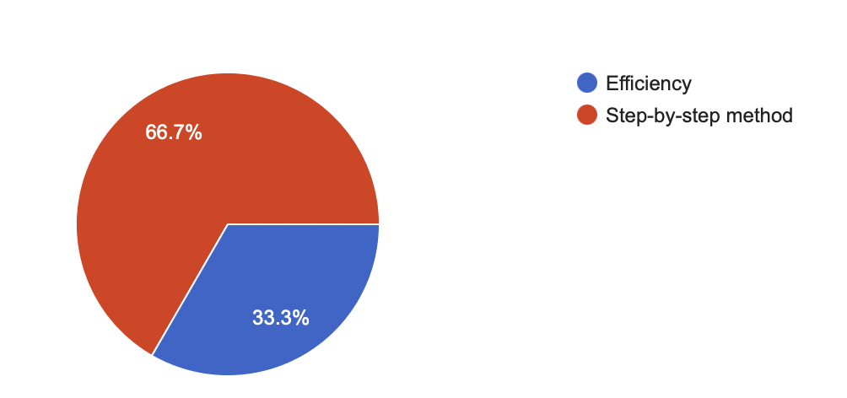

Most people who completed the questionnaire voted that a step-by-step method would be more helpful than having the most efficient method, with all the responses to the question “what method of solving do you currently use” being the standard method described in the ‘how does a human solve a cube’ section.

The interview I conducted was with humanities teachers Mr Cowlard and Miss Collins, both of whom have children who have tried to solve a cube.

What are your experiences with Rubik’s Cubes?   
Miss Colins- “Despite being taught many times how to solve it, I can only recognise the patterns if I am under supervision from my son Charlie (who was 10 years old at the time). Charlie experimented with Rubik’s cubes in a maths lesson at school and asked if I could get one at home. I became intrigued by the cube when my son left it scrambled and I learnt how to follow the steps to ease my frustration of the muddled cube. Charlie primarily learnt through YouTube videos after I prompted him to research them for himself, he can now solve a variety of cubes including 2x2, 3x3 and 4x4”.

Mr Cowlard- “I had a cube as a kid which was lying around the house, my son Noah (who was 10 at the time) was telling me about his friends that solved cubes at school and as it became a ‘trend’ we spent a lot of time together trying to solve it. He now has a collection of cubes beyond the scope of the traditional 3x3 and still enjoys the logical problems. I still cannot solve one fully myself (although I can just about do one side) but have come across many websites and apps that have helped me and my son in the past. Noah started off by using a website which allows you to scramble your cube and input your exact cube positions then solves it in so many moves. He liked that as it was successful but found that he wasn’t learning the algorithms but just copying what is said, we started falling out because of the cube!”.

What features do you think would be helpful with software to help you solve and scramble:

Miss Collins – “I’ve found that younger children are very obsessive when they find a new hobby and Charlie is an incredibly determined boy; when he puts his mind to something he will do it. However, it was very frustrating when neither of us could solve it and we sat there for hours trying to solve it. I found that Charlie liked being praised (as most people) when he completed a step so that could be something you could include. Children can also be quite passive; I think a questioning feature may be good (i.e.‘do you know what step is next?’) After mastering solving a 3x3, perhaps there could be a feature to make patterns or advance onto more advanced efficient algorithms”.

Mr Cowlard- “Noah is a very logical person and finds it hard to understand long complex paragraphs on how to solve, I think that step by step methods would be more helpful for solving a cube and having the ability to retrace your steps. We found watching YouTube videos to be very daunting and they all went at different paces, having slow downed simplified steps would have saved so much frustration from both me and Noah (and saved many arguments). Notation like clockwise, anticlockwise with example pictures was also immensely helpful; although solving the cube has taught him some resilience though which can only be a good thing”.

### Summarising findings and further research

After exploring different methods of solving a Rubik’s cube and using the results from the interviews and questionnaire, I have summarised the strengths and weaknesses of each of the features to consider implementing into my project:

|  |  |
| --- | --- |
| Strengths | Weaknesses |
| * Positive feedback/ Praise and encouragement * Validation * Step-by-step solutions * Aesthetically pleasing * Visual is better * Timed intervals * Possibility to backstep/ pause instructions being displayed * Choice to advance into more advanced cube solving methods and vary scrambling difficulty level | * Notation can be hard to understand * 3D inputs can be confusing * Can get confused on which steps you are on |

By researching online, I discovered five different ways a Rubik’s cube can be represented by programming software:

* The obvious solution is using a three-dimensional array of characters, 6 x 3 x 3. The colour of a face could be indexed by recognising a side, row and colour (i.e., cube[side][row][column]). However, I think the programme may run significantly slower because of the vast number of instructions needed to be executed
* Alternatively, a single array of 54 characters could be used, which would be much faster than the first structure. Its row and column could be calculated manually but would still be slow
* Could use two arrays, one for the corner cubies, and another for the edges. The elements of each array hold a cubie index (0-11 for edges; 0-7 for corners) and an orientation (0 or 1 for edges; 0,1 or 2 for the corners)
* A bitboard could be used (like a chess board). This would be faster than the other methods; by using 6 64-bit integers, rotating the cube could be executed by bitwise operations and faces done by masks (predefined set of bits that is used to select which bits are changed by earlier operations)
* Could use a 3D visualisation using OpenGL with an OpenTK library, by making 27 coloured cubies and using the right matrix transformation to rotate them.
* An object oriented approach including a face and cube class- the cube contains a list of faces which it can manipulate to scramble and solve the cube.

### Possible users

My target audience and testers will be a mixture of school students and children who will test and review the effectiveness on being able to scramble and solve the cube. I will also test my program on a student who doesn’t know how to solve a cube but is eager to learn, to see how a beginner can use the software to solve a cube.

## Proposed Solution

My project should display an interactable cube which can input any colours of the user’s choice (for customisation) and set a scrambling difficulty and scramble the cube. The user should them be able to press start solving and press through the steps on how to solve the cube or do it themselves and compare the efficiency of their method to the computers generated method. The instructions should be reversable in case the user wants to go back or forward a step and the cube should dynamically update with each step. A queue or stack of instructions may be a promising idea to keep track of which step the user is on- almost like an undo button, which is essentially a stack of instructions, which are being popped and pushed. My system should:

* Display a Rubik’s cube on screen
* Be able to scramble and solve a cube using randomisation
* Output a set of instructions for a user to follow- perhaps implementing a stack of instructions
* Feature validation to ensure the cube is solvable
* Being able to input the colours of their desired Rubik’s cube

By considering my options from the summarising findings and further research section, I feel the best way to program this would to be to create a dynamically updated 3D cube which I would then use an object-oriented approach and a combination of matrix transformations to output a series of instructions.

### Limitations:

Because of a lack of time, my system will not produce an optimal way to solve a cube, but just show one of the ways of solving it via unscrambling the cube. My solver will also be restricted to solving 3x3 cubes, not 2x2 or 4x4 as these would require a separate set of instruction to solve and will not use the human way of solving a cube. I think a camera module to scan the colours on a Rubik’s Cube would be a great addition to my project but in the limited time I think it is out of the scope of my project.

### Data Volumes:

Most of the data used will be via user input and will have to be processed and used to solve the cube; the user will only have to input colours which will be validated to ensure the input is correct.

### Hardware and software:

My project will use a PC on visual studios which will enable the use of C sharp. Using the programming languages, I am most familiar in will aid in producing the program and won’t hinder further development. The end user will need to have a PC which will be able to run a web browser as I am going to be using Blazor: a web framework used for writing dynamic interactive webpages which allows me to use HTML, CSS and code in C sharp.

## Objectives

|  |  |
| --- | --- |
| Task | Objectives |
| Input | * A suitable user interface should be designed to allow the user to input their cube options. * User should be able to interact with different buttons on the screen, being triggered by a mouse click- the user should enter the colours of the cube they have and be able to dynamically view each side of the cube. * There should be an input and start solving button, as well as a drop down list to select the scrambling difficulty * User should be able to view all sides of the cube, rotating it how they please |
| Validation | * Check if there are 9 of each colour inputted * Check that no 2 opposite colour stickers are on the same cubie * Check there are no same-coloured stickers on a cubie |
| Scrambling | * After the selected difficulty is selected by the user, the program should display the steps of scrambling for the user and then prompt the user to solve the cube themselves * The program should randomly generate cube scrambling at the difficulty level selected by the user and use recursive techniques to produce this. |
| Solving | * The program must store a list of instructions to solve this cube position after scrambling * The instructions should be fully simplified in terms of consecutive rotations on the same face * 2 90 degree turns in a row should be replaced with one 180-degree turn * 2 180 degrees in a row should be removed * If the user wants to view the instructions on how to solve the cube, they should be able to view the step-by-step solution using buttons on the screen |
| Output | * User must be able to visualise the cube on the screen * Program must display a set of instructions * It must have the choice to ‘undo’ an instruction via interactable buttons * Could display a motivational message once solved |

## References

### Information References

Rubik's cube videos-

<https://www.youtube.com/watch?v=R-R0KrXvWbc&t=6s>

<https://www.youtube.com/watch?v=7Ron6MN45LY&t=348s>

Rubik's Cube Solver 3x3x3 - Grubiks. 2022. Rubik's Cube Solver 3x3x3 - Grubiks. [ONLINE] Available at: https://www.grubiks.com/solvers/rubiks-cube-3x3x3/. [Accessed 20 July 2022].

Apple app store- CubeSolver

History of Rubik’s Cube: <https://www.youtube.com/watch?v=f-rjR0lUDmg>

Approaches:

<https://medium.com/@benjamin.botto/implementing-an-optimal-rubiks-cube-solver-using-korf-s-algorithm-bf750b332cf9>

How to solve a cube: guidebook titled “You can do the Rubik’s Cube”- published by Rubiks.com

Project references: <https://github.com/callumnewlands/Rubiks-Cube-Solver-VB>

Image Processing libraries for c- sharp: <https://csharp-station.com/4-best-c-libraries-for-image-processing/>

A forge-net: <http://www.aforgenet.com/>

Isaac computer science- <https://isaaccomputerscience.org/?examBoard=all&stage=all>

### Picture References

Figure 1- Sourced from youtube.com

Figure 2- Sourced from Rubik's Cube Solver 3x3x3 - Grubiks. 2022. Rubik's Cube Solver 3x3x3 - Grubiks. [ONLINE] Available at: https://www.grubiks.com/solvers/rubiks-cube-3x3x3/. [Accessed 20 July 2022].

Figure 3- Screenshots from Apple App Store application ‘CubeSolver’

Figure 4- Snippet from the Guidebook “You can do the Rubik’s Cube” published by Rubiks.com

# Documented Design

## Overview

For my game, I will use Visual Basic with Blazor which allows me to program in C# (a language I am familiar with) which will enable me to create more complex object-oriented solutions. Blazor specifically will provide the optimum user interface for human computer interaction; and will incorporate an interactable (via buttons and mouse clicks) webpage for the end user. The basic outline of the project is creating a visual 3D model of a cube using grouped two- dimensional arrays (faces) that make up a cube class. The user will be able to input their cubes colours by typing them on the screen and view a series of instructions to solve the cube (which will be retraceable to meet the user’s needs). The program will end when the cube is successfully solved, and a relevant ending screen should be displayed (including the number of moves it has solved the cube).

#### Mini Project- Tic-Tac-Toe

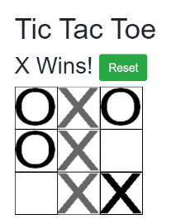The program I am trying to create will exploit multiple linking data structures, I first started by exploring data structures in Blazor by creating a Tic- Tac- Toe. To do this I followed ‘Exceptions not found’ blog post on an introduction to Blazor. At first, I found that the different organisations and syntax was confusing, but I felt much more optimistic and developed a clear vision on how I want my project to be organised and presented by the end of the mini project. Before starting, the blog introduces the idea of decomposing the problem into individual folders and classes. For tic-tac-toe, I thought about the different models needed and considered X’s, O’s, and a grid. I then created a class to model them called “Game Pieces”. By splitting every problem into a smaller sub problem, I found that the tasks were manageable: I will be using these techniques when programming my Rubik’s Cube. Furthermore, creating the game board class enabled me to create smaller subroutines such as WinningMoves(), IsADraw() and GetWinner(). Something I hadn’t considered before programming this was that the program needs ‘know’ how to stop when the cube is solved; to combat this I will have to program checks and potentially read in a solved cube to confirm the program works. This mini project also gave me a starting point in knowing how to create a user interface for Human-Computer-Interaction. Using a mixture of HTML syntax and C# features in Blazor was easier than I expected, dynamically applying the classes to their corresponding symbol (X and O) was satisfying. I also found that creating a button triggered when the game was complete was also an interesting feature. Having the human who are trying to solve the cube see a visual representation of their cube would be invaluable; so, I used the skills I learnt from Tic-Tac-Toe to create a prototype of a user interface I would like to create for my project.

#### Web Hierarchy

Below is how I am going to structure my webpage using Blazor, including a page layout and a hierarchy.

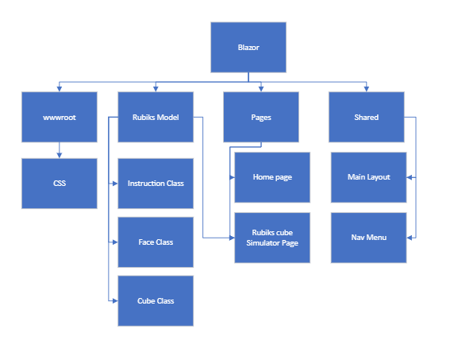

My project will be organised like the above, with the Rubik’s simulator page using the Rubik’s Model folder to access the cube, face and instruction class. The wwwroot folder holds the CSS for the system and the shared folder holds the code for the main layout and the navigation menu. The home page will be a welcome and the Rubik’s cube simulator page will be modelled like the GUI design below. The whole website will be structured like below:

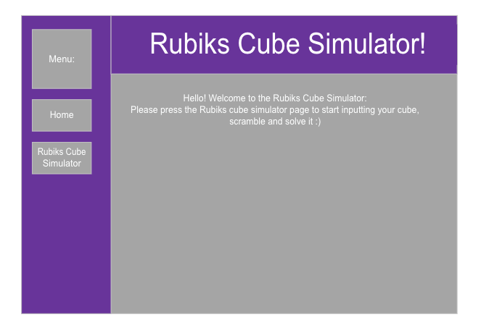

On the left you can see the menu which will link to different pages in Blazor, this screenshot shows an example of the home page being clicked. Using HTML and CSS it displays the Title and a message.

Cube:

At the beginning of the solver, the user should be able to input their cube colours onto the blank cube. Validation should then take place to see if the cube is solvable.

Titles and Subheadings:

Using Blazor a HTML <h1> and <h2> should be used to display titles and guide the user through their solving journey.

Current Move:

This will show the user what move they are on.

Display Buttons:

By identifying appropriate bootstrap buttons, Interactive buttons should be displayed which enable the user to display the other sides of the cube and input their required colours.

When Solving:

After successfully inputting in your cube’s colours current position, the cube colours should change depending on which instruction the user is currently on. This should be helpful to give the user an idea if they are on the right track.

‘Undo’ and ‘Redo’ Button:

These buttons will enable the user to go back or forward a step as they need, so they can solve the cube at their own pace. This will be introduced in the form of a stack, ‘popping’ and ‘peeking’ the next instructions.

#### GUI Design



\

#### System Hierarchy/ DFD diagram

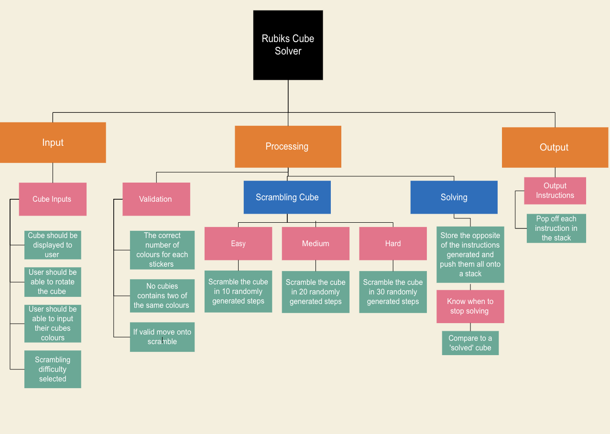

This is an overview of my system with proposed components. Once all inputs and validation has taken place, the scrambling and solving program will begin which will be made from several algorithms.

My designed solution can be broken down into four critical main parts:

1. Input: Using a Blazor programme, I will display each face of the cube individually, having intractable buttons to rotate the cube. The user will also be able to click on each of the stickers to change its colour until it matches the one on their cube that they want to solve. The colours will then be stored into a two-dimensional array, with the first dimension being the face, and the second dimension being the position on the face.
2. Validation: The programme should then see if the cube inputs are valid. A cube will be valid if it fulfils each of these conditions:
   1. There are 9 stickers for each colour (red, yellow, green, blue, orange, white on a classic cube)
   2. No cubie holds two of the same colours or of colours which should be in opposite positions on the cube

If these conditions are valid, it should send it to the corresponding ‘scramble’ and ‘solve’ section as an object instantiated from the cube class. This will then hold attributes of the cube.

1. Scrambling: According to the difficulty selected by the user, a scrambling algorithm will be applied using randomly generated values and perform these on the cube.
2. Solving: There are two different methods of solving I could implement. The first one is I solving the cube following the Beginner’s step-by-step method and will use three separate classes for each layer. I will pass the cube into each class as an aggregate object so that the layer can be solved, and the cube can be used outside of the class. If I have time, I will optimise these so there are no consecutive steps of the same move and then the steps will be output to the user via a stack. Alternatively, I could produce the a list of opposite instructions to the scrambling instructions (i.e. a “R” = “R’”) and push these instructions onto a stack to be popped off and performed. This will have the effects of reversing the cubes scramble.
3. Output: I will then output the instructions to the user using a 3D model of a cube, which performs the required instruction on the screen. As displayed in the GUI Interface section, corresponding buttons will be pressed to ‘undo’ certain moves to allow the user to go at their own pace.

These are critical as the cube will not be solvable nor explained without all these criteria being fulfilled, meeting my aims. I can be sure my project is completed to a satisfactory standard if these parts are completed.

## Object-Oriented Design

### Overview

By creating entities that interact with each other, I can use object-oriented techniques like inheritance, polymorphism, and encapsulations to model a Rubik’s cube, as well as the use of aggregated classes.

A cube is made up of many faces. A face is then made up of many cubies which can be classified as either an edge, corner, or middle. In my project, I am planning to enumerate the different faces of the cube and create 2D arrays of enumerated colours. The following is an example of how the data is going to be structured.

*Faces*

* There 6 faces on a Rubik’s Cube
  + Top
  + Bottom
  + Left
  + Right
  + Back
  + Front
* Each face is made up of 9 cubies
  + 4 edge cubies
  + 4 corner cubies
  + 1 middle cubie
* These will be stored in a list of 2D arrays
* The 2D arrays will be structured like this:

|  |  |  |  |  |
| --- | --- | --- | --- | --- |
|  | 0 | 1 | 2 |  |
| 0 |  |  |  |  |
| 1 |  |  |  |  |
| 2 |  |  |  |  |

* (0,0), (0,2), (2,0), (2,2) are all corner cubies
* (0,1), (1,0), (2,1), (1,2) are all edge cubies
* (1,1) is a centre cubie

All cubies will have an assigned colour out of an enumerated list

* W, G, O, R, B, Y

#### Cubies

All cubies do not change, they are fixed colours on a cube, however their position changes.

* There are three distinct types of cubies
  + Edge
    - Made up of 2 colours
  + Corner
    - Made up of 3 colours
  + Centre
    - Made up of 1 colour
    - Does not move

### Class Diagram

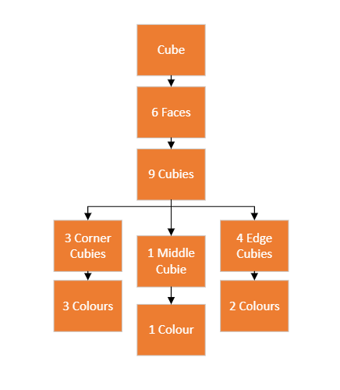

Here is an overall class diagram of the Rubik’s data structure. A cube is a list made up of 6 faces (becoming a one-to-many relationship), and a face is made up of 9 cubies. Sub-categories of cubies include corner, middle and edge cubies which will be an aggregated classes in the final program.

+CreateFace()

+SubmitFace()

+PutUserInputIntoFace()

**Functions**

+DisplayFace()

+SequenceForRotationLeftAndRight()

+SequenceRotationUpAndDown()

+DisplayAdjacentFace()

+WhichFaceToShow()

+faceToDisplay()

+IsCubeSolvable()

+NineOfEachColour()

+NumberOfColourCubies()

+ValidateNumberOfCubiesInputted()

+ValidCubieColourInputted()

+ConvertToLower()

+GetFace()

+ValidateCornerCubies()

+ValidateEdgeCubies()

+ApplyScramblingInstruction()

+ApplyCurrentInstruction()

Cube



-List<Face> faceList

-Int currentFace

-String CubieInput

-String cubeShow

-String errorMessages

-Dictionary- sequenceForUpDown/LeftRight, DisplayAfterSeeingAdjacentFaces,whichFaceToShow



**Subroutines**

+RotateLeftClockwise()

+RotateLeftAntiClockwise()

+RotateRightClockwise()

+RotateRightAntiClockwise()

+RotateUpClockwise()

+RotateUpAntiClockwise()

+RotateDownClockwise()

+RotateDownAntiClockwise()

+RotateFrontClockwise()

+RotateFrontAntiClockwise()

+RotateBackClockwise()

+RotateBackAntiClockwise()

+UpdateAllFacesAndTheirOrientation()

+SeeFrontFace()

+SeeBackFace()

+SeeRightFace()

+SeeLeftFace()

+SeeTopFace()

+SeeBottomFace()

Face



2D array (3x3) of cubies

String [ , ] Face

String colour



**Subroutines**

changeOne()

matrixRotationClockwise()

matrixRotationAntiClockwise()

matrixHalfRotation()

UpdateColumn()

UpdateRow()

UpdateFaceOrientation()

UpdateCubies()

**Functions**

getCubieColour()

getLeftColumn()

getRightColumn()

getTopRow()

getBottomRow()

ReturnCurrentFaceAndOrientation()

This is one design of how the classes will be organised; in this there are 3 main classes (Cube, Face, Cubies) However, in practice having a cubie class may not be necessary as a cubie is essentially an array full of strings and colours- we can manipulate the cubies via the face class.

In the final project there could be an Instruction class which keeps track of the current instructions, and a Rubik’s cube class which solves the cube.

Instruction



-List<string> instructions

- Int currentIndex

-string errormessage



**Subroutines**

+GetNextInstruction()

+GetPreviousInstruction()

+RightAlgorithm

+AddInstructionToList

+CompressList

**Functions**

+GetCurrentInstruction

Edge



string [ ] Colour



HasTwoColours()

CorrectRotation()

Corner



string [ ] Colour



HasThreeColour()

CorrectRotation()

Middle

Colour[ ]



HasOneColours()

Cubie- contains subclasses edge, centre, corner



Array of colours as string values

string [ ] Colour



HasColour()

CorrectRotation()

CorrectOnOppositeFace()

CubieColour()

CubieSwap()

CubieProperty()

#### Enumerations

In my project I could use multiple enumerations to manipulate data. Colours could be a vital enumeration in my project as the face class will be a two-dimensional array of cubie colours. The enumeration could be as follows:

|  |  |  |  |  |
| --- | --- | --- | --- | --- |
| Face 0 | 0 | 1 | 2 |  |
| 0 | G | G | R |  |
| 1 | B | W | B |  |
| 2 | G | Y | B |  |

Enum Colours

{

W= 0

Y= 1

R = 2

O = 3

G= 4

B = 5

}

|  |  |  |
| --- | --- | --- |
|  |  |  |
| TopFace  4 |
| LeftFace  1 | FrontFace  0 | RightFace  2 |
|  | BottomFace  3 |  |
| BackFace  5 |

Enum Faces

{

FrontFace =0

LeftFace=1

RightFace=2

BottomFace=3

TopFace =4

BackFace=5

}

Enum Moves

{

RotateRight= 0

RotateLeft= 1

RotateUp= 2

RotateDown = 3

RotateFront= 4

RotateBack = 5

}

§

## Pseudocodes

### Validation

I will validation in my program to check that the Rubik’s cube colours entered does exist and is solvable. This allows the user to enter their cube in any orientation and eases the human-computer interaction. The program should check if the colours entered are colours available on an actual cubes’ faces (i.e red, blue, orange, green, yellow or white ) The Program will also check if a corner or edge piece consists of more than one of the same colours, an error message should be displayed to the user and the program should continuously ask the user until their cube is valid. The following pseudocode model the subroutines and functions that will be implemented into the final project.

#### IsCubePossible()

FUNCTION IsCubePossible(face) AS BOOLEAN ***//so it is true or false***

Bool cubeIsPossible = true;

IF (ValidColours(face) == FALSE)

{

cubeIsPossible = false

}

IF (EdgesPossible() == FALSE)

{

cubeIsPossible = false

}

IF CornersPossible()

{

cubeIsPossible = false

}

IF ((cubeIsPossible) == TRUE)

{

RETURN TRUE; **//cube is possible**

}

ELSE

{

RETURN FALSE;

}

#### EdgesPossible()

To find if the edges are possible, first we must find a way to find what piece is in-fact an edge and what is a corner. To understand this problem further, I created a paper model using a cube net like below:

|  |  |  |  |  |  |  |  |  |
| --- | --- | --- | --- | --- | --- | --- | --- | --- |
|  | | | (0,0) | (0,1) | (0,2) |  | | |
| (1,0) | (1,1) | (1,2) |
| (2,0) | (2,1) | (2,2) |
| (0,0) | (0,1) | (0,2) | (0,0) | (0,1) | (0,2) | (0,0) | (0,1) | (0,2) |
| (1,0) | (1,1) | (1,2) | (1,0) | (1,1) | (1,2) | (1,0) | (1,1) | (1,2) |
| (2,0) | (2,1) | (2,2) | (2,0) | (2,1) | (2,2) | (2,0) | (2,1) | (2,2) |
|  | | | (0,0) | (0,1) | (0,2) |  | | |
| (1,0) | (1,1) | (1,2) |
| (2,0) | (2,1) | (2,2) |
| (0,0) | (0,1) | (0,2) |
| (1,0) | (1,1) | (1,2) |
| (2,0) | (2,1) | (2,2) |

Possible edge colours include:

GW WR

GR WB

GY RB

GO RY

OW BY

OB YO

Looking at this cube, the corners of the cube are at the co-ordinates:

(0,2) (2,2) (0,0)

(2,2) (2,0) (0,2)

(0,0) (2,0) (2,2)

(0,0) (0,2) (2,0)

(2,0) (2,0) (0,0)

(2,2) (2,2) (0,2)

(0,2) (0,2) (2,2)   
(0,0) (0,0) (2,0)

Looking for patterns in this, we can see that each corners have the column 2 or 0

FUNCTION CornersPossible()

SWITCH (Corners are possible)

CASE: BottomLeftFrontCorner

CornerColour(GetColour(FrontFace[2,0]), GetColour(LeftFace[2,2]), GetColour( BottomFace[0,0])) = CornerColourCombo(colour,colour,colour)

CornerColourCombo(colour,colour,colour).Remove()

CASE: BottomRightFrontCorner

CornerColour(GetColour(FrontFace[2,2]), GetColour(RightFace[2,0]), GetColour(BottomFace[0,2].Extract) ) = CornerColourCombo(colour, colour, colour)

CornerColourCombo(colour,colour,colour).Remove()

CASE: TopRightFrontCorner

CornerColour(GetColour(FrontFace[0,2]), GetColour( RightFace[0,0]), GetColour(TopFace[2,2]) )= CornerColourCombo(colour,colour,colour)

CornerColourCombo(colour,colour,colour).Remove()

CASE: TopLeftFrontCorner

CornerColour(GetColour(FrontFace[0,0]), GetColour(LeftFace[0,2]), GetColour(TopFace[2,0].Extract)) = CornerColourCombo(colour,colour,colour)

CornerColourCombo(colour,colour,colour).Remove()

CASE: TopRightBackCorner

CornerColour(GetColour(TopFace[0,2]), GetColour(RightFace[0,2]), GetColour(BackFace[2,2])) = CornerColourCombo(colour, colour , colour)

CornerColourCombo(colour,colour,colour).Remove()

CASE: TopLeftBackCorner

CornerColour(GetColour(TopFace[0,0]), GetColour(LeftFace[0,0]), GetColour(BottomFace[2,0])) = CornerColourCombo(colour,colour,colour)

CornerColourCombo(colour,colour,colour).Remove()

CASE: BottomLeftBackCorner

CornerColour(GetColour(BottomFace[2,0]), GetColour(LeftFace[2,0]), GetColour(BackFace[0,0])) = CornerColourCombo(colour,colour,colour)

CornerColourCombo(colour,colour,colour).Remove()

CASE: BottomLeftBackCorner

CornerColour(GetColour(BottomFace[2,2]), GetColour(LeftFace[2,2]), GetColour(BackFace[0,2])) = CornerColourCombo(colour,colour,colour)

CornerColourCombo(colour,colour,colour).Remove()

TRY CornerColourCombo[0].Remove

CATCH

RETURN TRUE

END TRYCATCH

END FUNCTION

}

Looking at the edges, they are at the co-ordinates  
(2,1) (0,1)

(1,2) (2,1)

(2,1) (1,0)

(1,0) (1,0)

(0,1) (2,1)

(1,2) (1,2)

We can see that each edge doesn’t particularly have a pattern, but are placed on one of 4 edges

(1,2) (1,0)

(2,1) (0,1)

(1,2) (1,0)

(1,2) (0,1)

#### CornersPossible()

The subroutine above uses switch case statements to confirm the cubes edge positions. The subroutine **GetColour(Face, row, column)** iterates through the desired face passed into the parameter and gets the enumerated character values of the colour of that cubie. If the combination of cubie colours matches preset colours in the list CornerColourCombo(), the pre-set colour is removed from the list. If another value is removed from the list and there is an error (as there are no more values in the list to be removed), the subroutine returns true. To set up the CornerColourCombo(colour,colour,colour) list, we first need to figure out the preset colours each corner has. In a Rubik’s cube, these colours never change, just their relative positions in the cube.

Possible corner colour combinations:   
WGO

YGO

YGR

GWR

WOB

YBO

RBY

WBR

The order in which these colours are in does not matter (I.e WGO is the same as OWG). Having a prerapaered list of these and removing values which have been identified will elimate the need of another incremented counter, speeding up the overall processing speed of my program.

#### EdgesPossible()

This will work in a remarkably analogous way to the earlier function but will compare a list of edges instead of corners.

FUNCTION EdgesPossible()

SWITCH (Edges are possible)   
 CASE: FrontTopEdge

EdgeColourCombo(GetColour(FrontFace[0,1]), GetColour(TopFace[2,1]) = EdgeColourCombo(colour,colour)

EdgeColourCombo(GetColour(FrontFace[0,1],GetColour(TopFace[2,1]).Remove()

CASE: FrontRightEdge

EdgeColourCombo(GetColour(FrontFace[1,2]), GetColour(RightFace[1,0]) = EdgeColourCombo(colour,colour)

EdgeColourCombo(GetColour(FrontFace[1,2],GetColour(RightFace[1,0]).Remove()

CASE: FrontBottomEdge

EdgeColourCombo(GetColour(FrontFace[2,1]), GetColour(BottomFace[0,1]) = EdgeColourCombo(colour,colour)

EdgeColourCombo(GetColour(FrontFace[2,1],GetColour(BottomFace[0,1]).Remove()

CASE: FrontLeftEdge

EdgeColourCombo(GetColour(FrontFace[1,0]), GetColour(LeftFace[1,2]) = EdgeColourCombo(colour,colour)

EdgeColourCombo(GetColour(FrontFace[1,0],GetColour(LeftFace[1,2]).Remove()

CASE: TopRightEdge

EdgeColourCombo(GetColour(TopFace[1,2]), GetColour(RightFace[0,1]) = EdgeColourCombo(colour,colour)

EdgeColourCombo(GetColour(TopFace[1,2],GetColour(RightFace[0,1]).Remove()

CASE: TopLeftEdge

EdgeColourCombo(GetColour(TopFace[1,0]), GetColour(LeftFace[0,1]) = EdgeColourCombo(colour,colour)

EdgeColourCombo(GetColour(TopFace[1,0],GetColour(LeftFace[0,1]).Remove()

CASE: TopBackEdge

EdgeColourCombo(GetColour(TopFace[0,1]), GetColour(BackFace[2,1]) = EdgeColourCombo(colour,colour)

EdgeColourCombo(GetColour(TopFace[0,1],GetColour(BackFace[2,1]).Remove()

CASE: RightBackEdge

EdgeColourCombo(GetColour(RightFace[1,2]), GetColour(BackFace[1,2]) = EdgeColourCombo(colour,colour)

EdgeColourCombo(GetColour(RightFace[1,2],GetColour(BackFace[1,2]).Remove()

Etc…

#### Use of Sets- ValidColour()

In my program, The user should type in a list of strings to enter onto each face. There will be two lists which will act as sets: a user inputted list and a set list of valid colours. When the user input is valid (all the correct colours are entered; the set should look like this:

User inputted set = “red,red,red,yellow,green,white,blue,green,orange”

ValidCubieColours = “red, yellow, green, blue, orange, white” 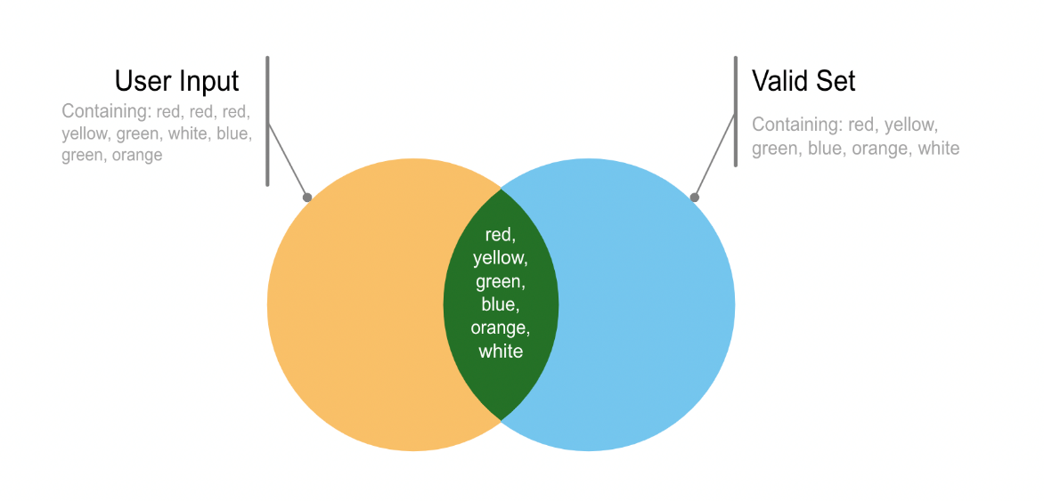

Here we can see that the cardinality of the intersection is 6 as all the colours in the valid set and the user input are used. We can also see that the cardinality of the union is 6, and the difference *UserInput*∖*ValidSet*=∅ and vice versa. We could say that the User Input is a subset of the valid set and could represent this in set notation as: UserInput={X in theValid *set* ∣*x* is a valid colour }



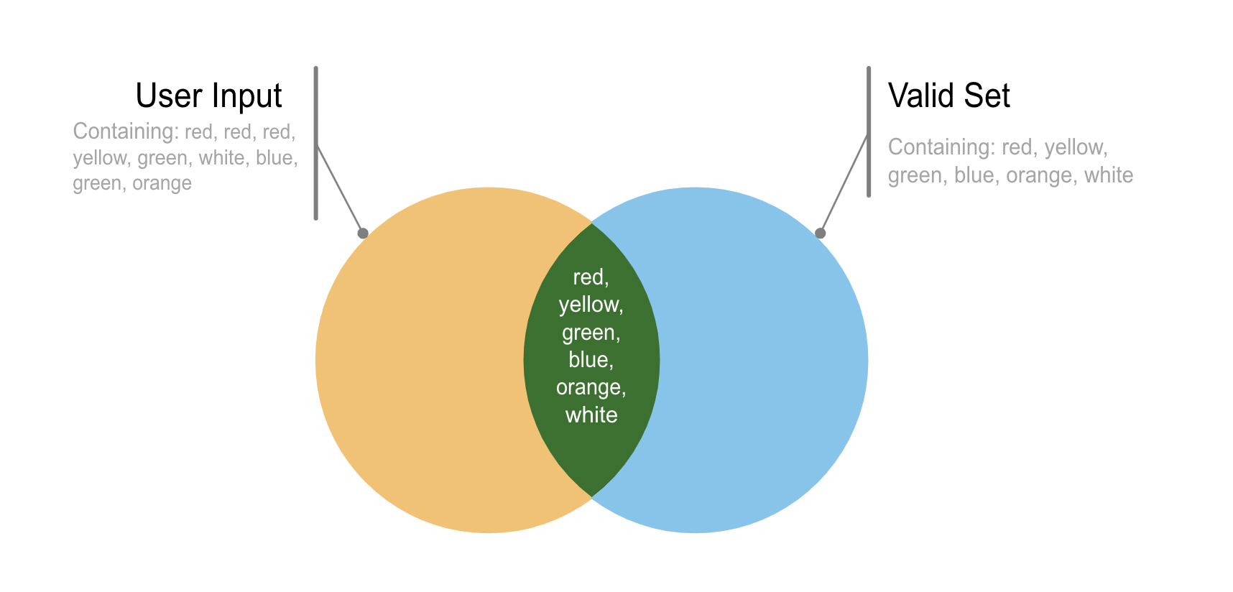

Take an example of an INVALID input:

User inputted set = “red,red,purple,yellow,green,white,blue,green,orange”

ValidCubieColours = “red, yellow, green, blue, orange, white”



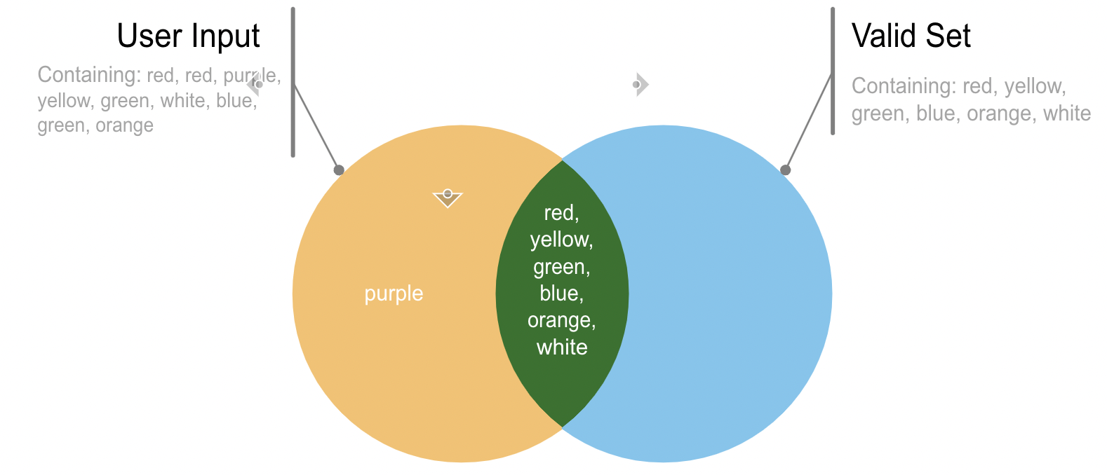

Here we can see that the cardinality of the intersection is still 6 as all the colours in the valid set and the user input are used. Here we can see that the cardinality of the union is 7, and the difference *UserInput*∖*ValidSet*=1

Finally, take another example of an INVALID input:

User inputted set = “red,red,purple,yelRow,green,white,blue,green,orange”

ValidCubieColours = “red, yellow, green, blue, orange, white”

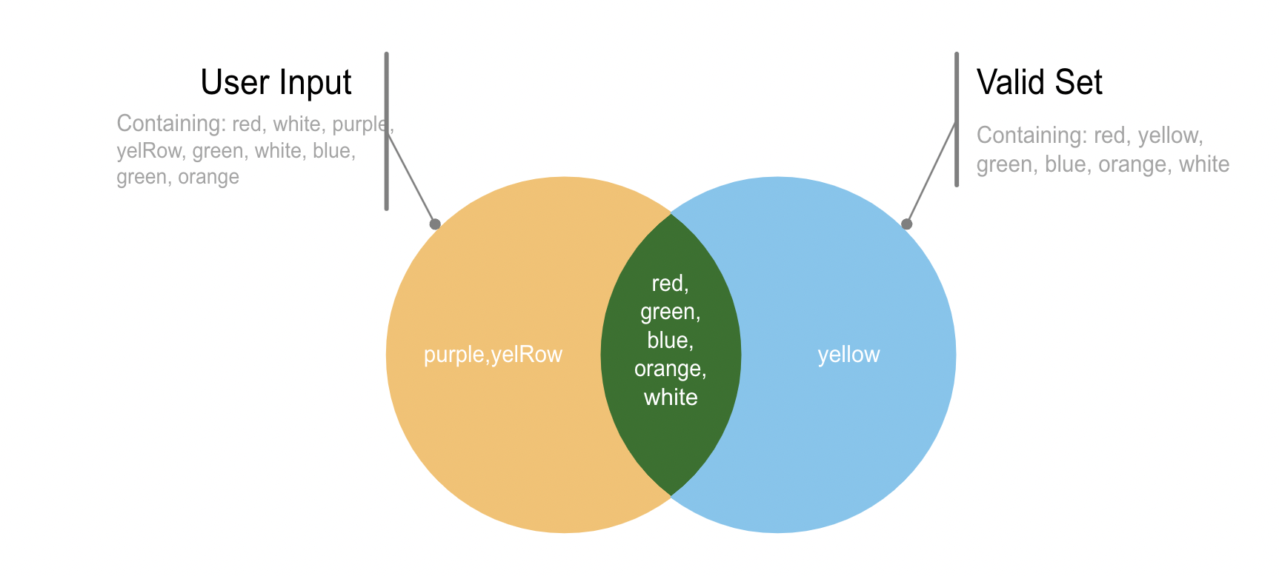

Here we can see that the cardinality of the intersection is 5, the cardinality of the union is 8, and the difference *UserInput*∖*ValidSet*=2 and the difference of ValidSet\UserInput = 1.

From this, I can see that the only way I can compare a valid set of user inputs to an invalid set of user inputs is to see if the union of the two sets is 6; if it is then I can say that the user input uses either red, yellow, green, blue, orange or white as their inputs and nothing else. I can implement this using the IEnnumberable feature on C sharp visual studios instead of using a lot of different IF statements; thus reducing the number of comparisions and operations the processor needs to do whilst running my program.

### Rotating the Cube

To rotate the cube in the following position, I will shift the positions on the cube to the different faces. The following rotations will be executed by a series of matrix transformations.

* Up = U
* Down = D
* Right = R
* Left = L
* Front = F
* Back = B

|  |  |  |  |  |
| --- | --- | --- | --- | --- |
| Face 0 (before) | 0 | 1 | 2 |  |
| 0 |  |  |  |  |
| 1 |  |  |  |  |
| 2 |  |  |  |  |

Let the front face be 0, the top face be 1, the back face be 2, the bottom face be 3, the left face be 4 and the right face by 5

To move the rightest column

* the co-ordinates of (2,0), (2,1) and (2,2) from face 3 maps onto face 0
* the co-ordinates of (2,0), (2,1) and (2,2) from face 0 maps onto face 1

|  |  |  |  |  |
| --- | --- | --- | --- | --- |
| Face 1  (before) | 0 | 1 | 2 |  |
| 0 |  |  |  |  |
| 1 |  |  |  |  |
| 2 |  |  |  |  |
| Face 3  (before) | 0 | 1 | 2 |  |
| 0 |  |  |  |  |
| 1 |  |  |  |  |
| 2 |  |  |  |  |
| Face 4  (before) | 0 | 1 | 2 |  |
| 0 |  |  |  |  |
| 1 |  |  |  |  |
| 2 |  |  |  |  |
| Face 5  (before) | 0 | 1 | 2 |  |
| 0 |  |  |  |  |
| 1 |  |  |  |  |
| 2 |  |  |  |  |
| Face 2  (before) | 0 | 1 | 2 |  |
| 0 |  |  |  |  |
| 1 |  |  |  |  |
| 2 |  |  |  |  |

* the co-ordinates of (2,0), (2,1) and (2,2) from face 1 maps onto face 2
* the co-ordinates of (2,0), (2,1) and (2,2) from face 2 maps onto face 3
  + I like to think about this as a ‘chain’ of instructions
* Face 4 doesn’t rotate (we are rotating the rightest column)
* Face 5 is rotated by a clockwise rotation of 90 degrees around the point (1,1), it is demonstrated on the graph below I plotted:

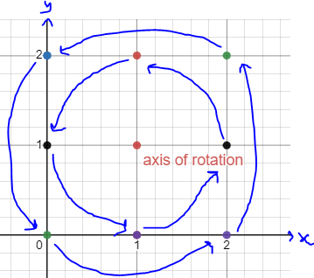

* To calculate the new position, we can use this equation:

$\begin{matrix}cosθ & -sinθ \\ sinθ & cosθ\end{matrix}$ X $\begin{matrix}X_{original} \\ Y_{original}\end{matrix}$ + $\begin{matrix}-1 \\ -1\end{matrix}$ = $\begin{matrix}X_{transformed} \\ Y_{transformed}\end{matrix}$ + $\begin{matrix}1 \\ 1\end{matrix}$ = $\begin{matrix}X_{final} \\ Y_{final}\end{matrix}$

Where $θ$ = 90 $∙$ (as we are rotating 90 degrees clockwise)

* + For a matrix transformation to be successfully completed, the axis of rotation must be at the origin (0,0)
  + To move the axis of rotation to (0,0) it must be translated by the matrix $\begin{matrix}-1 \\ -1\end{matrix}$. After the rotation of 90 degrees using the matrix operation $\begin{matrix}cosθ & -sinθ \\ sinθ & cosθ\end{matrix}$, we must then translate the graph back to its original position by translating it by the matrix $\begin{matrix}1 \\ 1\end{matrix}$

|  |  |  |  |  |
| --- | --- | --- | --- | --- |
| Face 1  (after) | 0 | 1 | 2 |  |
| 0 |  |  |  |  |
| 1 |  |  |  |  |
| 2 |  |  |  |  |
| Face 3  (after) | 0 | 1 | 2 |  |
| 0 |  |  |  |  |
| 1 |  |  |  |  |
| 2 |  |  |  |  |
| Face 4  (after) | 0 | 1 | 2 |  |
| 0 |  |  |  |  |
| 1 |  |  |  |  |
| 2 |  |  |  |  |
| Face 5  (after) | 0 | 1 | 2 |  |
| 0 |  |  |  |  |
| 1 |  |  |  |  |
| 2 |  |  |  |  |
| Face 2  (after) | 0 | 1 | 2 |  |
| 0 |  |  |  |  |
| 1 |  |  |  |  |
| 2 |  |  |  |  |

**Worked example**

Translating the point at (0,0), using the equation derived:

$\begin{matrix}cosθ & -sinθ \\ sinθ & cosθ\end{matrix}$ X $\begin{matrix}X_{original} \\ Y_{original}\end{matrix}$ + $\begin{matrix}-1 \\ -1\end{matrix}$ = $\begin{matrix}X_{transformed} \\ Y_{transformed}\end{matrix}$ + $\begin{matrix}1 \\ 1\end{matrix}$ = $\begin{matrix}X_{final} \\ Y_{final}\end{matrix}$

Subbing in values:

$\begin{matrix}0 & -1 \\ 1 & 0\end{matrix}$ X $\begin{matrix}0 \\ 0\end{matrix}$ + $\begin{matrix}-1 \\ -1\end{matrix}$ = $\begin{matrix}X_{transformed} \\ Y_{transformed}\end{matrix}$ + $\begin{matrix}1 \\ 1\end{matrix}$

$\begin{matrix}0 & -1 \\ 1 & 0\end{matrix}$ X $\begin{matrix}-1 \\ -1\end{matrix}$ = $\begin{matrix}X_{transformed} \\ Y_{transformed}\end{matrix}$ + $\begin{matrix}1 \\ 1\end{matrix}$

$\begin{matrix}\left(0×-1\right)+(-1 ×-1) \\ \left(1×-1\right)+(0×-1)\end{matrix}$ = $\begin{matrix}X_{transformed} \\ Y_{transformed}\end{matrix}$ + $\begin{matrix}1 \\ 1\end{matrix}$

$\begin{matrix}1 \\ -1\end{matrix}$ = $\begin{matrix}X_{transformed} \\ Y_{transformed}\end{matrix}$ + $\begin{matrix}1 \\ 1\end{matrix}$ = $\begin{matrix}2 \\ 0\end{matrix}$

Which is proved by the graph above!

When translating on the left, we need to rotate $90∙$ anticlockwise. Mathematically, this is identical to rotating something clockwise by 270 $∙$, so $θ$ = 270 $∙$. I call this rotation face permutation

|  |  |  |  |  |
| --- | --- | --- | --- | --- |
| Face 0 (before) | 0 | 1 | 2 |  |
| 0 |  |  |  |  |
| 1 |  |  |  |  |
| 2 |  |  |  |  |
| Face 0 (before) | 0 | 1 | 2 |  |
| 0 |  |  |  |  |
| 1 |  |  |  |  |
| 2 |  |  |  |  |

|  |  |  |  |  |
| --- | --- | --- | --- | --- |
| Face 0 (before) | 0 | 1 | 2 |  |
| 0 |  |  |  |  |
| 1 |  |  |  |  |
| 2 |  |  |  |  |

To implement a cube rotation, we would need to know the other face colours in the relative positions that are going to change, then you could swap their positions by moving the cubies to the next face or alternatively update the cubie on the next face with an assorted colour.

As the possible moves are predictable, we can code a method for each one, that acts on a face in the correct position.

Let our cube have these two faces with this starting position. We are going to call the function MoveRightHandSide()

Starting colours

**Front** Face - 0

|  |  |  |  |  |
| --- | --- | --- | --- | --- |
| Face 0 (before) | 0 | 1 | 2 |  |
| 0 |  |  | 0,2 |  |
| 1 |  |  | 1, 2 |  |
| 2 |  |  | 2, 2 |  |

**Top** face - 1

|  |  |  |  |  |
| --- | --- | --- | --- | --- |
| Face 2 (before) | 0 | 1 | 2 |  |
| 0 |  |  | 0, 2 |  |
| 1 |  |  | 1, 2 |  |
| 2 |  |  | 2, 2 |  |

Front face positions 0, 2; 1, 2 ;2, 2 need to move or update Top face (1) positions in the same location. This will have to be called from the Cube class, a sequence like:

#### FaceVerticalSwap()

FaceVerticalSwap = [ 0, 1, 2, 3 ] - **need to work out which faces change, in the correct sequence, 0 maps to 1, 1 maps to 2, 2 maps to 3, 3 maps to 0**

cubiesSwap = [ ] - **an array to store the cubies from the prior face to swap**

FOR i in FaceVerticalSwap **– loop through sequence of faces**

cubiesSwap = *GetRightColumn*(faceNum) - **get the colours (cubies) from prior face**

*UpdateVertical*(faceNum, colNum, cubiesSwap[] ) - **use the prior cubies, update the new column**

ENDFOR

Assuming faces is an array that stores a series of 2D arrays holding the cubies for each face, this could be a Class Object too.

#### GetRightColoum()

**facesArray = [face0, face1, face2, face3]**

*SUB GetRightColumn*(faceNum)

cubies = [ ] - **stores a column**

FOR i 0 to 3

cubies[I] = facesArray[faceNum] [ i , 2]

**use the faceNum parameter, use i to change rows, col 2**

ENDFOR

return cubies

ENDSUB

#### UpdateVertical()

*SUB UpdateVertical*(faceNum, colNum, cubiesSwap[] )

FOR i 0 to 3

facesArray[faceNum] [ i , colNum] = cubies[i]

**//update the chosen face from the facesArray with the new cubie**

ENDFOR

ENDSUB

However, after evaluating and tracing through this algorithm, this method may not work. It would update the new face and overwrite them with the new cubie values but not pass on the current face as it has been overwritten! I suspect that I need another data structure to store the current face: To try and process these ideas, I decided to prototype this algorithm by using simple arrays.

**Worked example from above**

FaceVerticalSwap = [ 0, 1, 2, 3] - **need to work out which faces, in the correct sequence**

cubiesSwap = [] - **an array to store the cubies from the prior face to swap**

FOR v in FaceVerticalSwap

cubiesSwap = *GetRightColumn*(**0**) - **get cubies from face zero (0)**

*UpdateVertical*(v, 2, cubiesSwap[R, B, B] - **Update face 1 (v), column 2 with cubies**

ENDOR

#### FaceBeingPermutated()

FaceBeingPermutated = [ (parameter of what face is being rotated) ]

cubiesSwap = [ ] - **an array to store the cubies from the prior face to swap**

FOR i in rowNum

FOR j in ColNum

cubiesSwap = *MatrixTransformation*(degrees, i, j)

*UpdateCubieColourl*(rowNum, colNum, cubiesSwap[] ) – **Update the cubes positions that have been transformed**

ENDFOR

#### MatrixTransformation()

FUNCTION MatrixTransformation(degrees, row-cordinate, col-cordinate)

***# Empty array***

Int[ , ] TrigonometricMatrixRotation

***# Insert Trigonometric transformations #***

TrigonometricMatrixRotation[0] = cos(degrees)

TrigonometricMatrixRotation[1] = -sin(degrees)

TrigonometricMatrixRotation[2] = sin(degrees

TrigonometricMatrixRotation[3] = cos(degrees)

#

ToOriginXCo-ordinate = row-cordinate -1

ToOriginYCo-ordinate = col-cordinate -1

HalfTransformedXCo-ordinate = (TrigonometricMatrixRotation[0] * ToOriginXCo-ordinate) +

(TrigonmetricMatrixRotation[1] *ToOriginYCo-ordinate)

HalfTransformedYCo-ordinate = (TrigonometricMatrixRotation[2] * ToOriginXCo-ordinate) +

(TrigonmetricMatrixRotation[3] *ToOriginYCo-ordinate)

TransformedXCo-ordinate = HalfTransformedXCo-ordinate +1

TransformedYCo-ordinate = HalfTransformedYCo-ordinate +1

Return:

TransformedXCo-ordinate;

TransformedYCo-ordinate

END FUNCTION

#### Rotation [Move] ()

There are several types of rotation as described in the analysis section: U, R, L, F, B and their anti-clockwise counter points. The following rotation function will incorporate all the functions and subroutines I have written about on the earlier page and will allow for rotations to be carried out on any part of the cube.

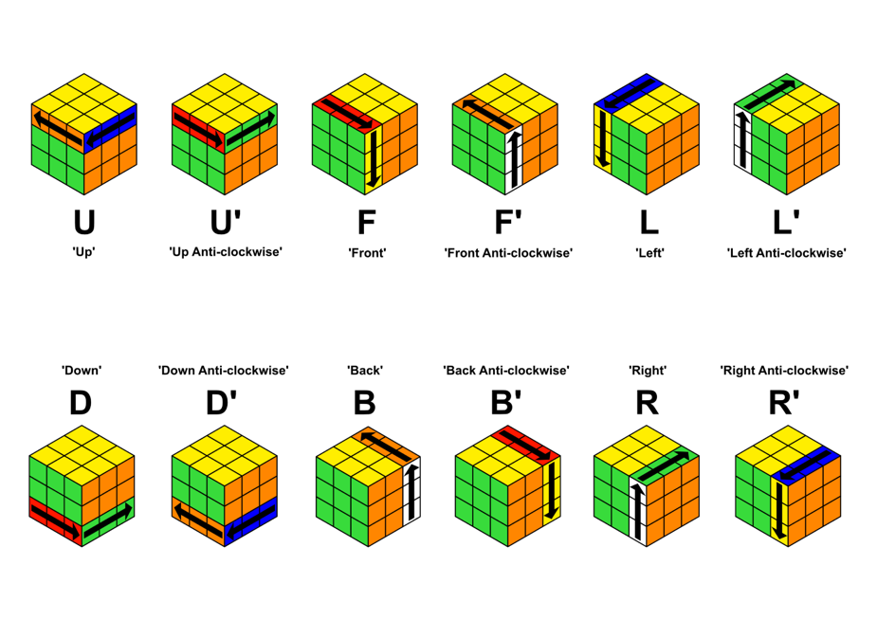

SUBROUTINE RotateFront(Face, degrees)

RotateLeft(FaceToRight,degrees)

END SUBROUTINE

As displayed in the picture, each of these moves must be implemented into the program and should correlate to their appropriate enumerations (see enumerations section) so they can be displayed on the screen appropriately. Starting with the two ‘parent’ subroutines (all other subroutines call these) ***RotateLeft()*** and ***RotateRight()*** . RotateLeft() shifts all the cubie colours from each face accordingly (as discussed earlier) and performs the matrix transformation to change the cubies positions on the left face. The degrees inputted must either be 90 or 270 (indicating a clockwise rotation or an anti-clockwise rotation). The subroutine RotateRight() works in the same way but on the right column.

When playing around with my physical cube, I found that RotateFront() is equivalent to a RotateLeft() subroutine being applied to the face to the right of the current face, and RotateBack() is equivalent to the RotateRight() subroutine being called to the face on the right of the current face. Likewise, I realised that the move RotateUp() is the same as performing a RotateFront() on the top face, and RotateDown() is identical to RotateFront() on the Bottom Face. This is explained visually on the next pages using snippets of example cubes and a small graphical representation of the subrotuine hierarchy:

SUBROUTINE RotateDown(Face, degrees)

RotateFront(FaceToBottom,degrees)

END SUBROUTINE

SUBROUTINE RotateUp(Face, degrees)

RotateFront(FaceToTop,degrees)

END SUBROUTINE

SUBROUTINE RotateBack(Face, degrees)

RotateRight(FaceToRight,degrees)

END SUBROUTINE

SUBROUTINE RotateRight(Face, degrees)

FaceVerticleSwap(FrontFace, RightColoumn,Degrees)

FaceBeingPermutated(RightFace, Degrees)

END SUBROUTINE

SUBROUTINE RotateLeft(Face, degrees)

FaceVerticleSwap(FrontFace, LeftColoumn,Degrees)

FaceBeingPermutated(LeftFace, Degrees)

END SUBROUTINE

Take three sides of a cube before a front rotation: Three sides after a front rotation:

|  |  |  |  |  |
| --- | --- | --- | --- | --- |
| Front Face | 0 | 1 | 2 |  |
| 0 |  |  |  |  |
| 1 |  |  |  |  |
| 2 |  |  |  |  |
| RightFace | 0 | 1 | 2 |  |
| 0 |  |  |  |  |
| 1 |  |  |  |  |
| 2 |  |  |  |  |
| TopFace | 0 | 1 | 2 |  |
| 0 |  |  |  |  |
| 1 |  |  |  |  |
| 2 |  |  |  |  |

|  |  |  |  |  |
| --- | --- | --- | --- | --- |
| Front Face | 0 | 1 | 2 |  |
| 0 |  |  |  |  |
| 1 |  |  |  |  |
| 2 |  |  |  |  |
| RightFace | 0 | 1 | 2 |  |
| 0 |  |  |  |  |
| 1 |  |  |  |  |
| 2 |  |  |  |  |
| TopFace | 0 | 1 | 2 |  |
| 0 |  |  |  |  |
| 1 |  |  |  |  |
| 2 |  |  |  |  |

As you can see, the columns 1 and 2 stay the same after a front rotate, but the front faces experience a clockwise matrix transformation. This is identical to performing a RotateLeft() function to the right face of the cube!

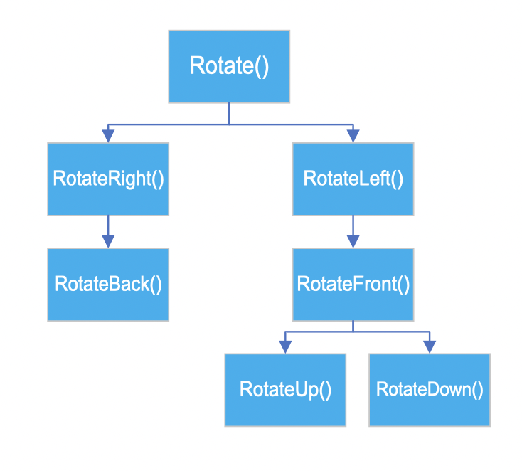

This diagram shows how all the different rotates call eachother. It works by reading backwards. EG: RotateBack() calls the function RotateRIght(), and RotateUp() calls RotateFront() which calls RotateLeft() which all are rotation subroutines.

### Algorithms ()

#### RightAlgorithm()

The standard ‘Right Algorithm’ U R U’ R’ U’ F’ U F will be implemented by using the methods Rotate. Rotate[move] (see rotation pseudocode) takes in the parameters face and degrees, turning by 90 degrees is a clockwise turn, turning by 270 is an anticlockwise turn.

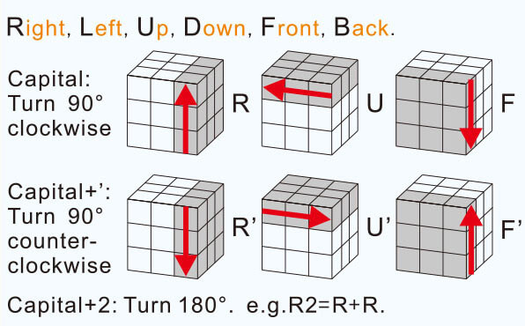

SUBROUTINE RightAlgorithm()

RotateUp(FrontFace, 90)

RotateRight(FrontFace, 90)

RotateUp(FrontFace, 270)

RotateRight(FrontFace, 270)

RotateUp(FrontFace, 270)

RotateFront(FrontFace, 270)

RotateUp(FrontFace, 90)

RotateFront(FrontFace, 90)

END SUBROUTINE

#### LeftAlgorithm()

SUBROUTINE LeftAlgorithm()

RotateUp(FrontFace, 270)

RotateLetf(FrontFace, 270)

RotateUp(FrontFace, 90)

RotateLeft(FrontFace, 90)

RotateUp(FrontFace, 90)

RotateFront(FrontFace, 90)

RotateUp(FrontFace, 270)

RotateFront(FrontFace, 270)

END SUBROUTINE

The standard ‘left’ Algorithm is essentially the opposite of the right algorithm. It is performed by: U’ L’ U L U F U’ F’ will be implemented by using the methods Rotate. Rotate takes in the parameters face and degrees, turning by 90 degrees is a clockwise turn, turning by 270 is an anticlockwise turn. The figure below demonstrates the physical representation of what happens after the left algorithm is applied.

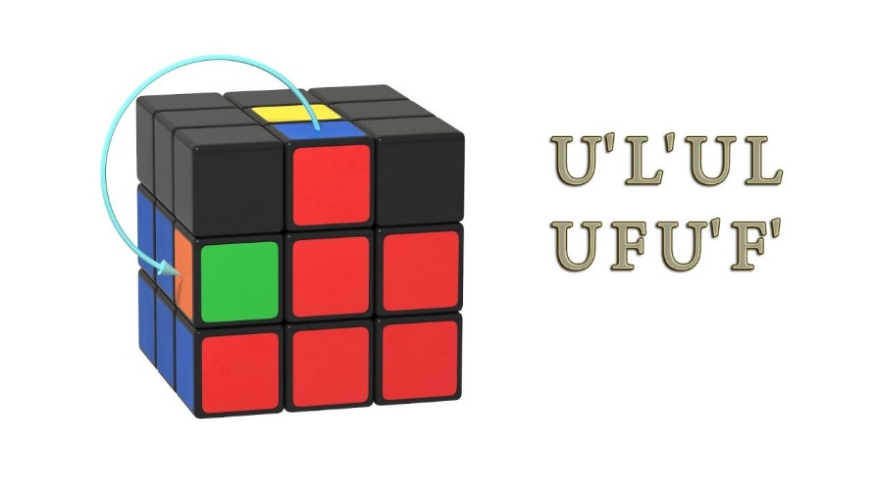

### Data structures

#### Overview and examples:

As mentioned in the analysis section, I will use a stack data structure to make sure that the instruction set is malleable for the user. To do this, every time an algorithm is called from the Algorithms () section, its corresponding symbol is enqueued () . A queue is a FIFO structure so the order of moves shouldn’t be reverse like it would be a stack. On the screen, the item under the first pointer of a queue will be displayed. Every time a user presses the ‘next instruction button’ the earlier instruction will be dequeued pushed onto a stack (a LIFO structure) and the new first item in the queue is displayed. If the user presses the ‘undo’ button on the screen, the stack should pop off the current instruction and place it back into the queue with a priority. This makes sure that if the user undo’s several moves it will place them back in the initial queues order. To ensure that the user does not produce a stack overflow or underflow if the user presses undo or next instruction when the program is finished, method handling should be used to prevent the system from crashing and display a relative error message.

I will also be investigating into the use of key value pairs in my project and how they can be used to store sequences of current face and orientations.

Going through an example, let the next algorithm needed to be used to solve the cube be the ‘Right Algorithm’ U R U’ R’ U’ F’ U F (see more in the Algorithms () section). The instruction is placed in a queue- a FIFO structure. When the user found that it has finished the current move (by pressing a button the screen), the instruction is then pushed. In this case, the user has completed the move U R U’

R’ is currently on display as it’s underneath the first pointer

Queue of instructions: R’ U’ F’ U F

|  |
| --- |
| U’ |
| R |
| U |

User has completed the move U’ R and U

Then the user decides to undo the moves U’:

U’ is enqueued with priority and is currently on display as it’s underneath the first pointer

|  |
| --- |
| R |
| U |

Queue of instructions: U’ R’ U’ F’ U F

User has completed the move R and U

Then the user decides to undo the move R:

R is enqueued with priority and is currently on display as it’s underneath the first pointer

Queue of instructions: R U’ R’ U’ F’ U F U

|  |
| --- |
| U |

User has completed the move U

The user then decides to undo the move U:

U is enqueued with priority and is currently on display as it’s underneath the first pointer

Queue of instructions: U R U’ R’ U’ F’ U F U

|  |
| --- |
|  |

User has completed no moves

The user then tries to undo the next move:

U is still displayed, along with an error message “no more instructions to undo”

Queue of instructions: U R U’ R’ U’ F’ U F U

|  |
| --- |
|  |

No items in stack, CANNOT UNDO

#### Dynamic implantation of stacks and queues

I will implement both queues and stacks into my project dynamically, as cannot predict the exact number of instructions that will be performed on the cube for it to be solved. To do this, I will use linked lists- a linear data structure in which the elements are not stored in contiguous memory locations - and object-oriented programming, encapsulating the data and methods in a class definition to supply an elegant solution.

#### Queues

This will store every instruction that is needed to be performed in the program, each instruction in the queue will create a new instance of the InstructionsToBePerformed class. It will have the following private attributes:

* instruction – the data for the element to be added to the queue
* priority- the priority of this element
* next- a pointer to the next instruction to be performed (or none if the node is at the end of the queue)

The class has public methods too:

* get the value of data
* get the value of priority
* get and set the value of next

I will also use the PriorityQueue class with two private attributes:

* front- a pointer to the front of the queue
* rear- a pointer to the end of the queue

The class will have the public methods:

* get and set the value of front
* get and set the value of rear

Although it is possible to implement this class without the rear pointer (by having one pointer that allows a new node of the lowest priority to be directly added at the end without having to traverse the whole linked list) but I decided to implement it so it can be easier for humans (including me!) to read and interpret. See the pseudocodes below of how this may be written:

#### InsturctionToBePerformed Class

PUBLIC FUNCTION get_next()

RETURN next

END FUNCTION

PUBLIC FUNCTION get_data()   
 RETURN data

END FUNCTION

PUBLIC FUNCTION get_priority()   
 RETURN priority

END FUNCTION

END CLASS

CLASS InstructionToBePerformed()

PRIVATE instruction String

PRIVATE priority: Integer

PRIVATE next: Pointer

PUBLIC PROCEDURE new(item_instruction, item_priority)

instruction = item_instruction

priority = item_priority

next = NULL

END PROCEDURE

PUBLIC PROCEDURE set_next(new_next)

next= new_next

END PROCEDURE

#### PriorityQueue Class

PUBLIC FUNCTION get_front()

RETURN front

END FUNCTION

PUBLIC FUNCTION get_rear()

RETURN rear

END FUNCTION

END CLASS

CLASS PriorityQueue

PRIVATE front: Pointer

PRIVATE rear: Pointer

PUBLIC PROCEDURE new()

front = NULL

rear= NULL

END PROCEDURE

PUBLIC PROCEDURE set_front(new_front)

front = new_front

END PROCEDURE

PUBLIC PROCEDURE set_rear(new_rear)

rear = new_rear

END PROCEDURE

#### Enqueue ()

To enqueue something onto the list, we need to think about the priorty to see where it should be placed. There are many cases to consider:

* Instructions should be placed ahead of elements of lower priority and behind elements of higher priority.
* If there are two or more elements with equal priority, the new element will be placed at the end of that part into the list.
* There could be no items in the list
* There may be no items of equal priority
* There may be no items of lower priority
* There may be no items of higher priority

Testing the code after implementing this is VITAL for the success of the project, this must be exhaustive to ensure that the program will work as expected.

The pseudo code below defines the enqueue method of the PriorityQueue class, it assumes that the priorities are integer values, with the higher the number being the highest priority. Using composition, I create an instance of the InstructionToBePerfomed() class and will manipulate the pointers to make sure the new instruction is in the right place.

PUBLIC PROCEDURE enqueue(data, priority):

new_instruction = InstructionToBePerformed()

IF front == NULL ***//if the queue is empty***

front = new_instruction

rear = new_instruction

***//makes the instruction be both the front and rear pointer***

ELSE

IF new_instruction.get_priority() > front.get_priority()

***//if the new instructions priorty is greater than the front priorities***

new_instruction.set_next(front) //  
 front = new_instruction

ELSE IF new_instruction.get_priority() <= rear.get_priority()

***//if the new instructions priorty is less than the rear pointers priorties***

rear.set_next(new_instruction)   
 rear = new_instruction

ELSE

current = front

WHILE current.get_priority() >= new_instruction.get_priority())

***//if the current priority is greater or equal than the new instructions priority***

previous = current

current = current.get_next()

END WHILE

new.instruction.set_next(current)

previous.set_next(new_node)

END IF  
 END IF

END PROCEDURE

#### Dequeue ()

When we dequeue instructions from a queue, you take the item at the front of the queue and eadjust the pointer so that the front points to the next instruction (or is set to NULL is the queue is then empty)

The pseudocode below defines the deqeue method of the PriorityQueue class.

PUBLIC FUNCTION dequeue()

IF front == NULL

dequeued_item = NULL

PRINT(“You have solved the cube, well done!!”)

ELSE

dequeued_item = front.get_data()

front = front.get_next()

END IF

END FUNCTION

#### Stacks

New elements will be added to the front so the head of the list can be used as the top pointer. When the head is the null pointer, the stack is empty. The two types of class will be an Instruction class holding:

* Data- the actual instruction
* Next- a pointer to the next node

Each element on the stack will be created as a new instance of the instruction class. I will then make a Stack class forming of a single data item ‘top’. Stacks primarily use the location of the top to pop or push items.

#### Stack Class

CLASS Stack

PRIVATE top: Pointer

PUBLIC PROCEDURE new()

top = Null

END PROCEDURE

END CLASS

#### Instruction Class

Using a linked list, it is more efficient to add a new node to the front of the list. Therefore, the top of the stack is always at the head of the linked list. I will create an instance of the instruction class within the method- using compositional techniques.

PUBLIC PROCEDURE push(data)

new_instruction = Instruction(data) ***//Creates the new instance of the instruction class***

IF top != Null

new_instruction.set_next(top) ***//Adjust the pointer to the next instruction***

END IF

top = new_instruction ***//Top will point to the new instruction***

#### Push()

CLASS Instruction

PRIVATE data: String

PRIVATE next: Pointer

PUBLIC PROCEDURE new(new_item)

data = new_item

next = Null

END PROCEDURE

PUBLIC FUNCTION get_next()

RETURN next

END FUNCTION

PUBLIC PROCEDURE set_next(new_next)

next = new_next

END PROCEDURE

END CLASS

#### Pop ()

To pop an element, we need to return the data value at the top of the stack and adjust the pointer so that the top now points to the next instruction in the list.

PUBLIC FUNCTION pop()

IF top== Null

OUTPUT(“No more instructions to output)

popped_data = Null

ELSE

popped_data = top.get_data()

top = top.get_next() ***//adjusting the top pointer***

END IF

RETURN popped_data // should be enqueue with priority.

END FUNCTION

#### Using all techniques

The following is an example pseudocode of how I may program this into my project, using all the techniques I have written about.

CubeSolvingSteps= new PriorityQueue() ***//creating a priority queue with all instructions needed to solved cube- everything with the same priority 0***

Instructions_that_are_done = Stack() ***//creating a new empty stack***

***//enqueuing all the instructions with the same priority***

WHILE get_front(CubeSolvingSteps) != Null ***//while the list of instructions to solve the cube ISNT empty***

IF (User presses forward button)

Dequeued_element =CubeSolvingSteps.dequeue() **//Dequeue the next instruction**

Instructions_that_are_done.push(Dequeued_element) **//push dequeued instruction onto stack**

ELSE IF (User presses back button)

Popped_instruction = Instructions_that_are_done.pop() **//Pop the instruction on the top of the stack**

CubeSolvingSteps.enqueue ( Popped_instruction, [get_priority[CubeSolvingSteps.front] +1]

***//enqueue the popped value with 1 more than the priority of the current instruction at the front of the queue (to ensure it is the next instruction to be dequeued)***

ELSE

OUTPUT getFront(CubeSolvingSteps) ***//output the front pointer of the queue***

END IF

END WHILE

|  |  |  |  |  |
| --- | --- | --- | --- | --- |
|  |  | **0** |  |  |
|  | **0,0** | **0,1** | **0,2** |  |
| **3** | **0,1** | **1,1** | **1,2** | **1** |
|  | **0,2** | **1,2** | **2,2** |  |
|  |  | **2** |  |  |

#### Dictionaries

When prototyping the cubes turning feature (see prototyping) , I realised I will need to keep note of a new variable called faceOrientation. I found that this way, I could manually check which sides of the cube were turning and what orientation they were in- see my paper model picture. I did this by assigning a numerical value to each side of the face as shown to the right. This proved successful and I continued my project as normal, although I did need to consider face orientations when rotating the cube. Instead of coding each pathway with repetitive code, I decided to create a dictionary. The key values were the face (first integer) and then the current face orientation (the second integer). The values I would store would be a sequence of how the 4 faces would swap on a rotation. By doing this the code would be easier if I had made any logical errors with the implantation of the rotation order and made my overall code much more elegant. Here is a list of the dictionary I will implement for a clockwise right rotation:

#### sequenceForRotationDictionary()

|  |  |
| --- | --- |
| Key (Face number, current face orientation number) | Sequence of faces that need to be rotated |
| 00 | 04532 |
| 01 | 02513 |
| 02 | 03541 |
| 03 | 01524 |
| 10 | 14230 |
| 11 | 10253 |
| 12 | 13245 |
| 13 | 15204 |
| 20 | 24135 |
| 21 | 25103 |
| 22 | 23140 |
| 23 | 20154 |
| 30 | 30452 |
| 31 | 32415 |
| 32 | 35401 |
| 33 | 31420 |
| 40 | 45302 |
| 41 | 42310 |
| 42 | 40351 |
| 43 | 41325 |
| 50 | 53042 |
| 51 | 52014 |
| 52 | 54031 |
| 53 | 51023 |

For example, When performing the rotation R (see photo), on face 0 orientation 0, the left hand column of face 0 goes to face 4. The lefthand column of face 4 goes to face 5. The lefthand column of face 5 goes to face 3. The lefthand column of face 3 goes to face 0. Face 2 has a clockwise matrix transformation performed on it.

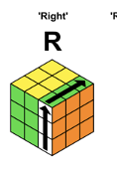

As explained in the design section of my project, all rotations of the cube can be derived from the Right turns clockwise rotation on the right. If we were going to be doing an anticlockwise rotation (for example the right anticlockwise on face 0 orientation 0), face 0 right hand column would map to face 3. Face 3 would map to face 5, face 5 right hand column maps to face 4, and face 2 would have an anticlockwise matrix rotation applied to it. We can use the dictionary on the left with some string manipulation to do an anticlockwise right transformation. Using the example above, 00 = 04532 for clockwise, 00= 03542. We could use sequence[0], sequence[3], sequence[2], sequence[1], sequence[4].

When writing this I also decided that having a dictionary for how the current orientation affected the cube could be beneficial. I decided to identify each of the cubes faces and their positions to help me program it.

#### faceAndOrientationDictionary()

Example:

Current face and orientation of the cube is 00. The user then clicks the right button and the current face and orientation is updates to 20 (face has changed to 2 and orientation stays the same). The dictionary faceAndOrientationDictionary then searches for the key value pair (kvp) 20, then at each face (looping through kvp.Value[0] and changing the orientation of that face from its current orientation to its new orientation determined by kvp.Value[1]. This then happens for each face and orientation pair positions (0,1) (2,3) (4,5) (6,7) (8,9) (ignore spaces on the right- they are for ease of reading) and the current cubes position is then displayed.

Every time the left, right, up or down buttons are pressed, every face and orientation is updated depending on the current face using the dictionary. This ensures that at every point the cube is being correctly positioned and the rotations will work as planned. Now, the following faces will be looped through with each button:

* Right button -> 0,2,5,1
* Left button -> 0,1,5,2
* Up button -> 0,4,5,3
* Down button -> 0,3,5,4

At every face shift, the current face orientation of all faces needs to be updated according to the dictionary on the left

|  |  |
| --- | --- |
| Current Face and Current Orientation | Other Faces and Orientation |
| 00 | 00 10 20 30 40 52 |
| 01 | 01 11 21 31 41 51 |
| 02 | 02 12 22 32 42 50 |
| 03 | 03 13 23 33 43 53 |
| 10 | 00 10 20 33 41 52 |
| 11 | 01 11 23 30 42 53 |
| 12 | 02 12 22 31 43 50 |
| 13 | 03 13 21 32 40 51 |
| 20 | 00 10 20 31 43 52 |
| 21 | 01 13 21 32 40 53 |
| 22 | 02 12 22 33 41 50 |
| 23 | 03 11 23 30 42 51 |
| 30 | 00 11 23 30 42 50 |
| 31 | 01 12 20 31 41 51 |
| 32 | 02 13 21 32 40 52 |
| 33 | 03 10 22 33 43 53 |
| 40 | 00 13 21 32 40 50 |
| 41 | 01 10 22 31 41 51 |
| 42 | 02 11 23 30 42 52 |
| 43 | 03 12 20 33 43 53 |
| 50 | 02 12 22 30 40 50 |
| 51 | 01 13 23 31 41 51 |
| 52 | 00 10 20 32 42 52 |
| 53 | 03 11 21 33 43 53 |

#### Seeing the different face- an alternative method

I decided to try another method where I create another dictionary so the user could see the other faces from its initial face. To do this I would need to make a key which combined the face and face orientation and see which face is relatively left. I would then create the display current face to ensure that its correct orientation was accounted for.

|  |  |  |  |  |
| --- | --- | --- | --- | --- |
| Current Face and Current Orientation | Face and orientation shown when See Left | Face and orientation shown when See Right | Face and orientation shown when See Up | Face and orientation shown when See Down |
| 00 | 10 | 20 | 40 | 30 |
| 01 | 41 | 31 | 21 | 11 |
| 02 | 22 | 12 | 30 | 42 |
| 03 | 33 | 43 | 13 | 23 |
| 10 | 52 | 00 | 41 | 33 |
| 11 | 42 | 30 | 01 | 53 |
| 12 | 02 | 50 | 31 | 43 |
| 13 | 32 | 40 | 51 | 03 |
| 20 | 00 | 52 | 43 | 31 |
| 21 | 40 | 32 | 53 | 01 |
| 22 | 50 | 02 | 33 | 41 |
| 23 | 30 | 42 | 03 | 51 |
| 30 | 11 | 23 | 00 | 50 |
| 31 | 01 | 51 | 20 | 12 |
| 32 | 21 | 13 | 52 | 02 |
| 33 | 53 | 03 | 10 | 22 |
| 40 | 13 | 21 | 50 | 00 |
| 41 | 51 | 01 | 22 | 10 |
| 42 | 23 | 11 | 02 | 52 |
| 43 | 03 | 53 | 12 | 20 |
| 50 | 12 | 22 | 30 | 40 |
| 51 | 31 | 41 | 23 | 13 |
| 52 | 20 | 10 | 42 | 32 |
| 53 | 43 | 33 | 11 | 21 |

When put into a dictionary, the program can search which face to show and update the current face and current orientation the user sees. This way I can store a temporary face which is outputted instead of outputting the cube at each different stage – mitigating the use of a lot of switch cases and if statements. This could be implemented like so:

#### DisplayAfterSeeingAdjacentFaces()

DisplayAfterSeeingAdjacentFaces = new Dictionary<string,string>();

DisplayAfterSeeingAdjacentFaces.Add(“00”,”10 20 40 30”); //see left, right, up, down

DisplayAfterSeeingAdjacentFaces.Add(“00”,”41 31 21 11”);

DisplayAfterSeeingAdjacentFaces.Add(“01”,”22 12 40 42”);

DisplayAfterSeeingAdjacentFaces.Add(“02”,”33 43 13 23”);

DisplayAfterSeeingAdjacentFaces.Add(“03”,”10 20 40 30”);

DisplayAfterSeeingAdjacentFaces.Add(“10”,”52 00 41 33”);

DisplayAfterSeeingAdjacentFaces.Add(“11”,”42 30 01 53”);

DisplayAfterSeeingAdjacentFaces.Add(“12”,”02 50 31 43”);

DisplayAfterSeeingAdjacentFaces.Add(“13”,”32 40 51 03”);

DisplayAfterSeeingAdjacentFaces.Add(“20”,”00 52 43 31”);

DisplayAfterSeeingAdjacentFaces.Add(“21”,”40 32 53 01”);

DisplayAfterSeeingAdjacentFaces.Add(“22”,”50 02 33 41”);

DisplayAfterSeeingAdjacentFaces.Add(“23”,”30 42 03 51”);

DisplayAfterSeeingAdjacentFaces.Add(“30”,”11 23 00 50”);

DisplayAfterSeeingAdjacentFaces.Add(“31”,”01 51 20 12”);

DisplayAfterSeeingAdjacentFaces.Add(“32”, “21 13 52 02”);

DisplayAfterSeeingAdjacentFaces.Add(“33”,”53 03 10 22”);

DisplayAfterSeeingAdjacentFaces.Add(“40”,”13 21 50 00“);

DisplayAfterSeeingAdjacentFaces.Add(“41”,” 51 01 22 10”);

DisplayAfterSeeingAdjacentFaces.Add(“42”,”23 11 02 52”);

DisplayAfterSeeingAdjacentFaces.Add(“43”,”03 53 12 20”);

DisplayAfterSeeingAdjacentFaces.Add(“50”,”12 22 30 40”);

DisplayAfterSeeingAdjacentFaces.Add(“51”,”31 41 23 13”);

DisplayAfterSeeingAdjacentFaces.Add(“52”,”20 10 42 32”);

DisplayAfterSeeingAdjacentFaces.Add(“53”,”43 33 11 21”);

### First method of solving

In this section, I investigate into how I would implement a solving method which the user would be able to input their own cube options and solve it using the human method. To do this I would have to implement the functions FirstLayerSolved(), SecondLayerSolved() and BottomLayerSolved().

#### FirstLayerSolved()

|  |  |
| --- | --- |
| Subroutine or Function | Explanation |
| Solve () | Algorithm that solves the cube, this will call many other subroutines and will store the instructions in a stack |
| IsFirstLayerSolved() | Boolean function- Checks if the first layer is solved by checking the permutation of the corners if the middle and edge cubie colours match. If solved, return true. |
| CheckForCross() | Check if there is a white cross on any desired face, if all the corners are permutated correctly and the edges are in the correct place. |
| FormDaisy() | Moves the white pieces onto the bottom face and forms a white cross |
| MoveDaisyToTopFaceWithCorrectEdges() | Flips the cross on the bottom onto the cross to the TopFace |
| PutCornersInTheCorrectPosition() | Orientate the corners into the correct position |
| PutEdgeInEmptySpaceOnTopFace() | Finds a place on the top face where the cubies position is not important, and moves an edge piece into that space |
| SolveTopLayer() | Solving the top face will involve permutating all the edges and making sure the corners are in the correct place. |

This section of my design section discusses the first method on solving the cube.To successfully implement my cube solving algorithm, each of the following subroutines or functions will written in pseudocode below

#### SecondLayerSolved()

|  |  |
| --- | --- |
| Subroutine or Function | Explanation |
| Solve () | Algorithm that solves the cube, this will call many other subroutines and will store the instructions in a stack |
| SolveMiddleRow() | Algorithm that solves the middle layer of the cube simoultaneouly checking if it is already solved. This subroutine will call many other subroutines and functions. |
| GetMiddleCubies() | Function which takes in an empty list of all the middle cubies and returns a list of all of them. This is done by iterating through each faces row 1. |
| PutEdgeInPlace() | Puts the side edge in the correct place by calling the following function. |
| IsPieceNeededtoMoveOnTheLeft() | Checks if the piece that is going to be moved is on the left or is on the right. If it is on the left, return true, else return false |
| RightAlgorithm() | Hard code the algorithm U R U’ R’ U’ F’ U F |
| LeftAlgorithm() | Hard code the algorithm U’ L’ U L U F U’ F’ |

#### BottomLayerSolved()

|  |  |
| --- | --- |
| Subroutine or Function | Explanation |
| Solve () | Algorithm that solves the cube, this will call many other subroutines and will store the instructions in a stack |
| IsCubeSolved() | Boolean function, starting at one corner of the cube, loop through the face checking if every colour is the same on that face. If it is, return true and the cube algorithm stops |
| IsWhiteFaceOnBackFace() | Boolean function- Loops through the bottom face and checks if every cubie is the colour white. If it is, then return true |
| MoveWhiteFaceOnBackFace() | Move the white face on the bottom by moving the whole cube by a half turn |
| MakeL() | Make an L shape with the yellow stickers on the bottom layer cubies if a line or cross has not been formed. |
| MakeLine() | Make a Line shape with the yellow stickers on the bottom layer cubies if a cross has not been formed. |
| MakeCross() | Make a Line shape with the yellow stickers on the bottom layer cubies if a cross has not been formed. |
| IsNotLine() | Boolean Function If the yellow stickers are not in a horizontal line, but are in a T-shape or a vertical line |
| WhichEdgePiecesMatchCentrePieces() | Boolean function- Loops through the relative faces and checks if the centre edges match the middle cubies, returns true if they are, else return false |
| PositionBottomCorners() | Position each corner so the corresponding stickers are in the correct corner on the cube |
| OrientedBottomCorners() | Move the stickers so all the yellow stickers are on the bottom and the corner cubies stickers are in the correct position. |
| DoEdgePiecesMatchCentrePieces() | Boolean function- Loops through the relative faces and checks if the centre edges match the middle cubies, returns true if they are, else return false |
| IsSolvedFaceOnTheTop() | Boolean function- Loops through top face and checks if all the stickers are white, returns true if they are, else return false |
| SolveFinalCube() | Hardcode the program to perform the algorithm F2 U L R’ F2 L’ R F2 |

#### Prototyping Cubie Input in Blazor for First Layer:

I decided to investigate whether it was practical to implement a cubie colour input and have the cube solve it. Obviously the first thing I had to do was implement a cubie input. To do this, I created a 2D table in HTML and related each face (2D array) in the face class to be outputted when certain buttons were pressed:

Here are what colours were shown for each face after the input:

* ‘green,green,green,green,green,green,green,green’
* ‘yellow,yellow,yellow,yellow,yellow,yellow,yellow,yellow,yellow’
* ‘blue,blue,blue,blue,blue,blue,blue,blue,blue’
* ‘white,white,white,white,white,white,white,white,white’
* ‘orange,orange,orange,orange,orange,orange,orange,orange,orange’
* ‘red,red,red,red,red,red,red,red,yellow’

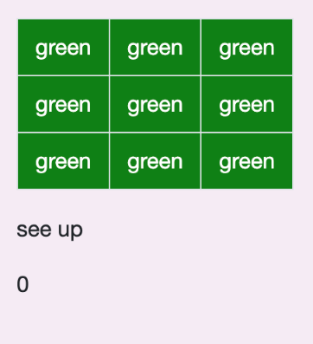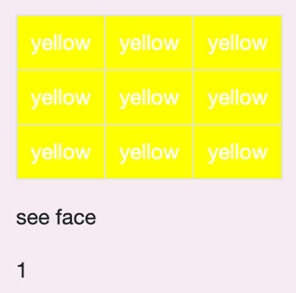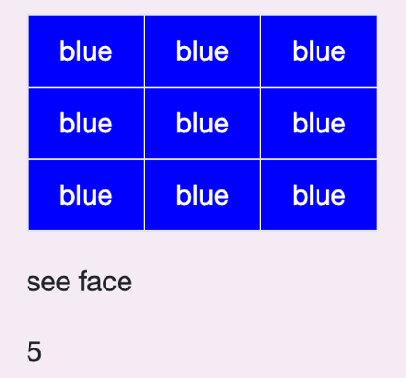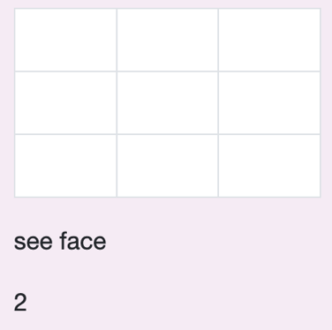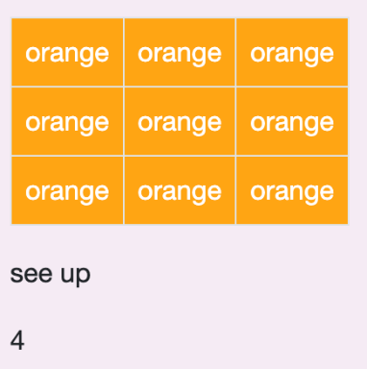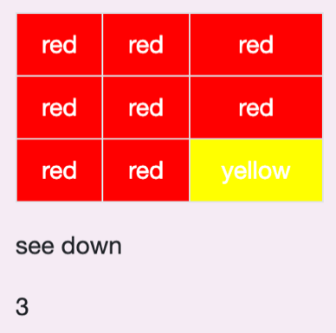

And then I modelled some validation code to ensure that the user was inputting the correct number of colour cubies (9 of each). The above cubie input is not a valid cube option as there are 10 yellow cubies but 8 red cubies instead of 9 of each. Here is the error message which appeared after I attempted to press start solving. 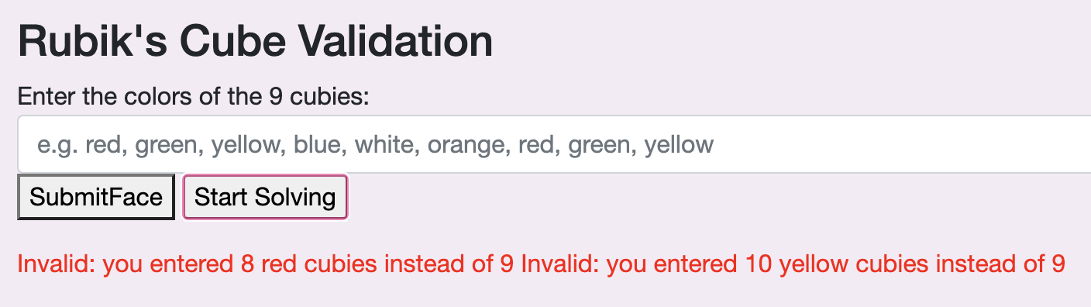

However, I didn’t like the way the user interface looked, as there were two invalid statements on one line, so it isn’t very clear or easy to understand. I opted to using more string interpolation to help sort this out.

Code before:

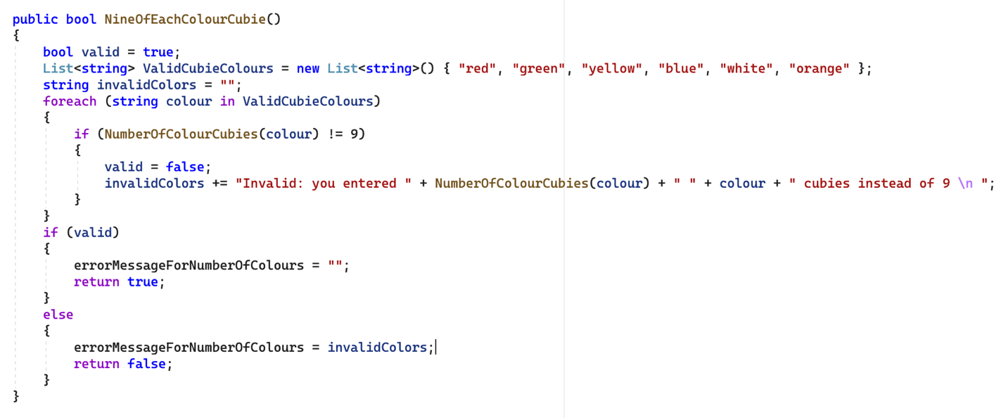

Code after:

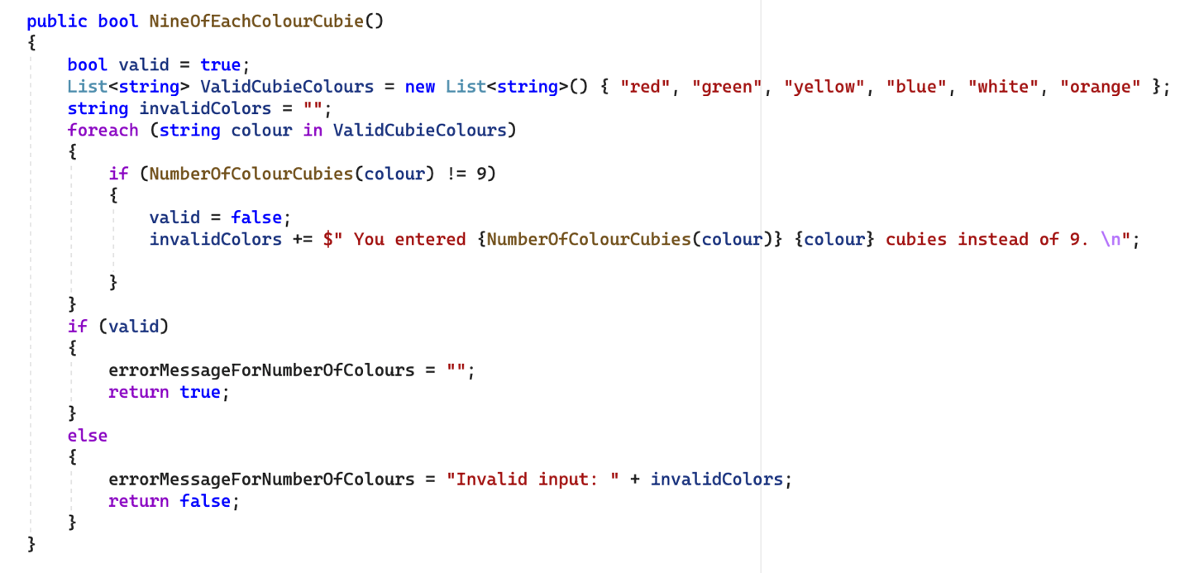

Result:

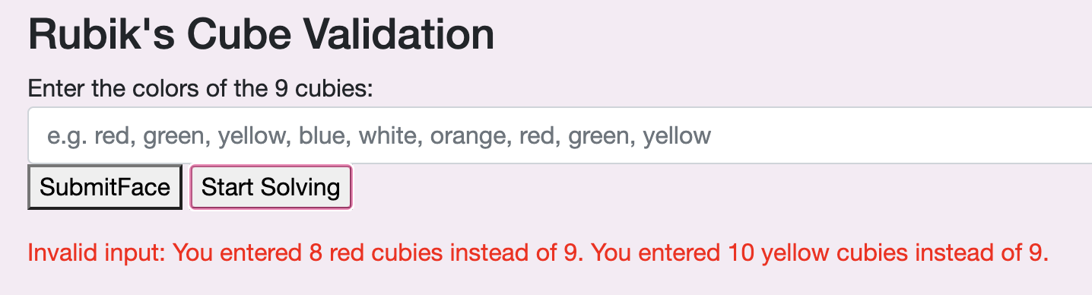

After that, I decided to deal with user errors which could occur (like entering the wrong number of colour, spelling colours wrong and then seeing if the cube options could update the cubies in the correct positions).

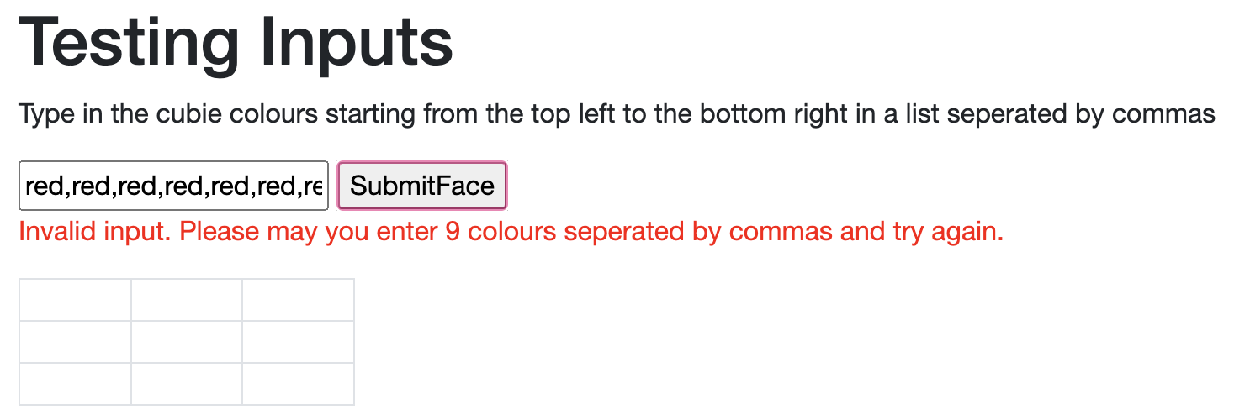

This was successfully implemented where 8 inputs where detected. The user can try again and input 9 and it will validate like below:   
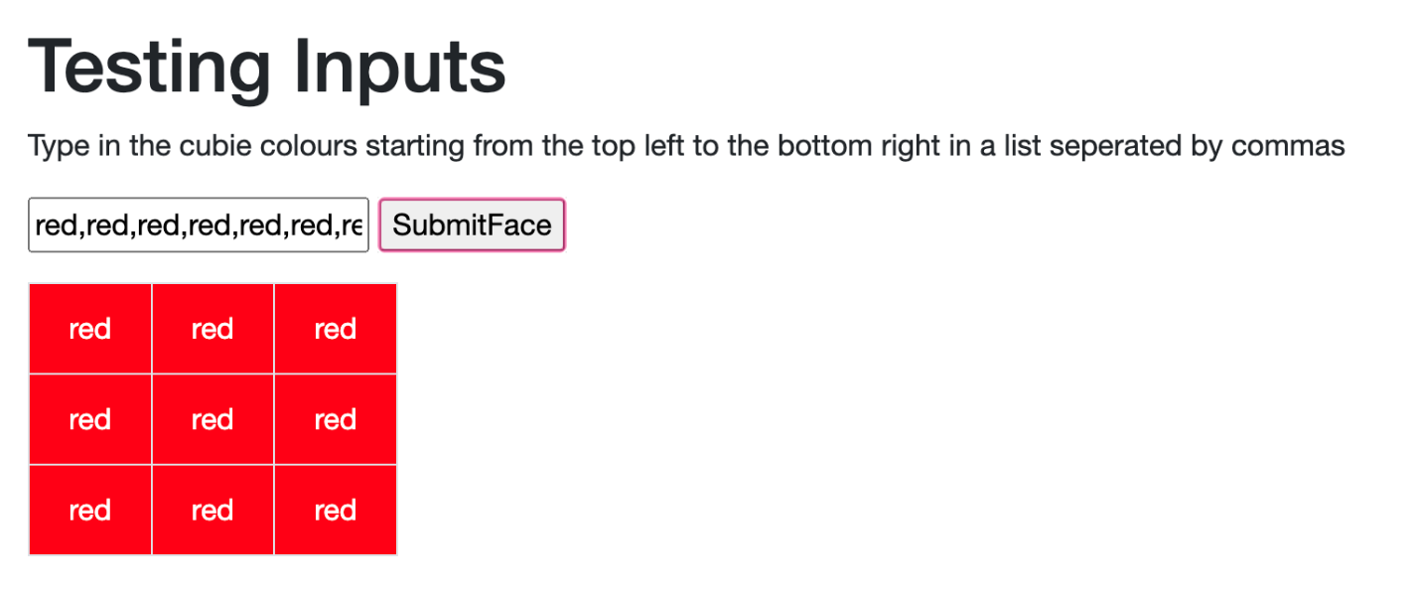

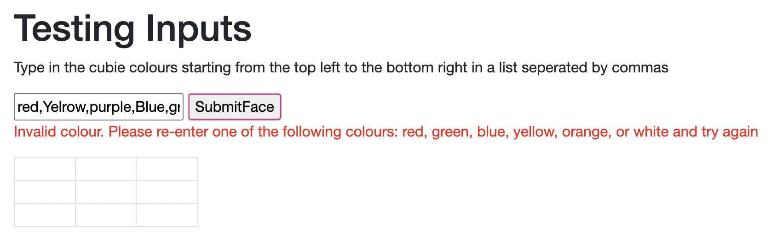

This was successfully implemented where misspelt colours and colours which are not on the cube were identified. The user can try again and input 9 correct colours and it will validate like below:

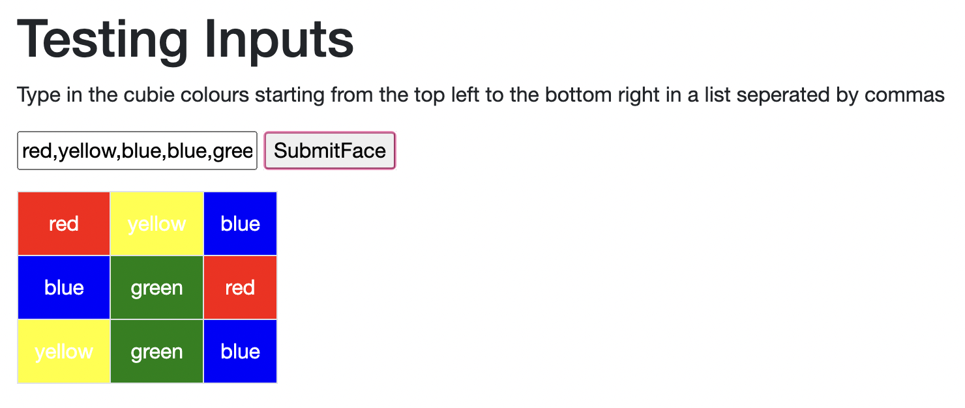

After prototyping the cubie inputs for the human manual solve, I opted to write some pseudocode and prototype the code to see I could potentially create a human manual solver.

#### Attempts at pseudocode

The subroutine will call all the other functions I have written in this section and solve the first layer of the cube.

SUBROUTINE SolveFirstLayer()  
 WHILE IsFirstLayerSolved() = FALSE

IF CheckForCross(BottomFace, White) = FALSE

THEN FormDaisy()

MoveDaisyToTopFaceWithCorrectEdges()

IF (edges are in the wrong place)

THEN PutEdgesInEmptySpaceOnTop()

END IF

PutCornersInTheCorrestPosition()

END IF

END WHILE

END SUBROUTINE

This Boolean function loops through the face and checks if all the stickers are white. The local variable ColourCounter is called which is set to 0 before it is called, it is incremented if the desired colour is identified. If there are 9 white coloured stickers, the function is true. However, the corresponding cubie colours on the top edge of the cube should all be the same colour as the colour of the middle of the cube (as shown in the diagram) 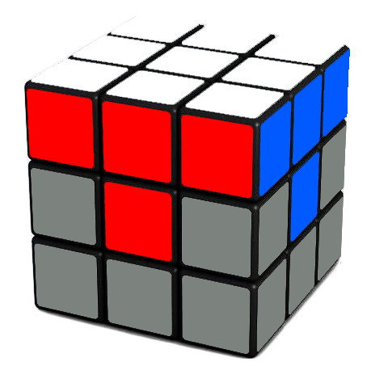

FUNCTION IsFirstLayerSolved(Face) AS BOOLEAN

ThereAreNineColours = FALSE

EdgesAreCorrect = FALSE

SidesChecked = 0

FOR row = 0; row<3 ; row++

FOR col = 0; col<3, col++

IF Face[row,col] = ‘W’

ColourCounter++

END IF

ENDFOR

IF ColourCounter = 9

ThereAreNineColours = TRUE

END IF

ELSE

RETURN FALSE

END ELSE

WHILE SidesChecked < 4

RotateCurrentFaceBy90Degrees(Face)

FOR TopRow3Position = 0, TopRow3Position < 3, TopRow3Position ++ ***//loops through the top rows three positions***

IF GetCubieColour(Face[TopRow3Position,0]) == GetMiddleCubie***//compares the middle cubies colour to the cubie on the top row***

ColourCounter ++

END IF

IF ColourCounter != 3 ***//if the top edge of the cube is not all the same colour, the first layer is not solved***

RETRUN FALSE

END IF

END FOR

SidesChecked ++ ***//Repeats for the 4 sides***

ENDWHILE

Code prototype snippets:

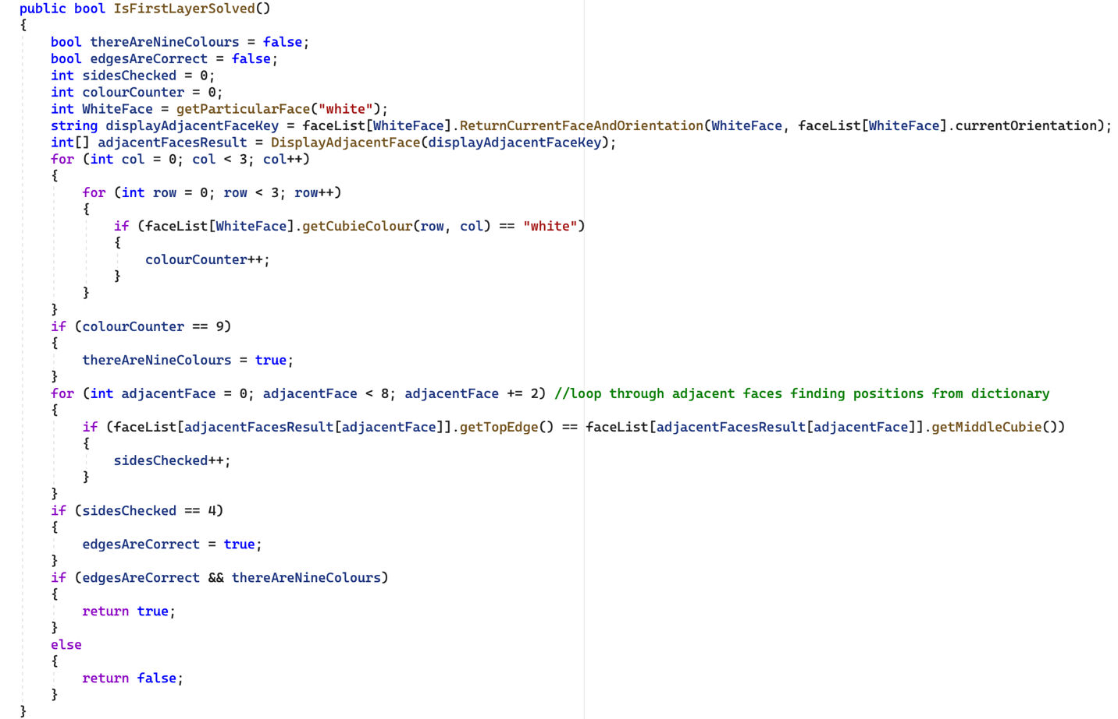

#### CheckForCross()

|  |  |  |  |  |
| --- | --- | --- | --- | --- |
| Face | 0 | 1 | 2 |  |
| 0 | (0,0) | **(0,1)** | (0,2) |  |
| 1 | **(1,0)** | **(1,1)** | **(1,2)** |  |
| 2 | (2,0) | **(2,1)** | (2,2) |  |

FUNCTION CheckForCross(Face, ColourCounter) AS BOOLEAN

FOR row = 0; row<3 ; row++

FOR col = 0; col<3, col++

IF i = 1

ColourCounter++

IF j = 1

ColourCounter++

ENDFOR

IF ColourCounter = 5

Return TRUE

ELSE

Return FALSE

This boolean function loops through the face and checks if a cross is formed from any sticker colour by calling the local variable ColourCounter. ColourCounter is set to 0 before it is called, it is incremented if the desired colour is identified. By iterating through row and column 1, if all the sticker colours are the same, a cross is formed (see diagram above)

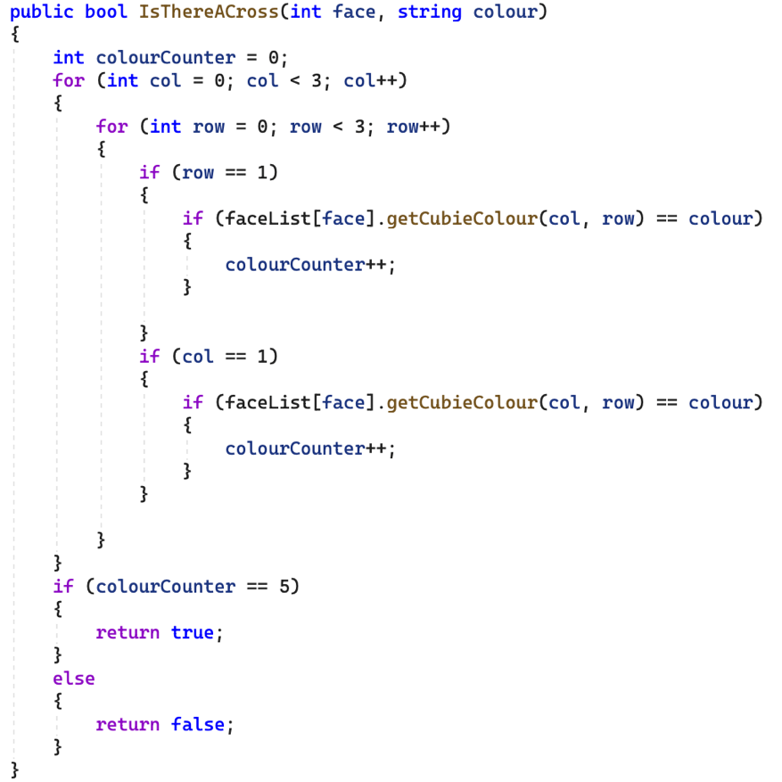

|  |  |
| --- | --- |
| Subroutine or Function | Explanation |
| Solve () | Algorithm that solves the cube, this will call many other subroutines and will store the instructions in a stack |
| SolveMiddleRow() | Algorithm that solves the middle layer of the cube simoultaneouly checking if it is already solved. This subroutine will call many other subroutines and functions. |
| GetMiddleCubies() | Function which takes in an empty list of all the middle cubies and returns a list of all of them. This is done by iterating through each faces row 1. |
| PutEdgeInPlace() | Puts the side edge in the correct place by calling the following function. |
| IsPieceNeededtoMoveOnTheLeft() | Checks if the piece that is going to be moved is on the left or is on the right. If it is on the left, return true, else return false |

#### IsCubeSolved()

FUNCTION IsCubeSolved() BOOLEAN

FOR Face = 0; Face < 6, Face++

FOR Row = 0; Row <3, Row ++;

FOR Col = 0; Col <3 ; Col ++

IF GetColour(Face[row,col]) != Face.GetMiddleCubie() **//face colour**

RETURN FALSE

END IF

END FOR

END FOR

END FOR

RETURN TRUE;

OUTPUT “You have solved the cube!”

END FUNCTION

This function loops through each face and checks each corresponding row and column for the same colour as the face is instantiated to have. If it does not match, the function is returned as false, and if everything matches, then the function is returned as true. However, the time-space complexity of this algorithm is O(n3) which is very inefficient, so in my final project I may think about implementing this in another way.

#### Solve ()

This subroutine calls each layer to be solved which calls other subroutines and functions until the cube is fully solved. At the end of each section, the Boolean function ***IsCubeSolved()*** should be called to see if more algorithms still need to be called or if the whole program should be terminated. This will hopefully eliminate the need for further instructions to be executed if they are unnecessary and thus save processing power.

SUBROUTINE Solve()

SolveFirstLayer()

SolveSecondLayer()

SolveBottomLayer()

END SUBROUTINE

#### The problem with the first method:

Whilst prototyping I concluded that this method would not be ideal to be implemented into my final project because of the following reasons:

* Time
  + This method would take me a very long time to implement and would be out of scope for a project to be done alongside my A Levels. The prototyping proves I do have the ability to develop these algorithms, but because of the timeline of this project this method seems unsuitable.
* Testing and Logic
  + Implementing the logic needed to solve the cube would require many trace tables, and testing would deem to be quite difficult.
* Quality over quantity
  + The method above would be many lines of inefficient code which is bad programming practice. I think that a smaller quantity of elegant efficient code would be nicer and more worth my time (and give me more practice and experience in programming).
* Other available methods
  + Other, shorter to implement but just as effective solving methods can be implemented which would also use high-level programming but many lines of unnecessary code.

### Solving- Alternative method

Because of time constraints on the project, another method of solving could be by producing an opposite list that the scrambling instructions so “R” turns into “R’” and pushing these onto a stack. These will be popped off and stored onto a new list of solving instructions (which will also reverse the order of the instructions for example R, U , L’ turns into L, U’, R’). Below is examples of algorithms I would implement to make this possible:

#### Scrambling Algorithm

To implement the scrambler, I will have to store an array of every possible move as such:

String[] moves = ["R", "R'", "L", "L'", "U", "U'", "D", "D'", "F", "F'", "B", "B'"]

These moves are described in the earlier section, a scrambled cube is made up of a randomly generated order of these moves stored into a list of scrambling instructions. My goal for this is to use recursion to ensure the efficiency in this scrambling method. I will also have import random numbers into my project using system.Random which would increase the runtime of my program but is necessary to make my program scramble the cube successfully.

#### Investigating recursion

If I am to create a list of instructions recursively, I need a base case which will be when the number of instructions needed to be added to the list = 1. Depending on the difficulty level (where easy is 10 steps, medium is 20 and hard is 30), each traverse should decrease the number of instructions added to the list by one.

FUNCTION ScramblingInstructions(int numberOfInstructions) **//the number of instructions to be determined by level of difficulty selected**

INT randomInstruction;

IF( numberOfInstructions ==0) **//this is the base case- if there are no more instructions to produce**

{

return ListOfScramblinginstructions; //return scrambling instructions

}

ELSE

{

randomInstruction = randomNumber(0, possibleMoves.Length);

**// a random number is generated which refers to an index position in a list of possible instructions**

ListOfScramblinginstructions.Add(possibleMoves[randomInstruction]);

**//add random instruction to list of scrambling instructions**

RETURN ScramblingInstruction(numberOfInstructions - 1);

**//return the scrambling function take away 1**

}

END FUNCTION

The function above takes in the number of instructions as a parameter and checks if the numberOfInstructions is equal to 0. If it is, it returns the list of scrambling instructions, if it isn’t, it generates a random number and adds a random instruction at the index position of the number generated to the list of scrambling instructions. It then returns itself by subtracting 1 from the numberOfInstruction. Take the list of possible moves to be: F,F’,R,R’,L,L’,U,U’,D,D’,B,B’ and lets go through an example.

The numberOfInstructions = 4, and the program checks if its 0. It is not 0 so a random number is generated between 0 and 11 (length of possible moves list). Say 3 is generated, the instruction R’ is added to the list of scrambling instructions. The function then calls the function ScramblingInstructions(4-1) so ScramblingInstructions(3) (calls itself but takes 1 away from the parameter). The number of instruction = 3 and the program checks it its 0. It is not 0 so another random number is generated. This time the number 11 is generated so B’ is added to the list of scrambling instructions. The function then calls the function ScramblingInstructions(3-1) so ScramblingInstructions(2). The number of instruction = 2 and the program checks if its 0. It is not 0 so another random number is generated. This time the number 6 is generated so U is added to the list of scrambling instructions. The function then calls the function ScramblingInstructions(2-1) so ScramblingInstructions(1). The number of instruction = 1 and the program checks if its 0. It is not 0 so another random number is generated. This time the number 10 is generated so B is added to the list of scrambling instructions. The function then calls the function ScramblingInstructions(1-1) so ScramblingInstructions(0). The number of instruction = 0 and the program checks if its 0. It is 0 so the function then returns the list of scrambling instructions R’,B’,U,B.

#### Solving Instructions

SUBROUTINE SolvingInstructions

FOR (currentIndex = 0; currentIndex < ScramblingInstructionList.Count; currentIndex++) Switch(ScramblingInstructionList.ElementAt(currentIndex))

Case “R”:

InstructionsToSolve.Push (“R’”);

Case “R’”

InstructionsToSolve. Push (“R”);

Case “L’”

InstructionsToSolve. Push (“L”);

Case “L”

InstructionsToSolve. Push (“L’”);

Case “U”

InstructionsToSolve. Push (“U’”);

Case “U’”

InstructionsToSolve. Push (“U”);

Case “D”:

InstructionsToSolve. Push (“D’”);

Case “D’”

InstructionsToSolve. Push (“D”);

Case “F’”

InstructionsToSolve. Push (“F”);

Case “F”

InstructionsToSolve. Push (“F’”);

Case “B’”

InstructionsToSolve. Push (“B”);

Case “B”

InstructionsToSolve. Push (“B’”);

Break;

END FOR

END SUBROUTINE

The pseudocode above loops through each element in the scrambling list goes through switch cases and pushes the opposite move to the instructionsToSolve stack. It goes through every value until the list of scrambling instructions is fully traversed.

#### PoppingOffAListOfInstructions

SUBROUTINE popOffInstructionsToList()

While(instructionToSolve.Count > 0)

poppedOffInstructionList.Add(instructionToSolve.Pop);

ENDWHILE

END SUBROUTINE

Then the instructions can be used in the instruction class to redo, undo and get the current instruction.

### Data Dictionary

Below is a list of every function, class and subroutine which is in my final NEA:

|  |  |
| --- | --- |
| Cube Class |  |
| **Name** | **Description** |
| List<Face>FaceList | Collects a list of 6 faces which make up a cube |
| Int currentFace | An integer which keeps track of the face which is displayed to the user |
| Int currentOrientation | Keeps track of the orientation of each face on the cube. All faces are instantiated with a current orientation of 0 except the back face which is orientation 2 |
| String cubeShow | A string which represents which face is shown and relates to the 3D cube stored in the CSS in the app.css |
| String errormessages (including errorMessageForNumberOfColours, errorMessageForCorner, errorMessageForNumberOfMovesInput, errorMessageForInstruction errorMessageForEdge. | Return error messages when validation is incorrect, the cube is insolvable, there is a user input error. It is displayed in red writing on the webpage. |
| String Inputs (including levelOfDifficulty, NumberOfMoves,CubieInput) | A get/setter which gets the user input of the levelOfDifficulty, NumberOfMoves and CubieInput. |
| String announcement | A private string which is updated whilst the program is running and is outputted on the screen in green. |
| Dictionary<string, int[]> DisplayAfterSeeingAdjacentFaces | Stores a sequence of adjacent faces and their orientation. Position 0 relates to the left adjacent face, 2 relates to the right, 4 relates to the up face and 6 relates to the down. The 1,3,5,7 position relates to the orientation of each adjacent face relative to the front face. Takes the face and orientation as a string as a key and an integer list as a value pair. |
| Dictionary<string, int> whichFaceToShow | A dictionary of strings which relates the face numbers to their string for the css animation to play (the css animation takes in a string as a parameter). Takes the face number as its key and the value pair is the string. |
| UpdateAllFacesCurrentOrientation = new Dictionary<string, int[]>(); | These are the only way the user can view each face, update each relevant face based on how the viewer is viewing the rotation- it also helps with the rotation subroutines. Takes in the face and orientation as a key and the value pair is a list of all the faces and what orientation they should be. |
| List<string[]> currentEdgeCubieColours = new List<string[]>(); | A list which extracts each edge cubie on the cube. Each pair of colours is stored alphabetically for ease of comparison. Its relative positions are stored as:   1. front top 2. front right 3. front bottom 4. front left 5. left top 6. left bottom 7. right top 8. right bottom 9. back top 10. back right 11. back left 12. back bottom   Should be updated after each operation to locate specific edges. |
| List<string[]> currentCornerCubieColours = new List<string[]>(); | A list which extracts each corner cubie on the cube. Each pair of colours is stored alphabetically for ease of comparison. Its relative positions are stored as:   1. top left front 2. top right front 3. bottom left front 4. bottom right front 5. top left back 6. top right back 7. bottom left back 8. bottom right back   Should be updated after each operation to locate specific corners. |
| movesToPerform = new Dictionary<string, Action> | A dictionary which takes in the move as a string and returns the action (subroutine) to be performed when that string is clicked. I could have done this in the form of switch and if cases but I thought a dictionary would be more elegant. |
| public string[,] DisplayFace() | Time complexity of O(n2)- loops through each row and column and displays the face which the currentFace integer keeps track of. This function returns the faceToShow which is used when outputting the cubes current face. |
| public void RotateLeftClockwise() | See testing section for full explanation: It creates placeholder string arrays to hold the left hand column of each face (looping through the relevant positions) and updates the left hand column of each adjacent face, and matrix rotates clockwise the face to the right of the face that the rotation is being performed on. It then adds the instruction ‘L’ to the instruction queue. |
| public void RotateLeftAntiClockwise() | The same concept as the public void RotateLeftClockwise() but the updates the left hand column of each face the opposite way and does an anticlockwise rotation on the face to the right of the face that the rotation is being performed on. It then adds the instruction ‘L’ ’ to the instruction queue. |
| public void RotateRightClockwise() | See testing section for full explanation: It creates placeholder string arrays to hold the right-hand column of each face (looping through the relevant positions) and updates the left hand column of each adjacent face, and matrix rotates clockwise the face to the right of the face that the rotation is being performed on. It then adds the instruction ‘R’ to the instruction queue. |
| public void RotateRightAntiClockwise() | The same concept as the public void RotateRightClockwise() but the updates the right hand column of each face the opposite does an anticlockwise rotation on the face to the right of the face that the rotation is being performed on. It then adds the instruction ‘R’ ’ to the instruction queue. |
| public void RotateFrontClockwise() | See testing section for full explanation: It creates placeholder string arrays to hold the adjacent faces right-hand column of each face (looping through the relevant positions) and updates the right hand column of each adjacent face, and matrix rotates clockwise the face to the front face that the rotation is being performed on. It then adds the instruction ‘F’ to the instruction queue. |
| public void RotateFrontAntiClockwise() | The same concept as the public void RotateFrontClockwise() but the updates the right hand column of each adjacent face the opposite direction and does an anticlockwise rotation on the front face that the rotation is being performed on. It then adds the instruction ‘F’ ’ to the instruction queue. |
| public void RotateBackClockwise() | See testing section for full explanation: It creates placeholder string arrays to hold the adjacent faces left-hand column of each face (looping through the relevant positions) and updates the left- hand column of each adjacent face, and matrix rotates clockwise the back face. It then adds the instruction ‘B’ to the instruction queue. |
| public void RotateBackAntiClockwise() | The same concept as the public void RotateBackClockwise() but the updates the left hand column of each adjacent face the opposite direction and does an anticlockwise rotation on the back face that the rotation is being performed on. It then adds the instruction ‘B’ ’ to the instruction queue. |
| public void RotateUpClockwise() | See testing section for full explanation: The It creates placeholder string arrays to hold the top row of each face (looping through the relevant positions) and updates the top row of each adjacent face, and matrix rotates clockwise the face on top of the face that the rotation is being performed on. It then adds the instruction ‘U’ to the instruction queue. |
| public void RotateUpAntiClockwise() | The same concept as the public void RotateUpClockwise() but the updates the top row of each face the opposite way and does an anti clockwise rotation on the face to the right of the face that the rotation is being performed on. It then adds the instruction ‘U’ ’ to the instruction queue. |
| public void RotateDownClockwise() | It creates placeholder string arrays to hold the bottom row of each face (looping through the relevant positions) and updates the bottom row of each adjacent face, and matrix rotates clockwise the face on top of the face that the rotation is being performed on. It then adds the instruction ‘D’ to the instruction queue. |
| public void RotateDownAntiClockwise() | The same concept as the public void RotateDownClockwise() but the updates the bottom row of each face the opposite way and does an anti-clockwise rotation on the face to the right of the face that the rotation is being performed on. It then adds the instruction ‘D’ ’ to the instruction queue. |
| Public void RotateRightHalf() | Calls the subroutine RotateRightClockwise twice |
| Public void RotateLeftHalf() | Calls the subroutine RotateLeftClockwise twice |
| Public void RotateUpHalf() | Calls the subroutine RotateUpClockwise twice |
| Public void RotateDownHalf() | Calls the subroutine RotateDownClockwise twice |
| Public void RotateBackHalf() | Calls the subroutine RotateBackClockwise twice |
| Public void RotateFrontHalf() | Calls the subroutine RotateFrontClockwise twice |
| public int[] DisplayAdjacentFace(string key) | A function which takes in a string key as a parameter and returns the adjacent faces using the dictionary by returning its value pair. |
| public int[] FindingCurrentOrientation(string key) | A function which takes in a string key as a parameter and returns the orientation of that face and the faces adjacent |
| public string WhichFaceToShow(int key) | A function which takes in an integer key (face number) as a parameter and returns the string for which face to show using the dictionary by returning its value pair. |
| Public action WhichMoveToPerform(string key) | A function which takes in a string key of the move wanting to be performed and returns the name of the action which is to be performed |
| public void UpdateAllFacesAndTheirOrientation() | A subroutine which updates all the faces and their orientation. It calculates the face the user is currently displaying by calling the function ReturnCurrentFaceAndOrientation and uses this as the key to find the other faces orientations should be. The subroutine then loops thoigh each face- stores the face the program is changing in an integer FaceIndex and updates the orientation by calling the UpdateFaceOrientation subroutine. |
| public string faceToDisplay() | A function which returns the name of the face to show by putting in the currentFace into the function WhichFaceToShow and returns the value |
| public void SeeFrontFace() | Sets the current orientation and current face to 0 then calls the subroutine UpdateAllFacesAndTheirOrientation to change the cubies position so rotations can be performed. |
| public void SeeBackFace() | Sets the current orientation to 2 and current face to 5 then calls the subroutine UpdateAllFacesAndTheirOrientation to change the cubies position so rotations can be performed. |
| public void SeeLeftFace() | Sets the current orientation to 0 and current face to 1 then calls the subroutine UpdateAllFacesAndTheirOrientation to change the cubies position so rotations can be performed. |
| public void SeeRightFace() | Sets the current orientation to 0 and current face to 2 then calls the subroutine UpdateAllFacesAndTheirOrientation to change the cubies position so rotations can be performed. |
| public void SeeTopFace() | Sets the current orientation to 0 and current face to 4 then calls the subroutine UpdateAllFacesAndTheirOrientation to change the cubies position so rotations can be performed. |
| public void SeeBottomFace() | Sets the current orientation to 0 and current face to 3 then calls the subroutine UpdateAllFacesAndTheirOrientation to change the cubies position so rotations can be performed. |
| public void CreateFace(string[,] faceInput, int currentFace) | Loops through each row and column and replaces the current cubies with the user inputs cubies. |
| public bool IsCubeSolvable() | Sets the Boolean value solvable to true. It then goes through 4 conditions to be true calling 4 functions: NineOfEachColourCubie(), ValidateCornerCubies(), ValidateEdgeCubies(), Solvable(). If any of these are false the cube is not solvable, else an announcement “Solvable Cube Entered” |
| public bool NineOfEachColourCubie() | A function which sets the Boolean value valid to true and instansitaes a list of ValidCubieColours consisting of “red”, "green", "yellow", "blue", "white" and "orange". It then loops through each colour in valid cubie colour and counts them using the function NumberOfCollourCubies(), if there are 9 colours, it returns true, and the error message is blank. Else, the error message is set to “invalid input: “ + invalidColours and the subroutine is retuned as false. |
| public int NumberOfColourCubies(string colour) | A function which returns wheather there are 9 cubies of a certain colour. The subroutine loops through each face and counts the number of times the argument is identified. It returns the number of times the colour comes up on the cube. |
| public void SubmitFace() | A subroutine which checks if the user has inputted the cube option in the correct forma; it splits up the cubie input where there is a comma and calls ValidNumberOfCubiesINputted() and ValidCubieColour(). If they are both true, put the user input into face and set the cubie input and errorMessageForInput blank to clear the user of any previous errors. |
| public bool ValidNumberOfCubiesInputted(List<string> cubieInput) | A function which returns true if the number of colours the entered is nine, else, return false and change the errorMessageForInput to “Invalid input. Please may you enter 9 colours seperated by commas and try again. ". |
| private bool ValidCubieColourInputted(List<string> cubieInput) | A function which returns true if the colour inputted is a valid colour out of "red", "green", "yellow", "blue", "white", "orange". This function uses IEnnumerable and finds all the common values between the user input and set colours. If the number of colours in the union equals the number of colours in the valid set (6), return true, else, set errorMessageForInput to "Invalid colour(s). Please re-enter one of the following colours: red, green, blue, yellow, orange, or white and try again". |
| private void PutUserInputIntoFace(List<string> cubieInput) | A subroutine which loops through the user input and puts the new cubies into the face. It calls the subroutine ConvertToLower() and puts the colour in the cube from the top left to the bottom right. |
| private List<string> ConvertToLower(List<string> cubieInput) | A subroutine which loops through the list and converts each element into lower case letters. |
| public string[,] GetFace() | A function which returns a string array of colours representing cubies which make up a face. |
| public bool ValidateCornerCubies() | A function which returns if the corner cubies are correct. It sorts each element in the list of validCornerCubieColours in alphabetical order and loops through each currentCornerCubie. It compares each element in the valid list to the inputted list and returns true if the number of valid corners equals 8. Else, it will break the loop to reduce excess time wasted and update the errorMessageForCorner to "Invalid input: " + all the colours in the invalid corner(s). |
| public bool ValidateEdgeCubies() | This function is the same concept as the ValidateCornerCubies() but compares valid edge pieces with the current edge pieces and returns true if the number of valid edges equals 12, else it will also break the loop to reduce time wasted and updates the errorMessageForEdge to "Invalid input: " + all the colours in the invalid edge(s). |
| public bool isCubeSolved() | A function which loops through the cube to see if it is already solved. It has a triple for loop (which leads to quite a high time complexity of O(n3) but it is a fairly small list so it should be okay), looping through each face, row and column if there are 9 of each colour and the colours match the middle cubie, the announcement is changed to “Cube is (already) solved!”, else, return false. |
| Public void ApplyScrambleToCube | A subroutine which gets the randomly generated scrambling instructions from the instruction class and loops through each move in the list of instructions. The action from WhichMoveToBePerfomed is returned and called. After the for loop, the solving instructions are calculated and stored in the list solvingInstructions. |
| public ApplyCurrentInstructionToCube() | A subroutine which finds the current instruction to be performed by using the instruction class to get the current instruction and then calls the method. It updates any announcements and errorMessageForInstruction from the instruction class |
| public void UndoCurrentInstructionToCube() | Stores the current instruction into a temporary string called currentInstruction. It then gets the move to be performed by finding the anti-move of the current instruction. It then performs the anti-move to get the cubes previous position. It updated any announcements and errorMessageForInstruction from the instruction class. |
| Public void validatingNumberInput() | Uses a try catch structure to try and get the number of moves inputted by the user. If the number is greater or equal to 100, an errorMessageForNumberOfMovesInput = " Invalid: number is too big, try again " , or if the number = 0, it means that the string entered wasn’t a string and updates the errorMessageForNumberOfMovesInput is updated to Invalid: please enter an integer like 23 and try again or if the input is valid it announces Custom scramble submitted successfully. If the program catches an error, it will update the errorMessageForNumberOfMovesInput = " Invalid: please enter an integer like 23 and try again " |
| Face class |  |
| public string[,] face = new string[3, 3] | Creates an empty three by three string array which represents a face. |
| public string colour = "" | A string which keeps count of the colour of the cubie in the face array – represents the elements in the face array. |
| public int currentOrientation; | An integer which keeps track of the current orientation of the face. |
| public string getCubieColour(int x, int y) | A function which returns a string based on the co-ordinates of the parameters passed into the function. |
| public void matrixRotationAntiClockwise() | A subroutine which loops through the face via 2 for loops and swaps the cubies around so they are in an anticlockwise position. It then changes the positions in the face on the actual cube data structure. |
| public void matrixHalfRotation() | A subroutine which loops through the face via 2 for loops and swaps the cubies around so they are flipped around the middle cubie. This uses the same concept as the matrixRotationAntiClockwise(). It then changes the positions in the face on the actual cube data structure. |
| public void matrixRotationClockwise() | A subroutine which loops through the face via 2 for loops and swaps the cubies around so they are flipped around the middle cubie clockwise. This uses the same concept as the matrixRotationAntiClockwise(). It then changes the positions in the face on the actual cube data structure. |
| public string[] getColumn(int columnToGet bool reverse ) | A function which returns a string array and takes in the columnToGet and bool reverse. It sees if the column to get is 0 and if the cubies order need to be reversed, it loops the column 0 and stores it in the swapColumn and returns the swapColumn. Else if the column to get is 0, it reverse is true, the for loop loops backwards through the cubie columns and returns the cubies in column 0 in reverse order. Else if the column to get is 2, it reverse is false, the for loop loops through the cubie column 2 and returns the cubies in column 2 . Else the column to get is 2, it reverse is true, the for loop loops backwards through the cubie columns and returns the cubies in column 2 in reverse order. |
| public string[] getRow(int columnToGet bool reverse ) | A function which returns a string array and takes in the rowToGet and bool reverse. It sees if the row to get is 0 and if the cubies order need to be reversed, it loops the row 0 and stores it in the swapColumn and returns the swapColumn. Else if the row to get is 0, it reverse is true, the for loop loops backwards through the cubie columns and returns the cubies in row 0 in reverse order. Else if the row to get is 2, it reverse is false, the for loop loops through the cubie row 2 and returns the cubies in row 2 . Else the row to get is 2, it reverse is true, the for loop loops backwards through the cubie row and returns the cubies in row 2 in reverse order. |
| public void UpdateNewColumn(string[] col, int targetCol) | This subroutine takes in the string array of the column we are placing into the cube and the integer the target column. It looks through the target column and puts in the cubies stored in the col[] and puts them into the cubes face. |
| public void UpdateNewRow(string[] row, int inttargetRow) | This subroutine takes in the string array of the row we are placing into the cube and the integer the target row. It looks through the target row and puts in the cubies stored in the row[] and puts them into the cubes face. |
| public void UpdateFaceOrientation(int orientation) | A subroutine which takes in the integer orientation and calls the subroutine UpdateCubies. The orientation passed in is now the orientation of the face. |
| public string ReturnCurrentFaceAndOrientation(int currentface, int currentorientation) | The function ReturnCurrentFaceAndOrientation takes in the parameters the integer currentface and the integer currentorientation. It concatenates the currentface integer and current orientation integer into a string by converting the integers to strings. It returns this concatenated string. For example, currentface = 1 and currentorientation = 2 returns “12”. |
| public void UpdateCubies(int currentOrientation, inttargetOrientation) | A subroutine which takes in the parameters integer currentOrientation and the integer targetOrientation. The program calculates the number of rotations needed to update the orientation by performing (4 + targetOrientation – currentOrientation) modulo 4 (modulo returns the remainer). A for loop is then used to perform a matrixRotationClockwise the number of times the cubies need to be updated. For example, the current orientation is 1 and the program wants to update this to orientation 4. It calculates the number of turns via (4 + 4-1)%4 = 7%4 which equals to 3 so 3 rotations are needed to move the cube from orientation 1 to 4. |
| public string getMiddleCubie() | A function which returns a string which the middle cubie is in by looping through the face and returning the value in position 1,1. |
| Public string FlipFaceDisplay() | Loops through the back face and uses a temporary display face to display the back face backwards (as it is in orientation 0). It essentially is the same code as the matrix half turn but it returns the temporary face. |
| Instruction class |  |
| public List<string> Scramblinginstructions = new List<string>(); | A public list which is a list of strings of instructions to scramble the cube |
| private Stack<string> AntiInstructions = new Stack<string>(); | A private stack to store the anti-instructions of the scrambling instructions. |
| public List<string> Solvinginstructions = new List<string>(); | A public list which stores the solving instructions of the cube (essentially it is the popped off version of the solving instructions) |
| Random randomNumber = new Random(); | A random number is imported from the library random |
| String errorMessageForInstruction and announcement | A string which is updated when there is an error message or an announcements. |
| string[] possibleMoves = new string[] { }; | An array of every possible move the scrambling algorithm can add to the scrambling algorithm |
| Dictionary<string, string> possibleMovesAndAntiMoves; | A dictionary which stores each move and its relative antimove in string format. For example: R -> R’ , F2 -> F2 |
| public int currentIndex = 0; | A public integer which represent which instruction the user is currently on by finding the relevant element in the position of the list. This is instantiated to 0 so the first instruction is shown when the program first loads. |
| public bool isSolvingListComplete = false | A public bool which is set to true when the end of the solving instructions list is reached. This ensures the final move is not completed twice. |
| private string CurrentInstruction = ""; | This private string returns the CurrentInstruction by referencing the element in which the currentIndex is at. |
| public string errorMessageForInstruction = ""; | A public string which is set up as empty but is set up with a value if there is a user error (this may occur by pressing back on the first element of a list or pressing next when the list is complete which would result in an index out of range error) |
| public string GetCurrentInstruction() | This function returns the string current instruction. If there are no instructions in the instruction list, return null, else, return the element in the instruction list at the current index. |
| public void GetNextInstruction() | This subroutine first checks if the current index +1 is less than the length of the instructions list. If it is, the current index is incremented, and the current instruction is set to the element at the current index. The error message remains blank. Else, the current instruction is not incremented and the error message for instruction is set to "No more instructions to click through ". If the currentIndex = the number of solving instructions divided by 2 subtract 1 then update the announcement to “Half-way there!”. If there are no more instructions to loop through change the announcement to Congratulations! You have solved the cube! |
| public void GetPreviousInstruction() | This subroutine first checks if the current index - 1 is greater than 0. If it is, the current index is decreased by 1, and the current instruction is set to the element at the current index. The error message remains blank. Else, the current instruction is not decreased by 1 and the error message for instruction is set to "No more instructions to undo "; |
| public void ConjoiningInstructions() | This subroutine uses run length encoding techniques to compress two identical consecutive instructions like ‘U’ ‘U’ to ‘U2’. It uses a for loop starting at the 1st position rather than the 0th and compares the previous instruction to the current instruction, if the are the same, update the previous instruction to the element at the previous instruction + “2” and removes the instruction at the current instruction. |
| Public void CreateScramblingInstructions(string levelOfDifficulty, int number) | Switches through each case and calls its relative subroutine. For example is the level of difficulty = “easy” then the EasyScramble() subroutine is called. |
| Private void EasyScramble() | Uses random to generate the maxNumberOfInstruction between 8 and 13 instructions. It then calls the RecursiveScramble function using the maxNumberOfInstructions as the parameter. |
| Private void MediumScramble() | Uses random to generate the maxNumberOfInstruction between 18 and 23 instructions. It then calls the RecursiveScramble function using the maxNumberOfInstructions as the parameter. |
| Private void HardScramble() | Uses random to generate the maxNumberOfInstruction between 28 and 33 instructions. It then calls the RecursiveScramble function using the maxNumberOfInstructions as the parameter. |
| Private void CustomScramble() | Calls the RecursiveScramble function using the numberOfInstructions as the parameter . |
| private List<string> RecursiveScramble(int numberOfInstructions) | A recursive function which calls itself until the number of scrambling instructions = 0. It adds a random move from the possible move list every cycle by generating a random number and finding the possible move at that index. |
| public string findingAntiMove(string move) | Returns a string AntiMove by taking in the current move in the key and uses the possibleMovesAndAntiMoves dictionary to find the antimove and returns it. |
| private void AntiMove(List<string> instructions) | Loops through each move in the scrambling instruction list and pushes the antimove of each instruction onto the AntiInstructions stack |
| private void solvingInstructions() | Stores the integer of how many anti moves there are (if we don’t do this before we pop off the values, it will only loop through half ofg the instructions. It then uses a for loop to loop through each antimove in the stack of antimoves and pops them off to a new list of Solving instructions. |
| public List<string> GetScramblingInstruction(string levelOfDifficulty, int number) | A function which returns the scrambling instruction by calling the subroutine CreateScrambleInstruction() using the levelofDifficulty and number. |
| public List<string> GetSolvingInstruction() | A function which returns the solving instructions by first calling the AntiMove() subroutine by using the ScramblingInstruction as a parameter. It then calls solvingInstructions() , ConjoiningInstructions() and then returns the SolvingInstructions. |

### Prototyping Rotations in Blazor

To start prototyping a righthand move, I initially started by programming this in console using C sharp and visual basic.

using System;

namespace CS_SwappingTwoSides

{

    class MainClass

    {

        static void DisplayFace(char[,] face) ***//loops through array and outputs it***

        {

            for (int row = 0; row < 3; row++)

            {

                for (int column = 0; column < 3; column++)

                {

                    Console.Write(face[row, column]);

                }

                Console.WriteLine();

            }

            Console.WriteLine();

        }

        static void GetRightHandColumn(char[,] face, char[] righthandcolumn***) //gets the righthand column and output it***

        {

            for (int i = 0; i < 3; i++)

            {

                righthandcolumn[i] = face[i, 2];

            }

            Console.WriteLine(righthandcolumn);

            Console.WriteLine();

        }

        static void SwapRightHandColumns(char[,] face, char[] righthandcolumn) ***//Creating a subroutine to swap the sides***

        {

            for (int row = 0; row < 3; row++)

            {

                for (int column = 0; column < 3; column++)

                {

                    face[row, 2] = righthandcolumn[row];

                    Console.Write(face[row,column]);

                }

                Console.WriteLine();

            }

            Console.WriteLine();

        }

        public static void Main(string[] args) ***//Main program, instantiating the arrays and calling subroutine with appropriate parameters***

        {

            char[,] TopFace = new char[3, 3] { { 'W', 'O', 'B' }, { 'O', 'R', 'G' }, { 'Y', 'W', 'R' }, }; ***//making a 2D array of coloured cubies***

            char[] RightHandColumnOfTopFace = new char[3]; ***// creating an empty array with 3 spaces***

            char[,] NextFace = new char[3, 3] { { 'B', 'Y', 'G' }, { 'W', 'O', 'R' }, { 'G', 'W', 'B' }, };

            char[] RightHandColumnOfNextFace = new char[3];

            DisplayFace(TopFace);

            DisplayFace(NextFace);

            GetRightHandColumn(TopFace, RightHandColumnOfTopFace);

            GetRightHandColumn(NextFace, RightHandColumnOfNextFace);

            SwapRightHandColumns(TopFace, RightHandColumnOfNextFace);***// we use the current face and the next righthand column as parameters***

            SwapRightHandColumns(NextFace, RightHandColumnOfTopFace);

        }

    }

}

Result:

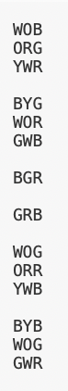

    class MainClass

    {

        static int N = 3; ***//Dimension of array is 3x3, hence the 3***

***//Function to rotate the matrix***

***//90 degree clockwise***

        static void rotate90Clockwise(char[,] Face)

        {

***//Traverse each cycle***

            for (int i = 0; i < N/2 ; i++)

            {

                for (int j = i; j < N-i-1; j++)

                {

***//Swap elements of each cycle in a clockwise direction***

                    char temp = Face[i, j];

                    Face[i, j] = Face[N - 1 - j, i];

                    Face[N - 1 - j, i] = Face[N - 1 - i, N - 1 - j];

                    Face[N - 1 - i, N - 1 - j] = Face[j, N - 1 - i];

                    Face[j, N - 1 - i] = temp;

                }

            }

Results: By creating relevant two-dimensional arrays of characters, I can output two different faces by using two for loops and different characters for the different colours. With white, orange, blue, red, green, yellow being represented by ‘W’, ‘O’, ‘B’, ‘R’, ‘G’, ‘Y’ respectively. By creating subroutines, I can model swapping the colours using a programming syntax I am confident in. My attempt was successful, and the following output proves this.

***//function to print matrix***

        static void DisplayFace(char[,] Face)

        {

            for (int i = 0; i < N; i++)

            {

                for (int j = 0; j < N; j++)

                {

                    Console.Write(Face[i, j]);

                }

                Console.WriteLine();

            }

            Console.WriteLine();

        }

        public static void Main(string[] args)

        {

            char[,] Face = { { 'G', 'Y', 'O' }, { 'R', 'G', 'O' }, { 'R', 'Y', 'Y' } }; ***//Creating a two dimensional array of the original face***

            DisplayFace(Face); ***//Calls the display face subroutine and takes in Face (an array of characters) as a parameter***

            rotate90Clockwise(Face);

            DisplayFace(Face);

        }

    }

}

Result: 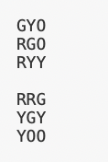

As you can see from the algorithm above, I have decided to use another approach to implement a matrix rotation. Initially, I tried to use trigonometry (using the pseudocode above) but found this attempt to be harder, used more lines of code and overall was not as efficient. The second (successful approach) used cycles using the first and last rows and columns. For each cycle, we swap the elements involved with the corresponding cell in the matrix in a clockwise direction. To do this I used the temporary char ‘temp’: letting the row and column sizes to be 3 (n = 1).

Before Rotation:

*During the first iteration:*

|  |  |  |
| --- | --- | --- |
| **1** | **2** | **3** |
| **4** | **5** | **6** |
| **7** | **8** | **9**  After Rotation: |

Face[i,j] = Element at leftmost top corner = 1

Face [j, n-1-i] = Element at the top rightmost corner = 3

Face [n-1-I, n-1-j] = Element at the bottom rightmost corner = 9

Face[n-1-j][i]= Element at the bottom leftmost corner = 7

*During the second iteration:*

Face[i,j] = 2

|  |  |  |
| --- | --- | --- |
| **1** | **2** | **3** |
| **4** | **5** | **6** |
| **7** | **8** | **9** |

Face [j, n-1-i] = 6

Face [n-1-I, n-1-j] = 8

Face[n-1-j][i]= 4

For the rotation to take place: 1 moves to 3, 3 goes to 9, 9 goes to 7, 7 goes to 1, 2 goes to 6, 6 goes to 8, 8 goes to 4, 4 goes to 2!

The time complexity of this algorithm is O(n*n), as there are 2 for loops, meaning that it is quick!

##### Moving the matrix rotation to Blazor:

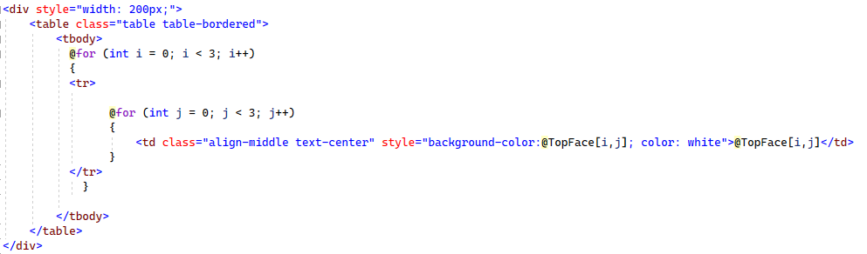

string [,] TopFace = new string [3, 3] {{"White", "Orange", "Blue"}, {"Orange", "Red", "Green"}, {"Yellow", "White", "Red"},}; //making a 2D array of strings of coloured cubies

string [] RightHandColumnOfTopFace = new string [3]; // creating an empty array with 3 spaces

Using Blazors syntax, I have created a table to be outputted on the screen representing the side of a cube:

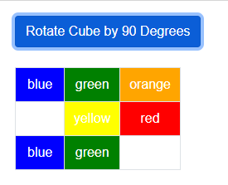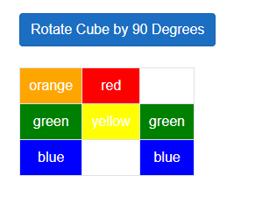

This was successfully implemented with an interactable button, updating the cubes output automatically.

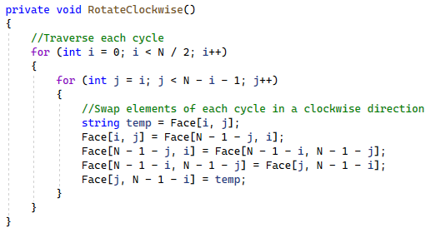

# Technical Solution

### Skills dictionary

|  |  |  |  |
| --- | --- | --- | --- |
| Skills | Shown | Page reference | Grade Band |
| Stack/Queue operations | See instruction class – Scramblinginstructions(list) , AntiInstructions (stack), Solvinginstructions (list). See subroutine AntiMove() and solvingInstructions()) | 129,131 | A |
| Advanced matrix operation | See face class matrixRotationAntiClockwise(), matrixHalfRotation(),matrixRotationClockwise() and CSS under cubeNew | 136, 137, 138, 123, 124 | A |
| Recursive Algorithms | See instruction class RecursiveScramble() | 130 | A |
| Dynamic generation of objects based on complex user-defined use of OOP model | See cube class and HTML page and CSS | 103-121  131-148 | A |
| Complex OOP Model | Use of cube class, face class and instruction class | 103-145 | A |
| Complex user-defined algorithms | See cube class and RotateRightClockwise(), RotateRightAntiClockwise(), RotateLeftClockwise(), RotateLeftAntiClockwise(), RotateUpClockwise(), RotateUpAntiClockwise(), RotateDownClockwise(), RotateDownAntiClockwise(), RotateFrontClockwise(), RotateFrontAntiClockwise(), RotateBackClockwise(), RotateBackAntiClockwise(). See instruction class- GetScramblingInstructions(), RecursiveScramble(), GetSolvingInstructions() – these call other complex algorithms. See face class- getRow(), getColumn(), UpdateNewRow(), UpdateNewColumn(), UpdateCubies(),matrixRotationAntiClockwise(), matrixHalfRotation(),matrixRotationClockwise() | 107-110  129-130  122-125 | A |
| List operations | See instruction class- GetCurrentInstruction(), GetNextInstruction(), GetPreviousInstruction() | 128 | A |
| Efficiency | Run-length encoding in instruction class – ConjoiningInstruction() | 129 | A |
| Dictionaries | See cube class DisplayAfterSeeingAdjacentFaces, UpdateAllFacesCurrentOrientation, movesToPerform, faceToShow. See instruction class – possibleMovesAndAntiMoves, | 102, 105, 106, 127 | B |
| Multi-dimensional array | See face class – face is a 2 dimentional array which is updated via matrixRotationAntiClockwise(), matrixHalfRotation(),matrixRotationClockwise() | 122-126 | B |

Here again is another copy of the system hierarchy, the code below should reflect all the processes in this. :



### Cube Class

The cube is the main class. It uses a 2D list to store each of the cubes faces to represent the Rubiks cube. Each face is a class with its own method, the cube class is used to co-ordinate and update the interactions between the faces. Dictionaries are used to store sequences for updating the columns and rows within each face. This depends on the move being chosen- seeing the left, right, up, down , front and back faces.

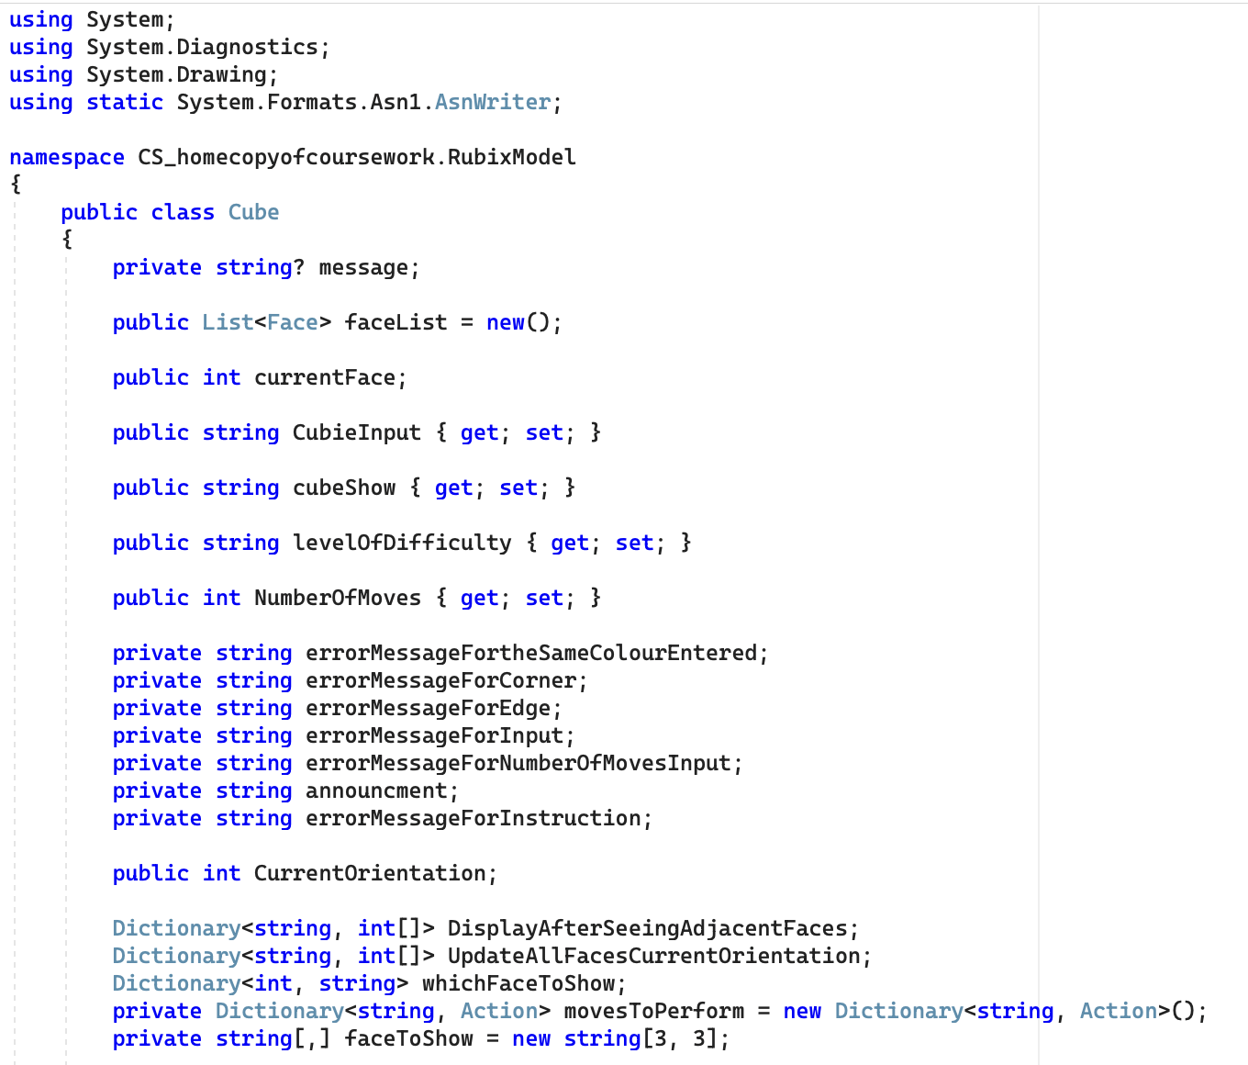

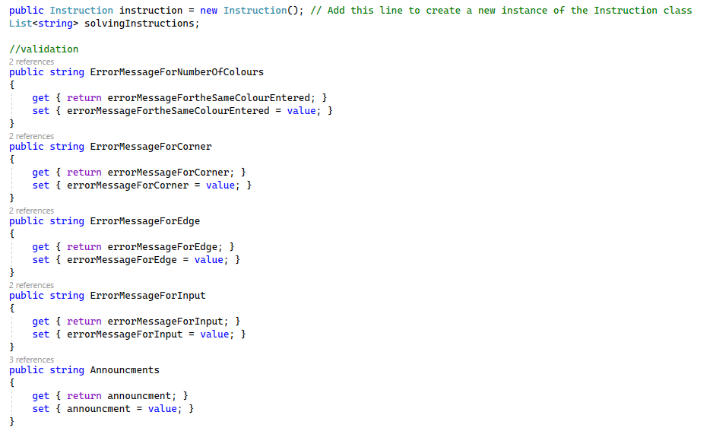

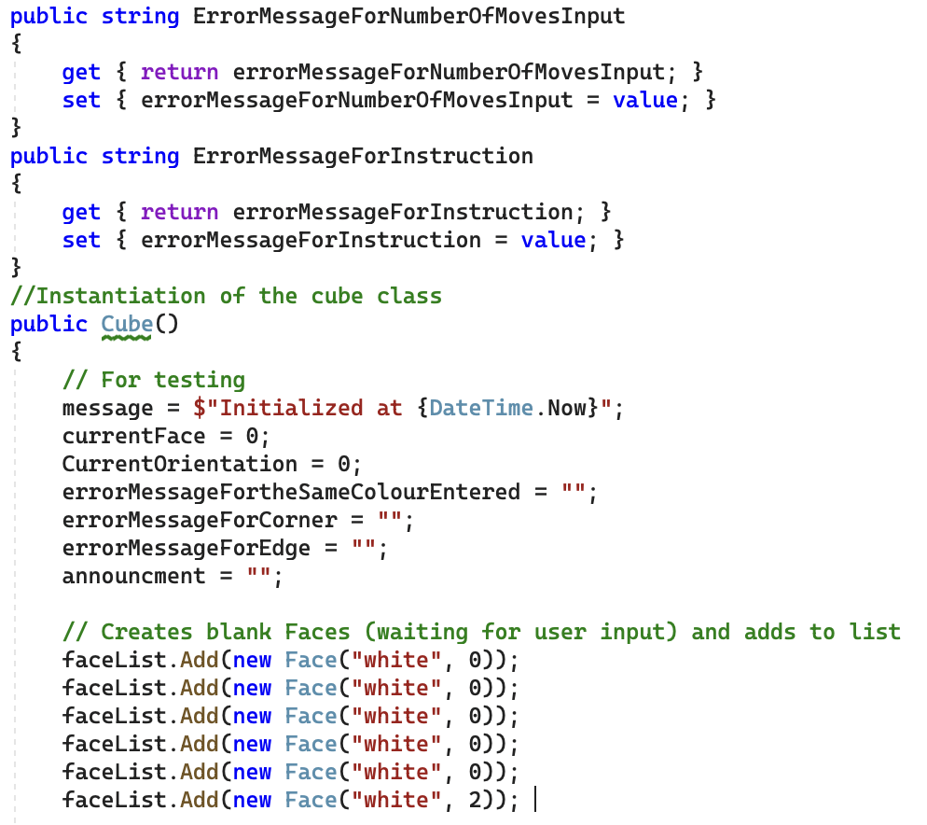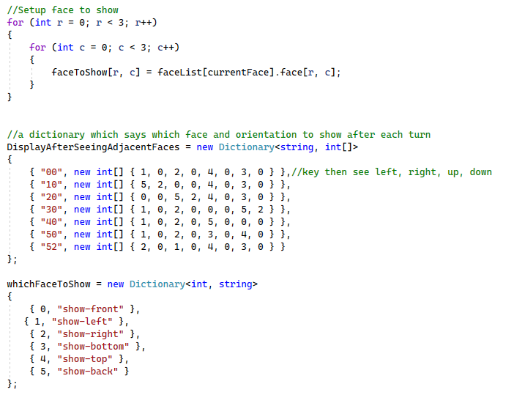

Dictionaries above list all the faces and their possible orientation for the user to see. Positions 0 and 1 reference what face is on the left and what orientation it should be displayed in. Position 2 and 3 reference what face is on the right and what orientation it should be displayed in. Position 4 and 5 reference what face is on the top and what orientation it should be displayed in. Position 6 and 7 reference what face is on the bottom and what orientation it should be displayed in.

The dictionary whichFaceToShow references each face number with its string reference for the CSS to understand. Face 0 relates to the show-front, face 1 relates to show-left, face 2 relates to show-right, face 3 relates to show-bottom, face 4 relates to show-top and face 5 relates to show-back.

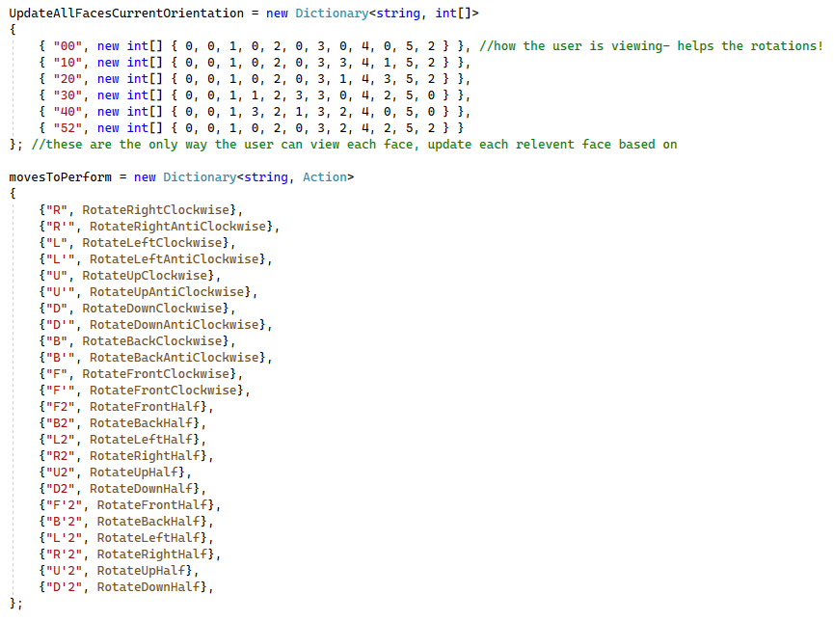

The dictionary movesToPerform relates the string move with the subroutine which execute it.

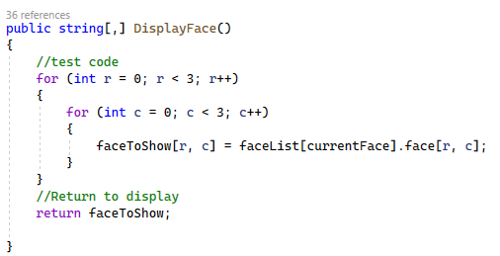

DisplayFace loops through each row and column of the current face and updates the faceToShow.

Below is the R, R’, L, L’, U, U’, D, D’, F, F’, B, B’ rotations:

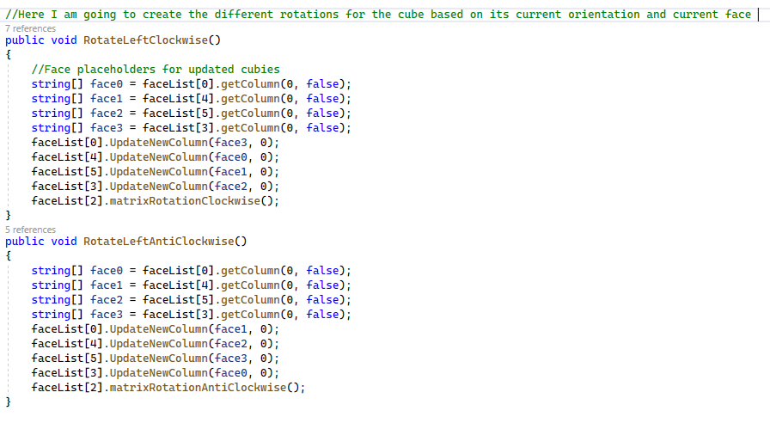

Each of the rotations are manually coded using the face classes methods getColumn, getRow, UpdateNewColumn and UpdateNewRow. The rotations are thoroughly explained in the testing section. Essentially, a temporary array to hold the appropriate column or row and then the appropriate row on each face is updated. Either a clockwise or an anticlockwise rotation is performed depending on what the move is.

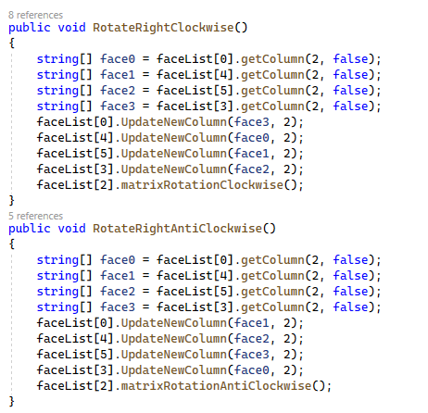

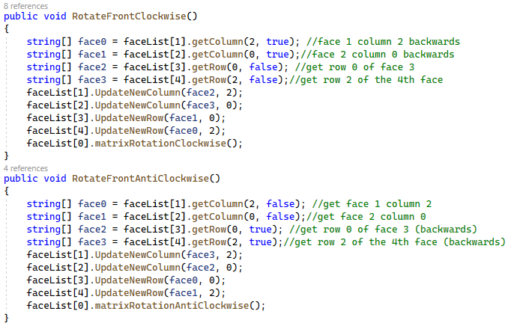

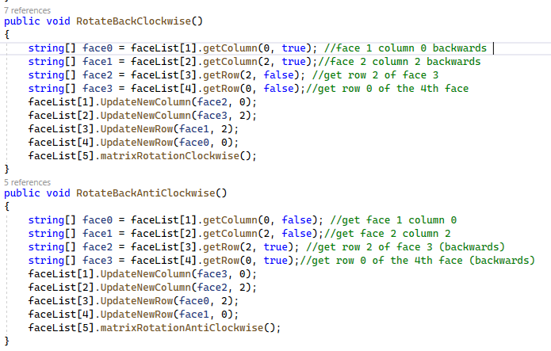

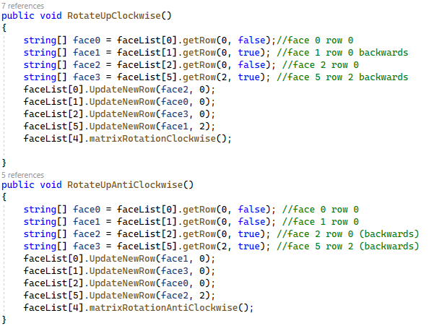

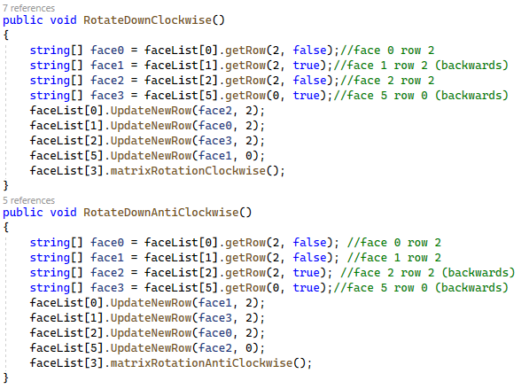

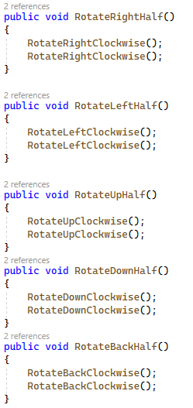

These subroutines apply 2 of each rotation to apply a half rotation to the cube.

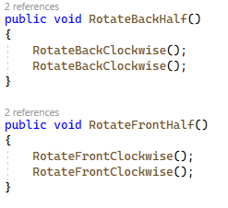

Here are how to access a key-value pair in the dictionary:

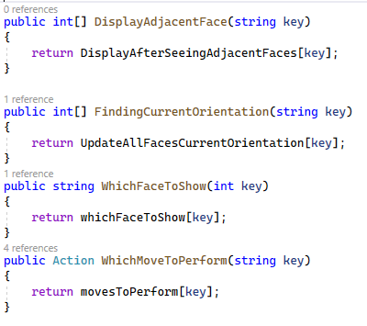

Following methods are for displaying the cube:

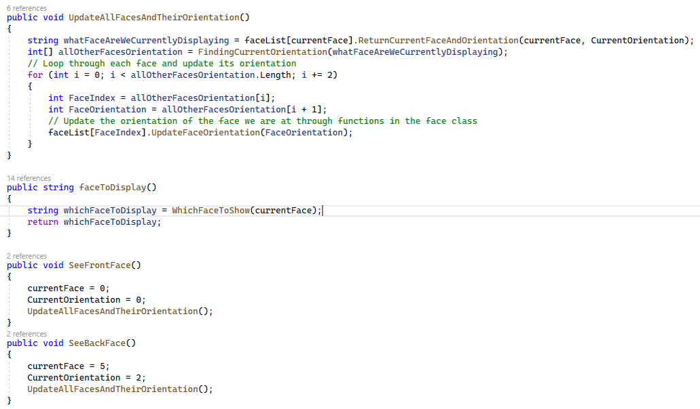

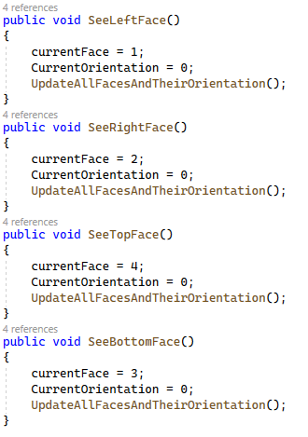

Validation section:

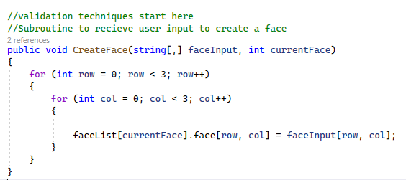

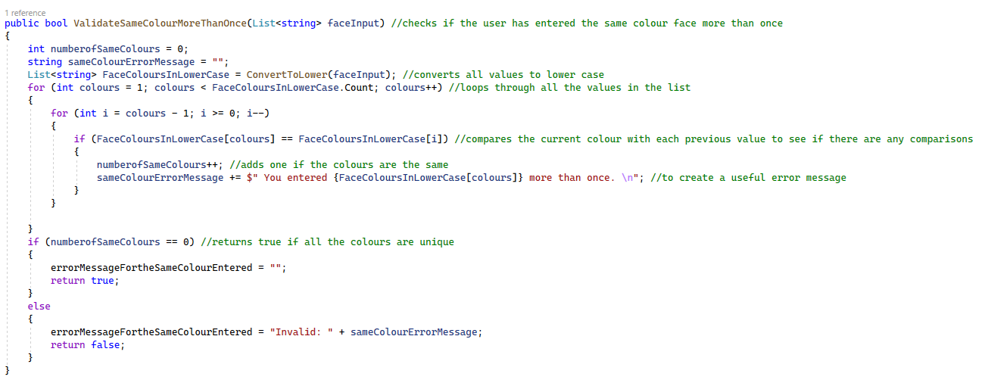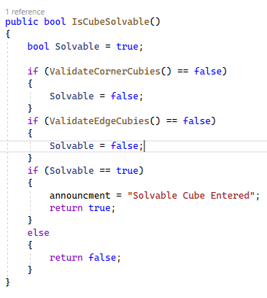

All conditions must be forfilled for the cube to be considered solvable. The methods are copy and pasted on the following pages.

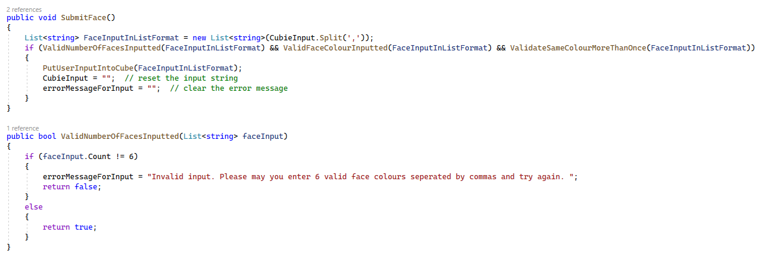

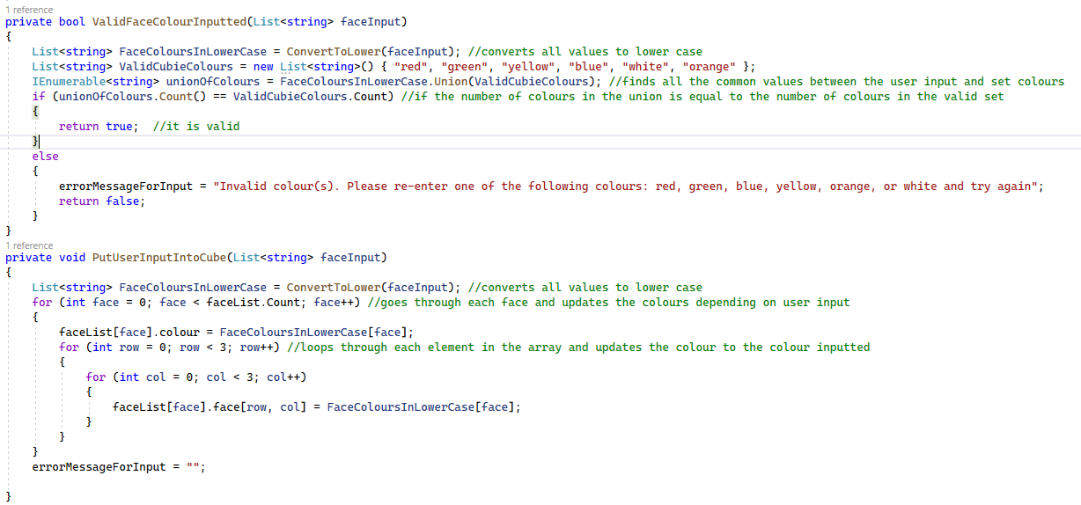

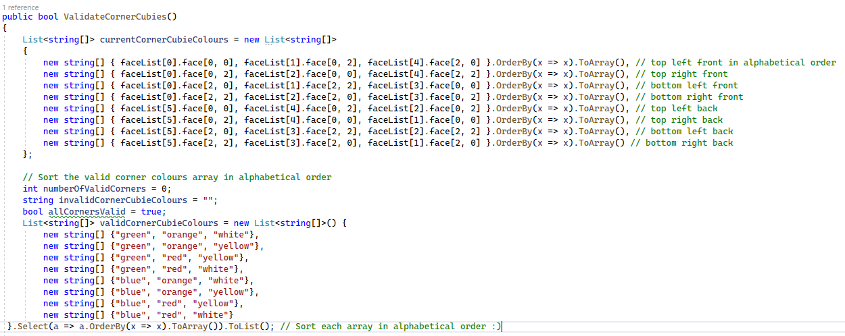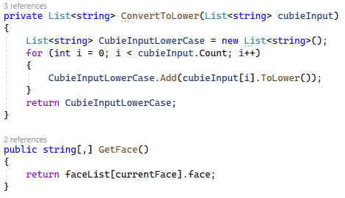

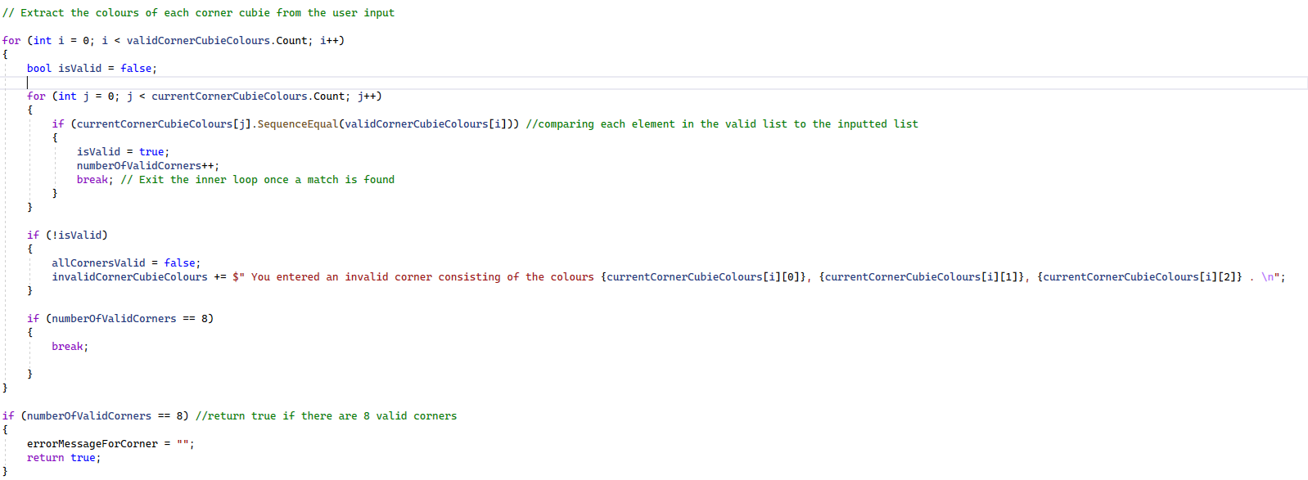

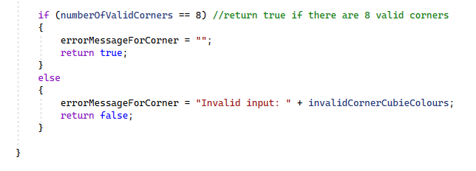

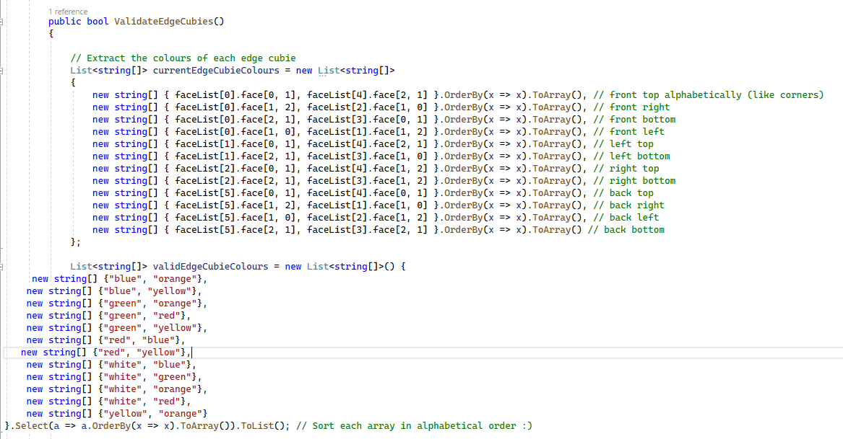

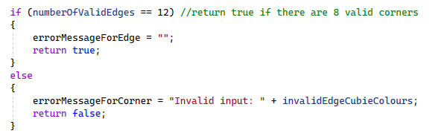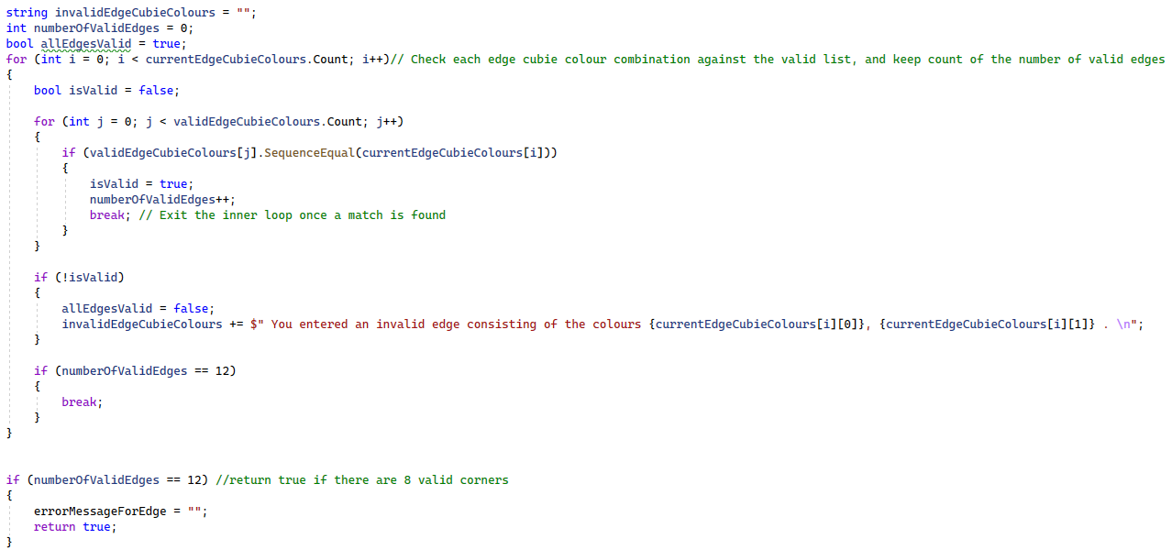

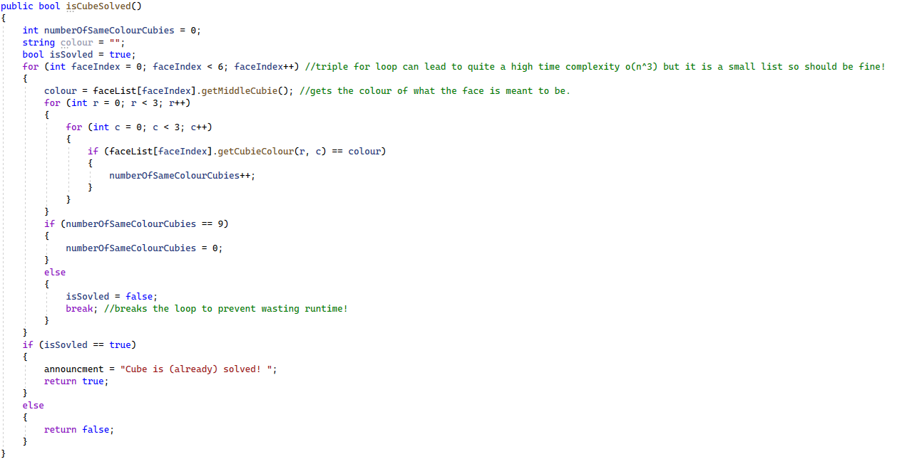

Scrambling and solving via cube class

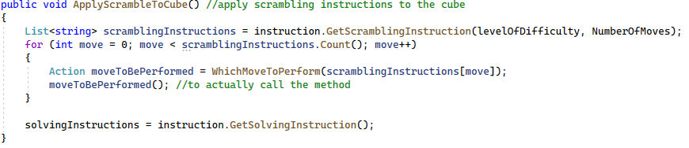

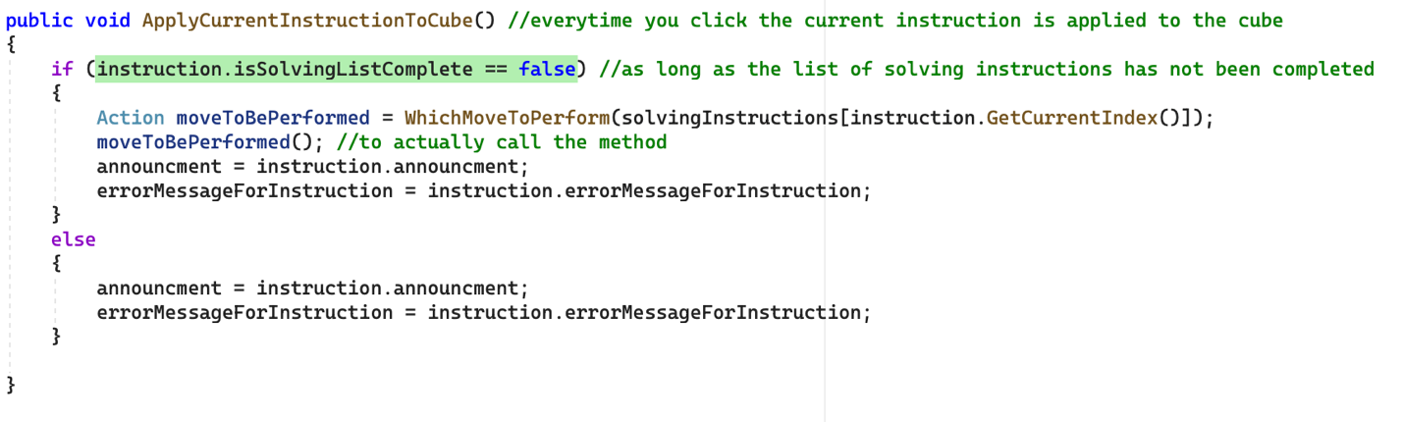

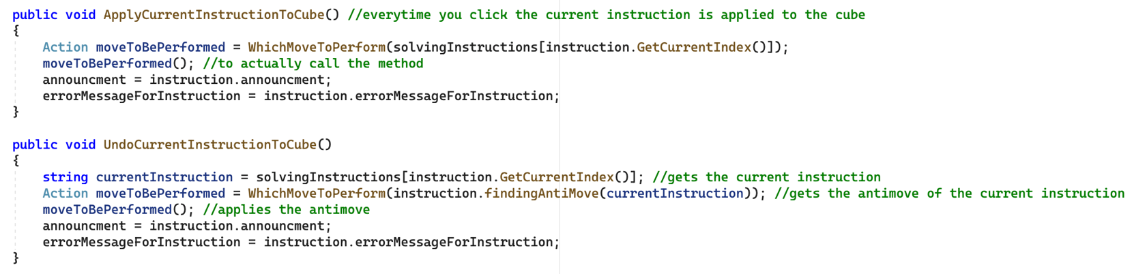

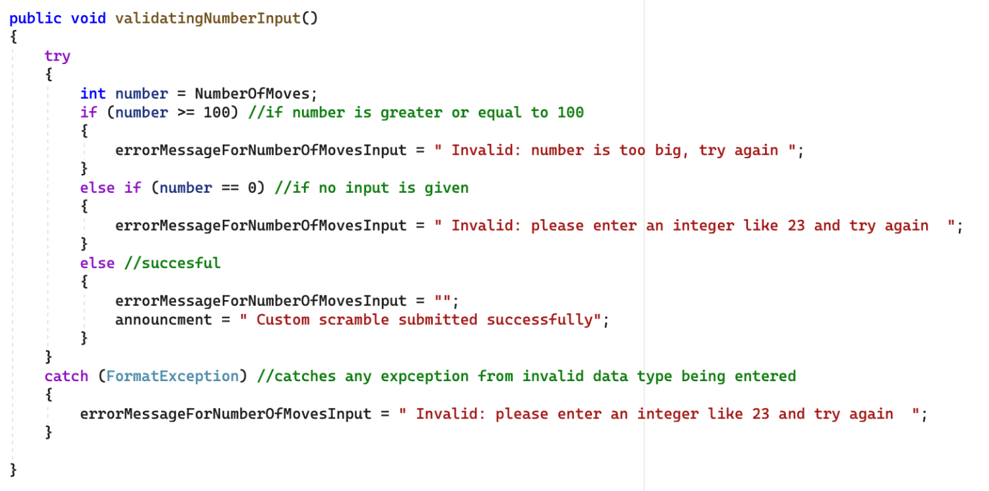

### Face Class

The face class handles the operations of each cubie in the cube. It rotates, replaces and stores the colours of the faces. It does this using methods and string array manipulation and handles the orientation displayed to the user.

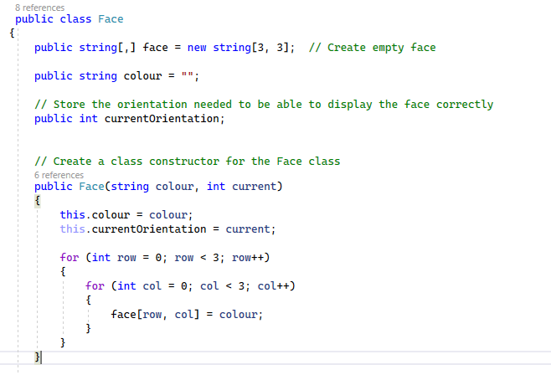

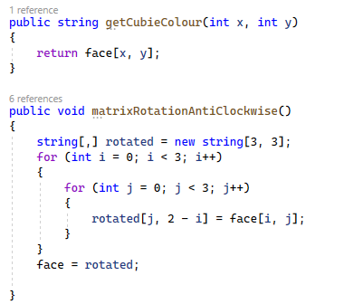

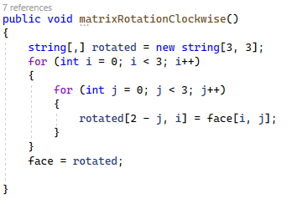

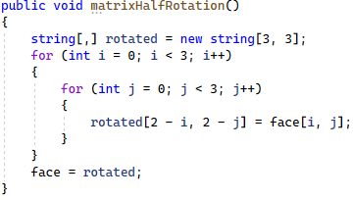

The subroutines above moves all the cubies in the face to its relevant position according if it is an anti-clockwise, clockwise or half turn. This is explained more in the design section under *Prototyping rotations in Blazor.*

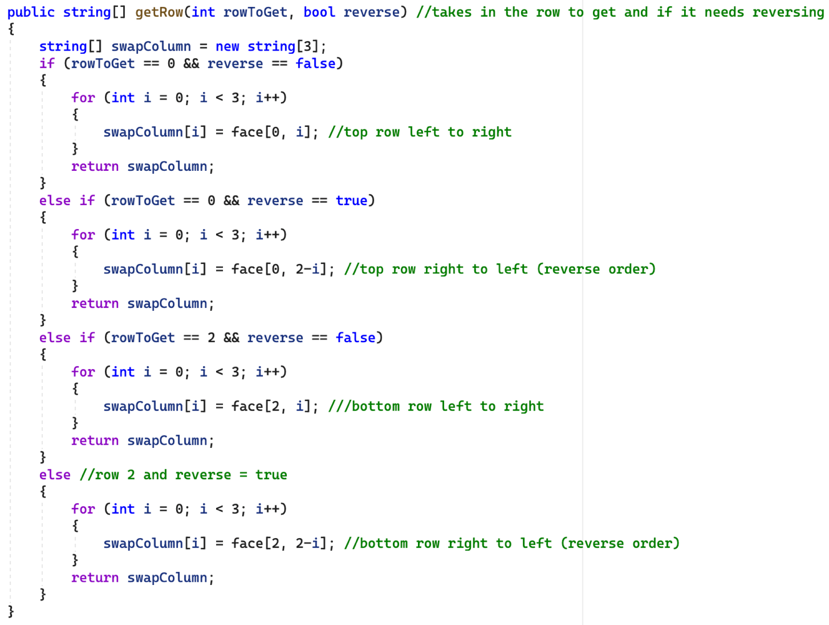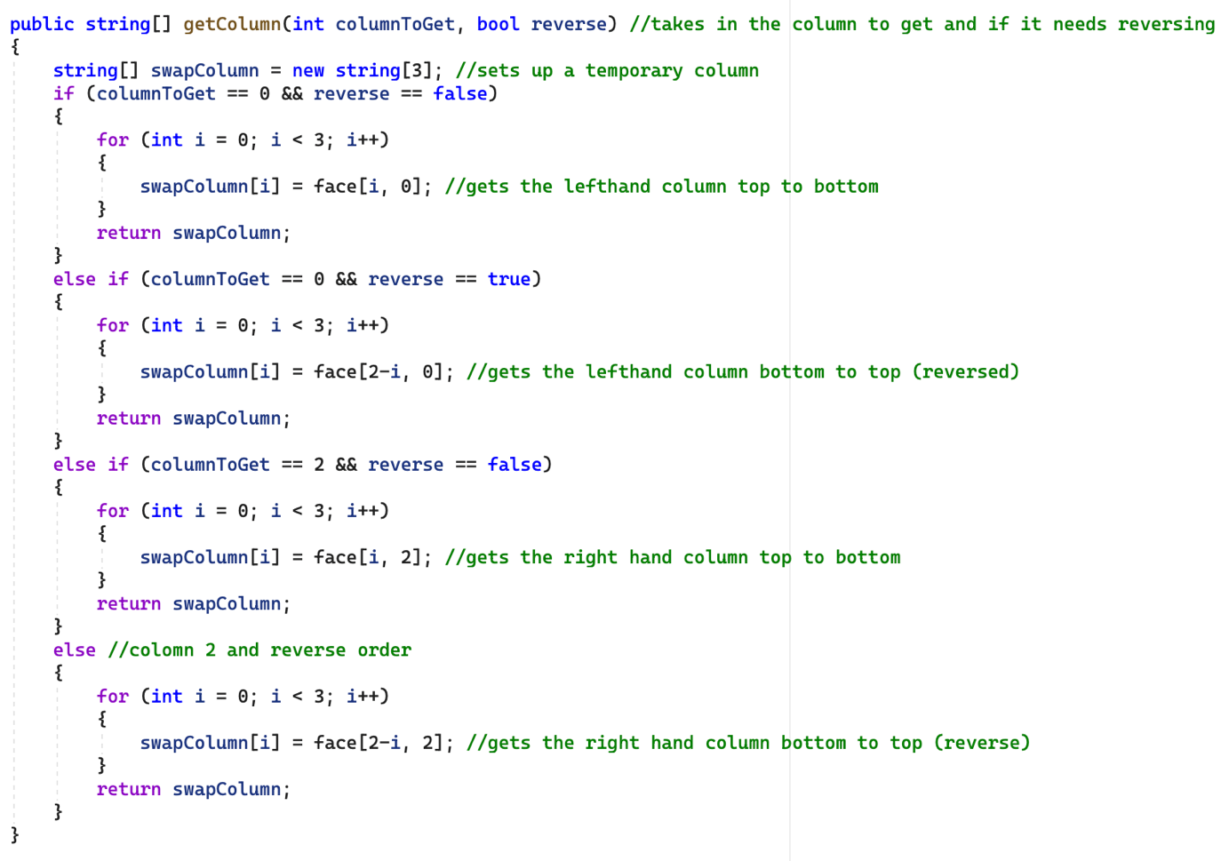

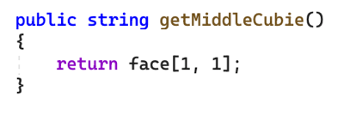

Returns the colour of the middle cubie of the face (stored in position 1,1)

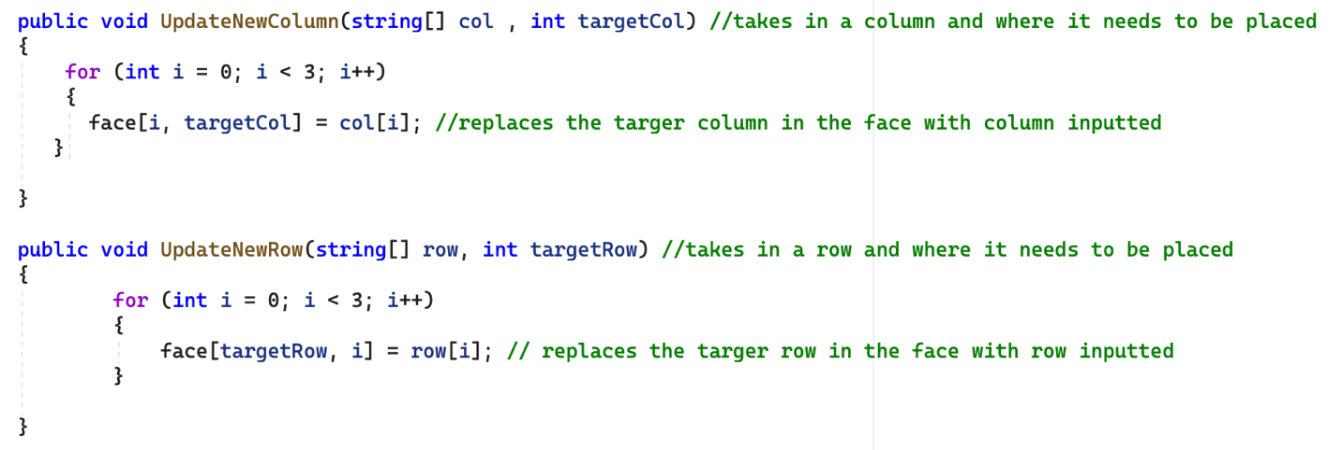

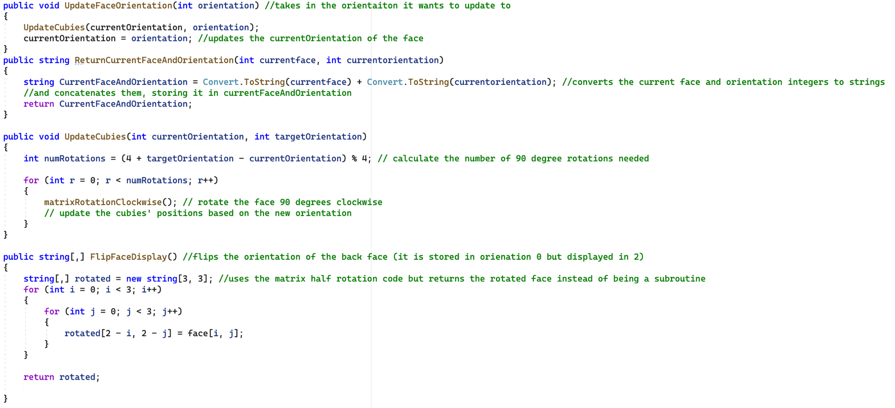

### Instruction Class

The instruction class handles the scrambling and solving of the cube. It used recursive techniques to scramble according to the user’s difficulty and solves using queues, dictionaries and stacks. It also keeps track of the current, next, and previous instructions so the user can loop through the instructions as many times as they need.

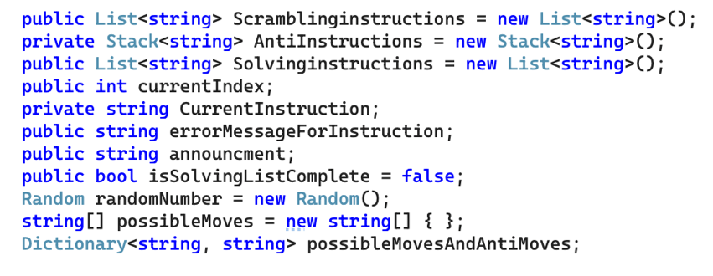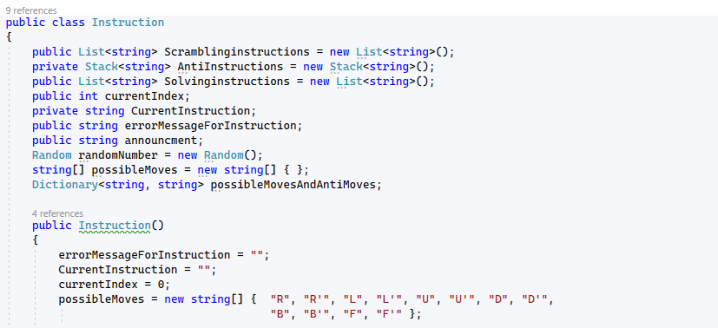

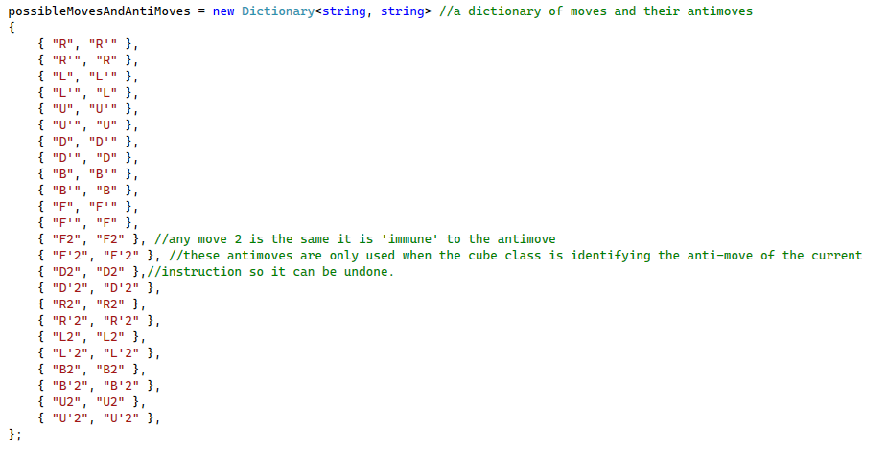

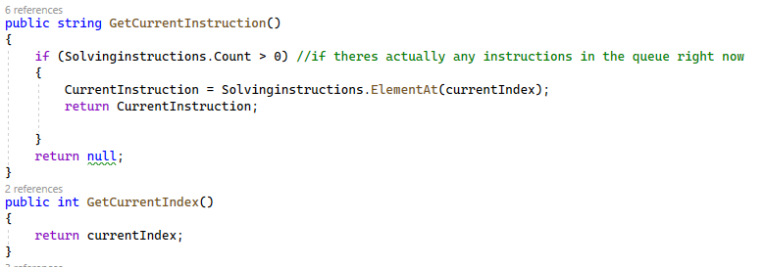

Management of queues using lists:

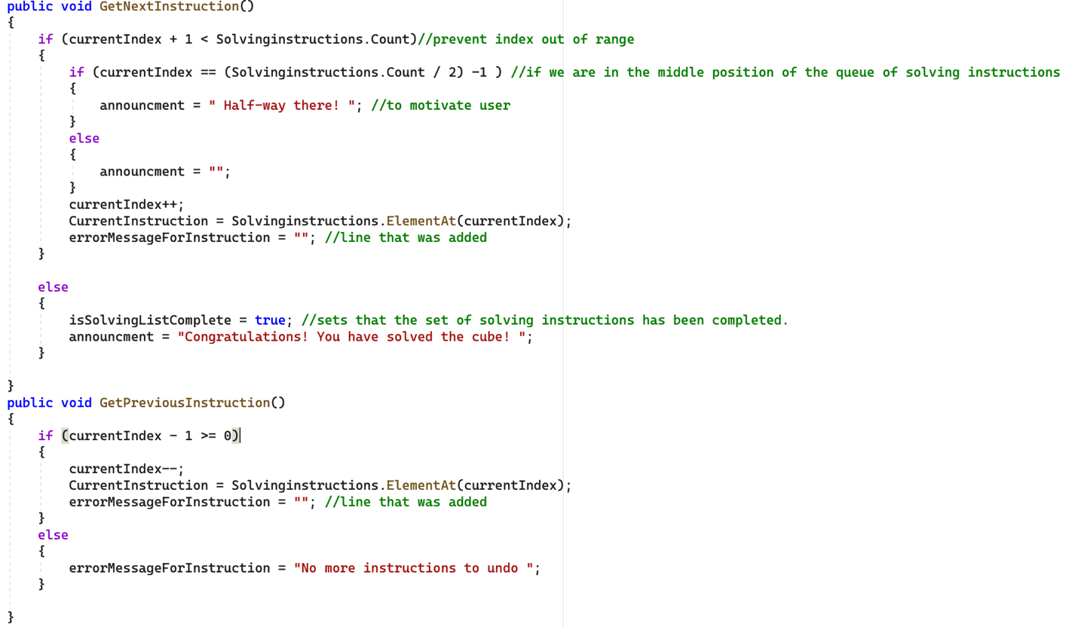

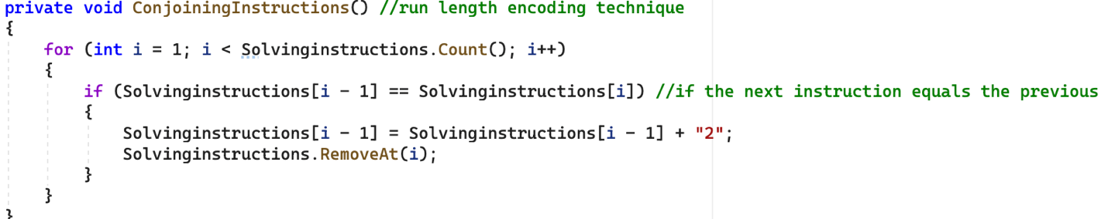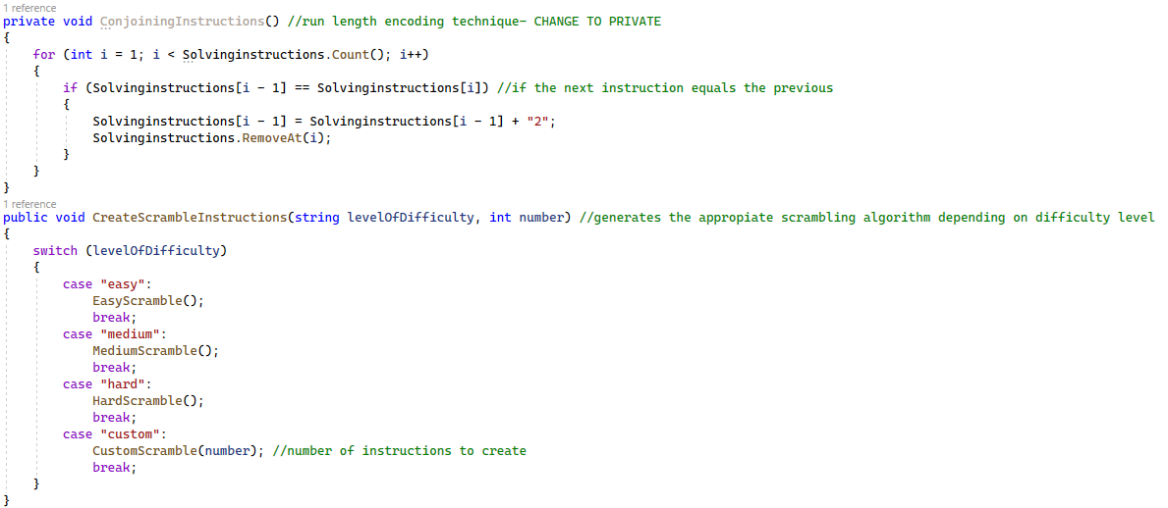

Recursion and use of stacks:

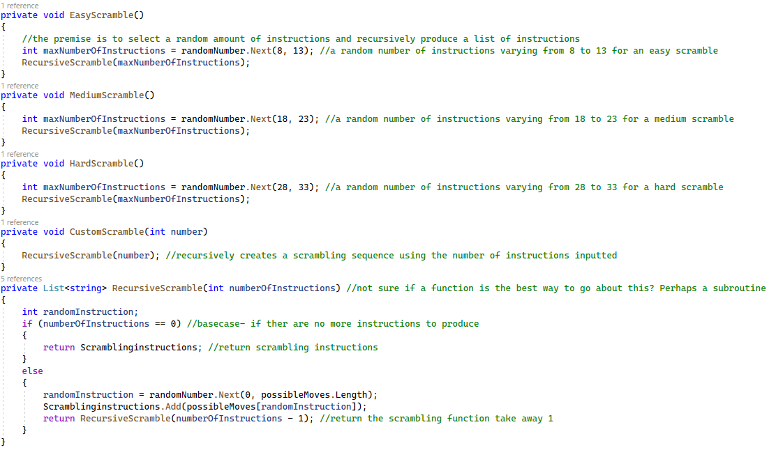

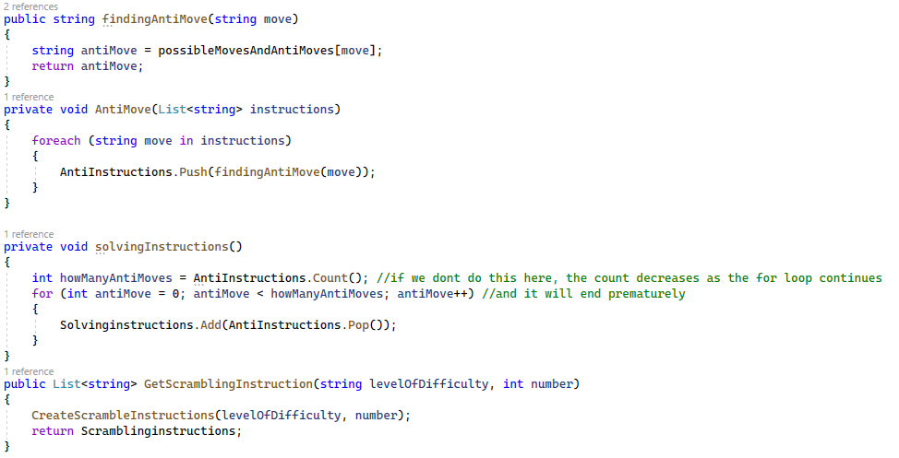

Pops off instructions from anti-instructions and stores it in the solving instructions list. Essentially reverses the anti-instruction list

Uses C# inbuilt stack structure to loop through each instruction in the list, finds its Anti-move and pushes it onto the list.

Functions which take in the key and return the value stored in the dictionary. FindingAntimove uses the possibleMovesAndAntiMoves dictionary.

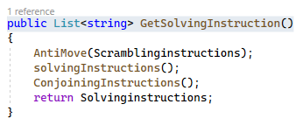

Calls all subroutines to return the solving instructions generated.

### CSS StyleSheet

Below is a screenshot of the CSS used to create 3D renditions of a cube and structure the page. I have also attached a photo of what the finished product looks like:

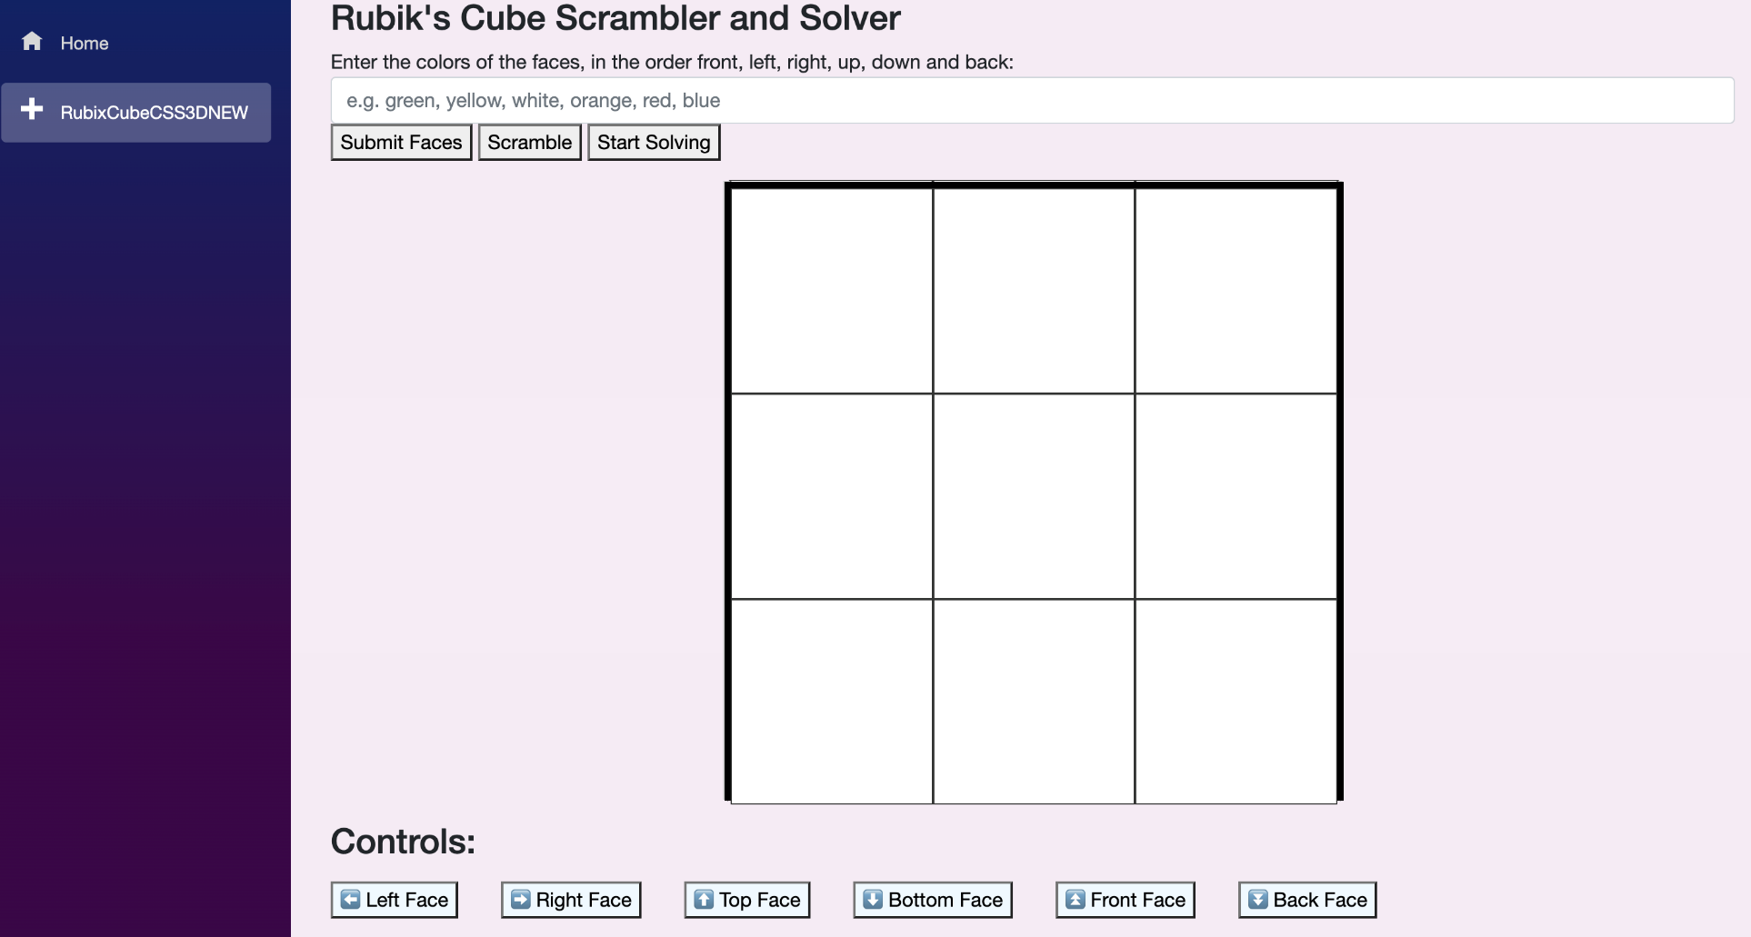

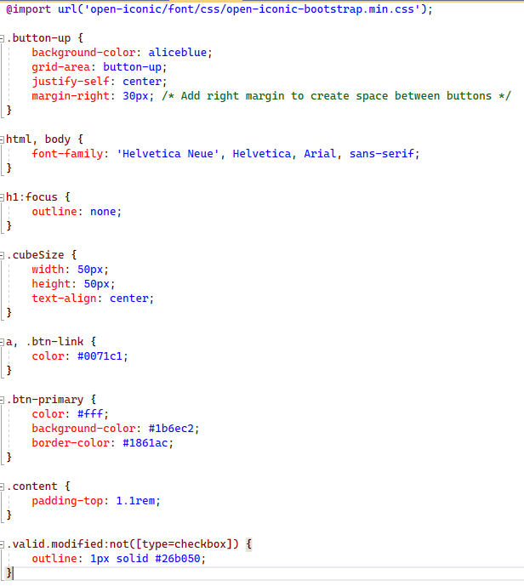

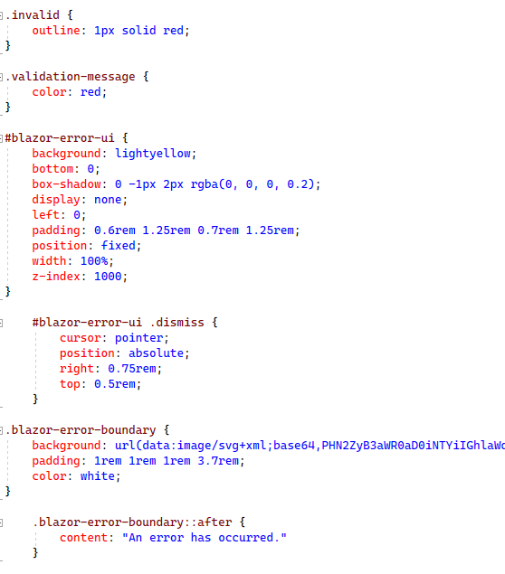

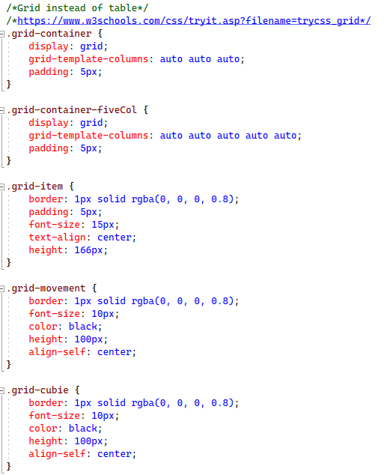

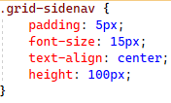

3D model of cube using matrix operations:

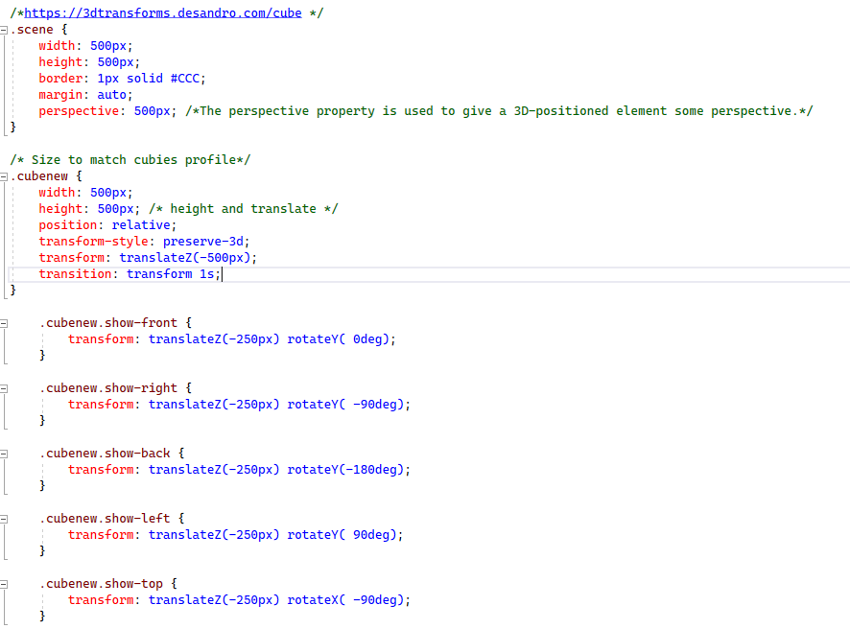

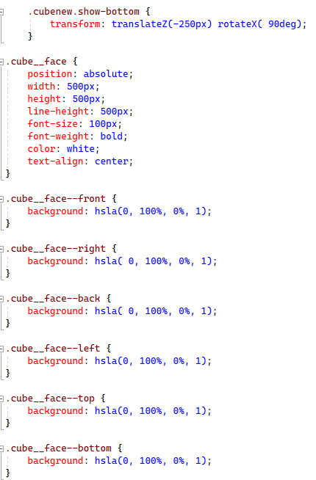

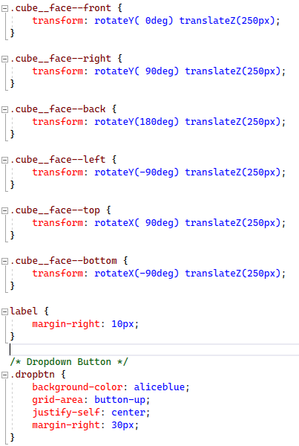

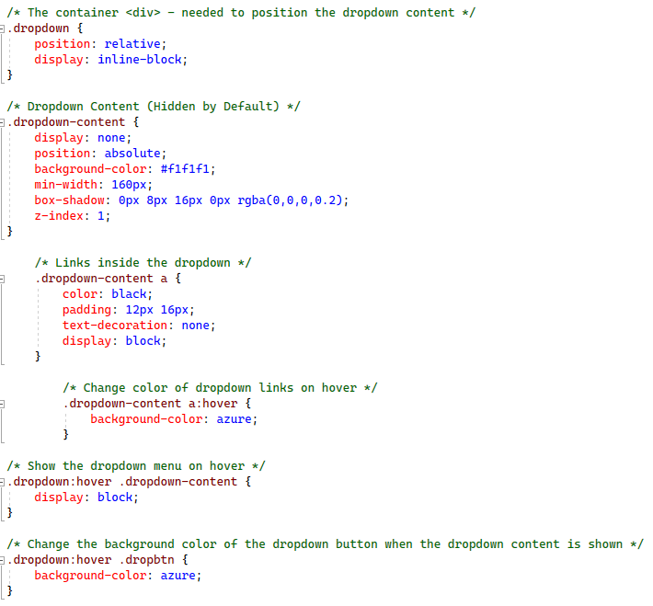

### HTML format for Rubik’s Solving page

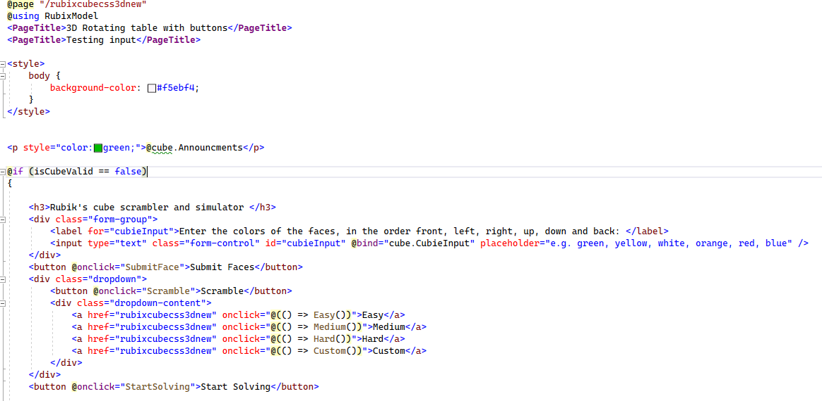

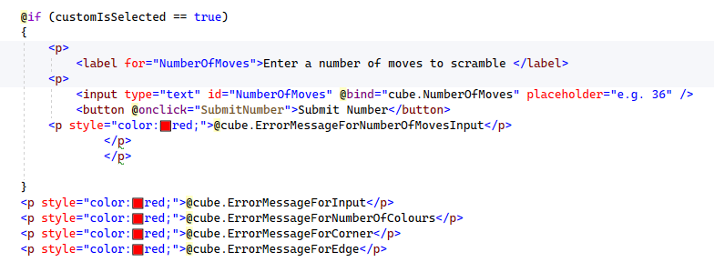

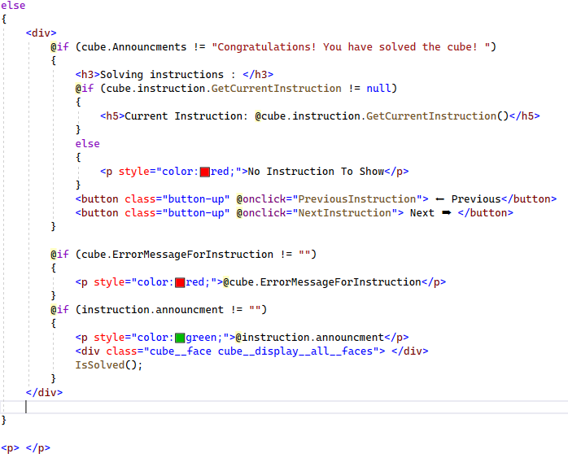

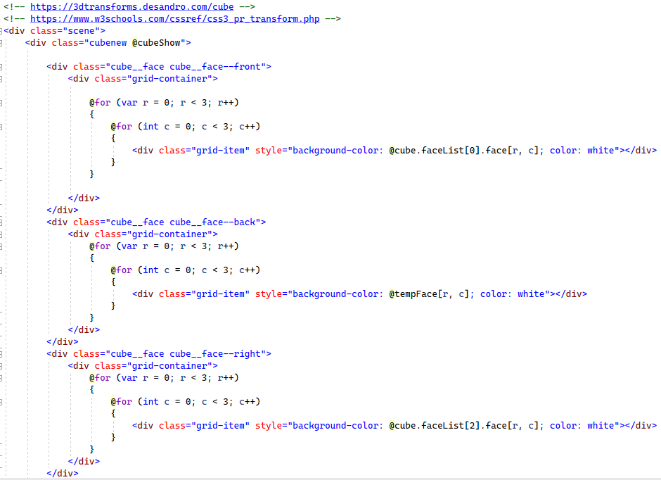

Loops through each face and displays the cubies colours in each relative position. The back face loops through the temporary face which has corrected the back face to show in the correct orientation.

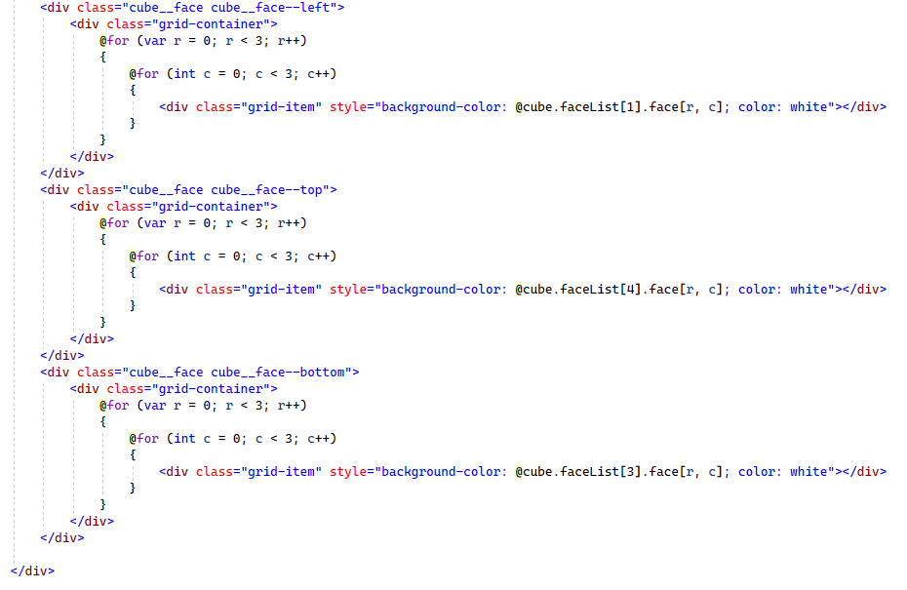

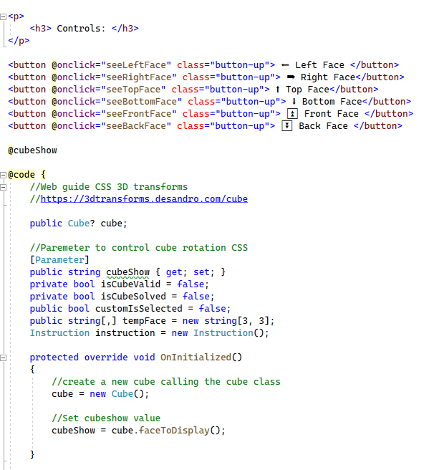

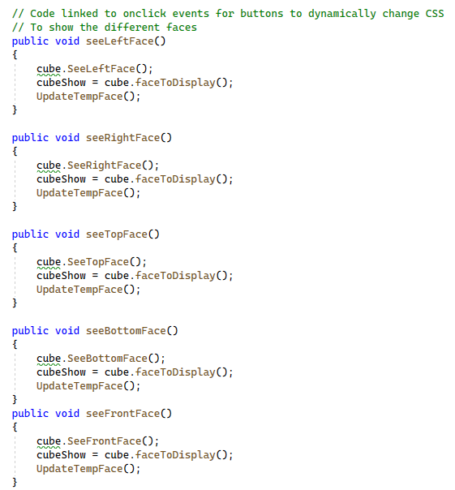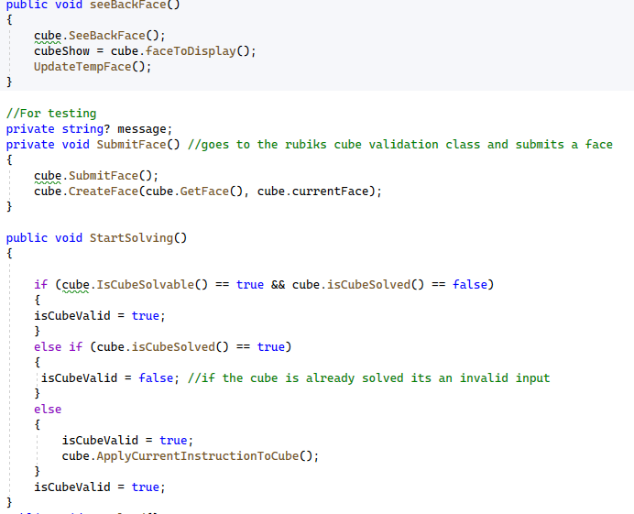

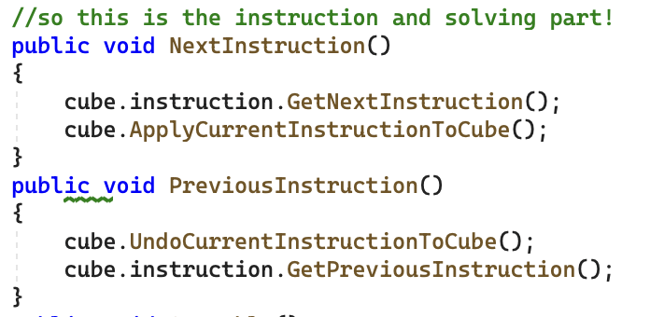

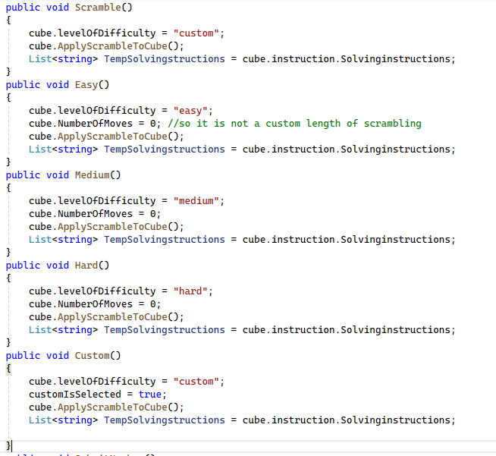

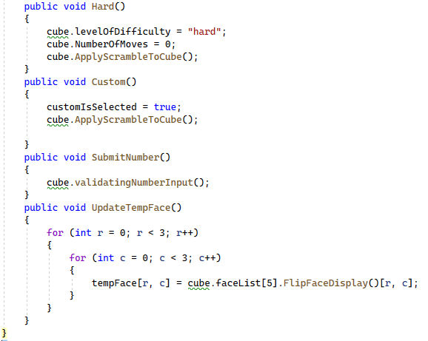

### HTML for the home page

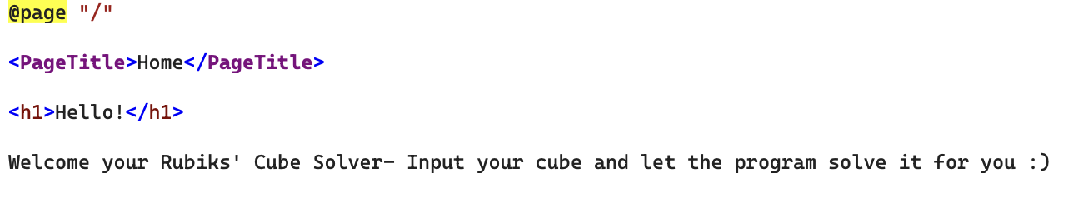

### Blazor File Structure and Navigation Page

Here is the Blazor file structure I designed in the design section, followed by a screenshot of the folders and the navigation page:



As discussed in the design section, I organised my files in the following manor. The pages folder consists of the 2 pages which make up the system (home page and the Rubik’s cube simulator page). The Rubiks cube simulator page uses the Rubik’s model folder and the wwwroot folder holds the CSS for the system. The shared folder holds the code for the main layout and the navigation menu.

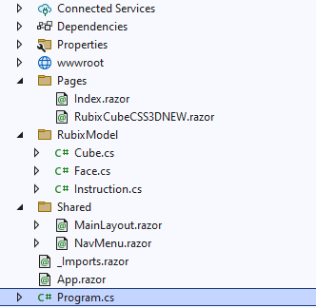

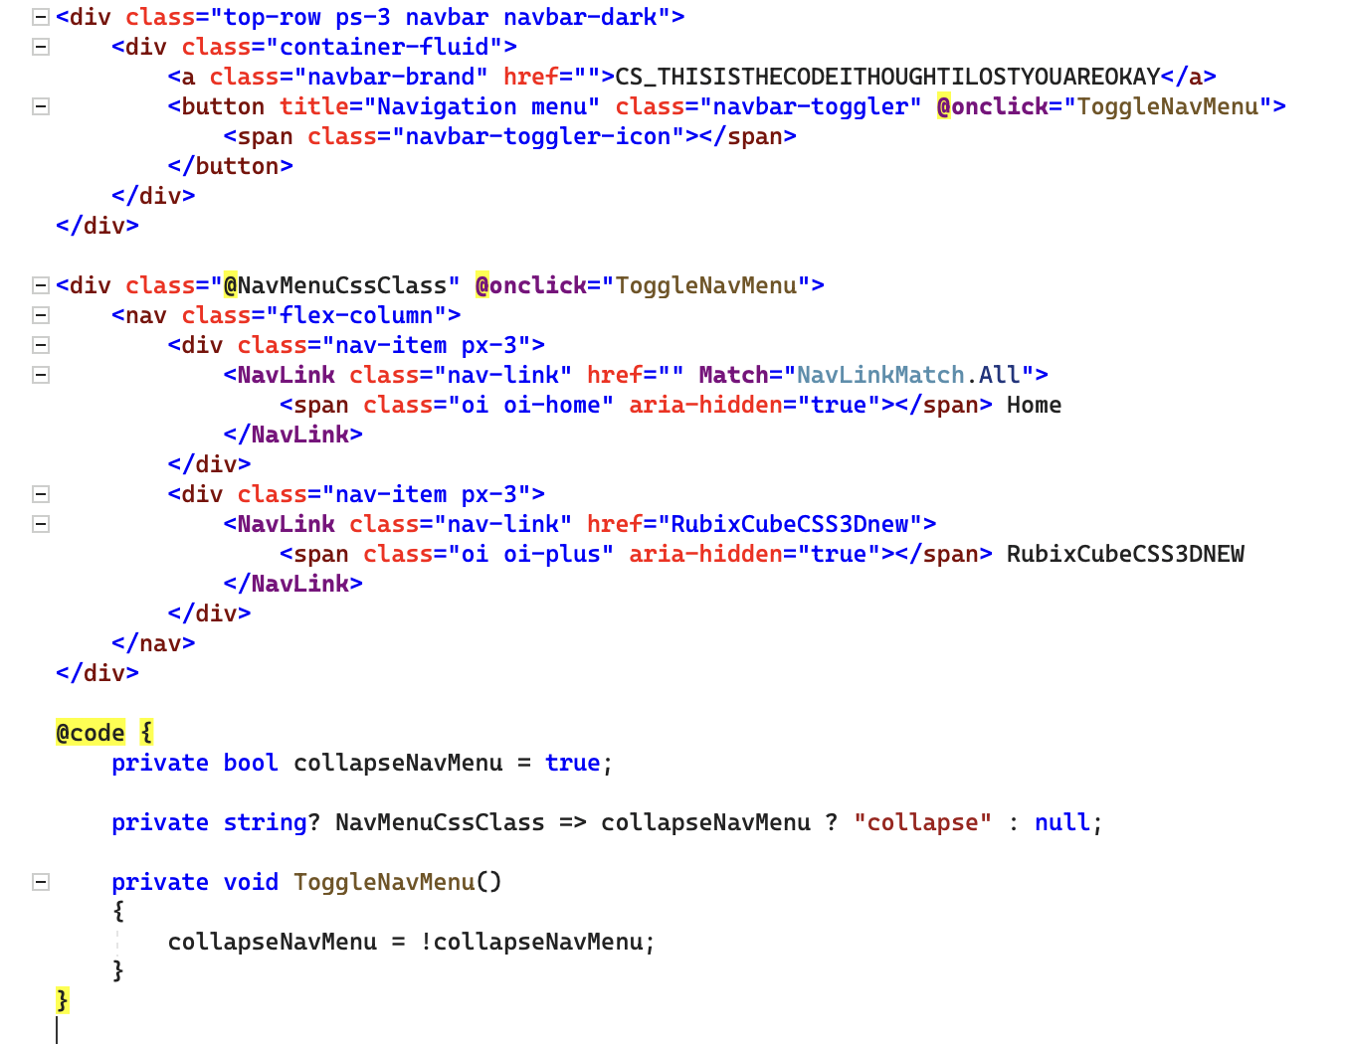

# Development and Testing

Whilst developing I decided to prototype lots of different approaches to display the cube on the screen. Below you will find screenshots of each approach and which one I ended up going with at the end.

### Different approaches to display the cube

#### 2D approach

Here is some evidence of the cube a 2D design I programmed, starting on the front face, pressing the see right button, pressing the see left button twice, pressing the see right once, pressing see up once and pressing see down twice.

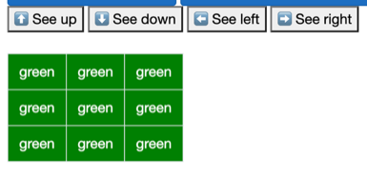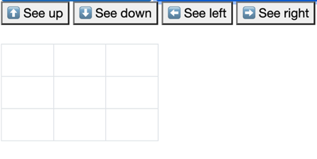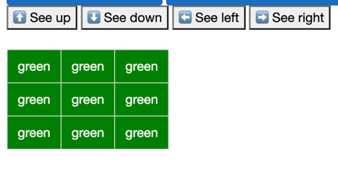

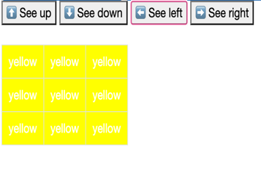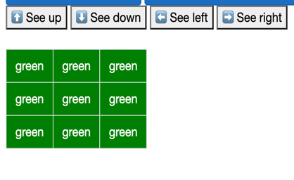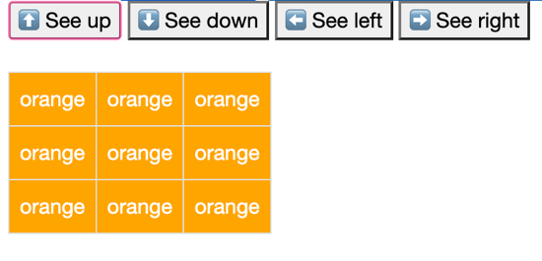

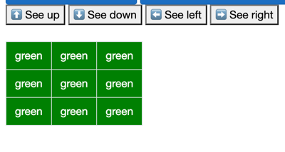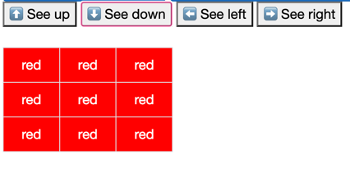

#### 2D design with grid spacing

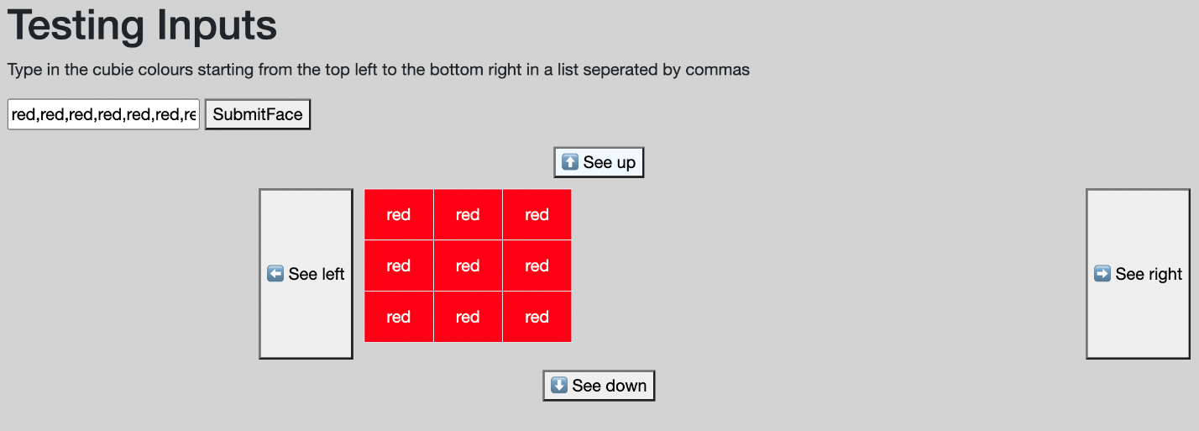

I attempted to structure the buttons around the cube using CSS to make it look like the prototyped design in the design section. Initially this did not work very well although the premise was there. I couldn’t quite work out why the see right was so much further right than the other components, so I went into the code and investigated.

After researching online on how to centre everything using HTML; I implemented the following code:

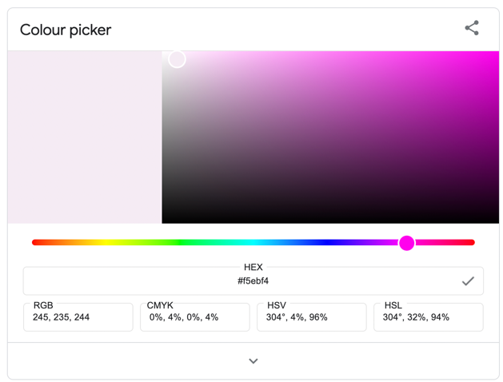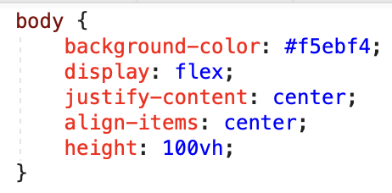

And updated the background colour so it was a little nicer using a hexadecimal colour chart. Here is what it looked like after my changes.

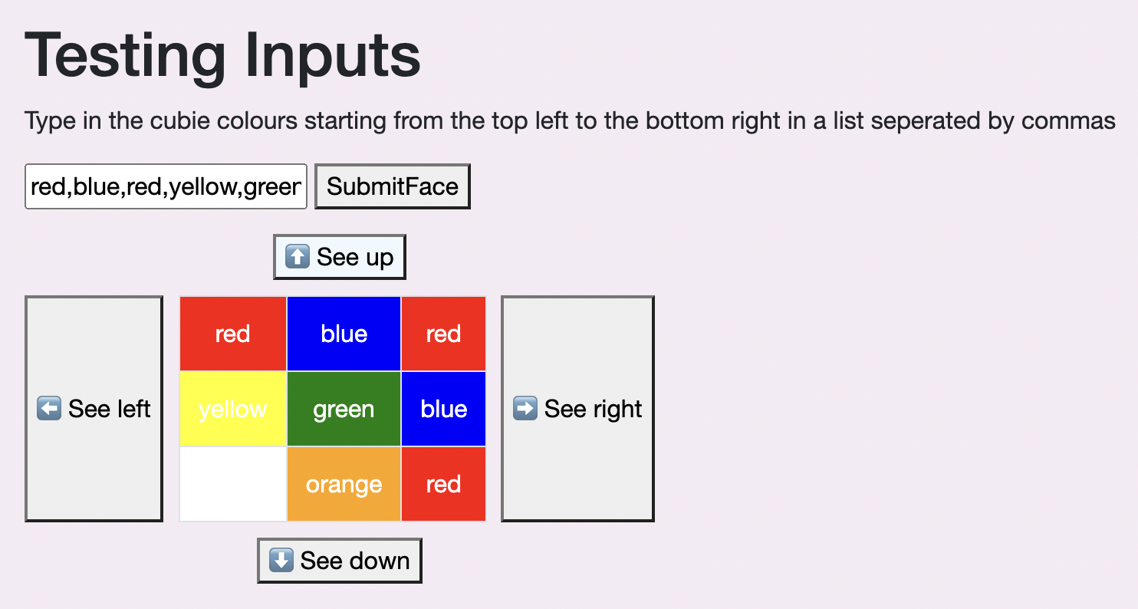

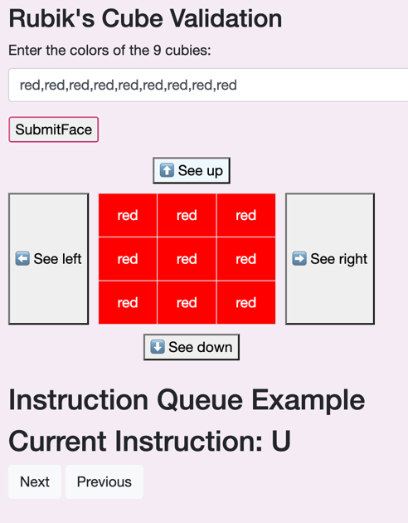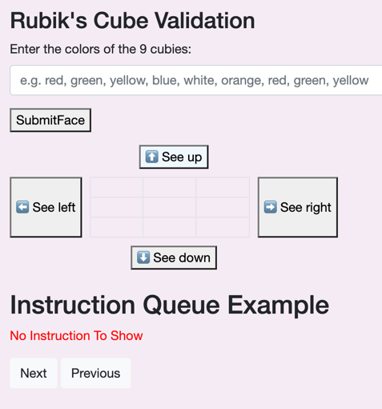Here are further screenshots of more styling with the 2D design:

#### A flat cube net

Below are screenshots of how I attempted to create a solver using a 2D net method; unfortunately I found this much more confusing and when attempting rotations and trying to picture it in three dimensions in my head. As you can see in the last photo, a new random row of yellow has been introduced which is very random. Given enough time, I think I could have gotten this to work. I found the main problem with this method was that when the cube is set up the back face is at orientation 2 compared to the rest of the faces being orientation 0. This caused knock on effect as the cubie in position (0,0) in orientation 0 would be the same as the cubie in orientation (2,2) in orientation 2, but the cube wasn’t considering this.

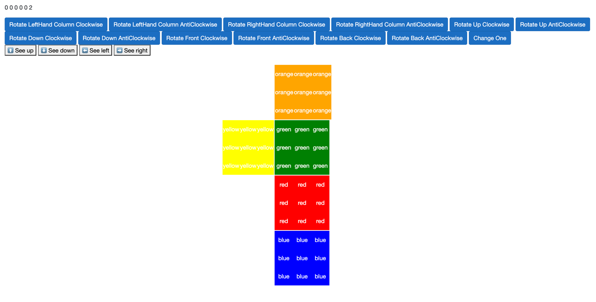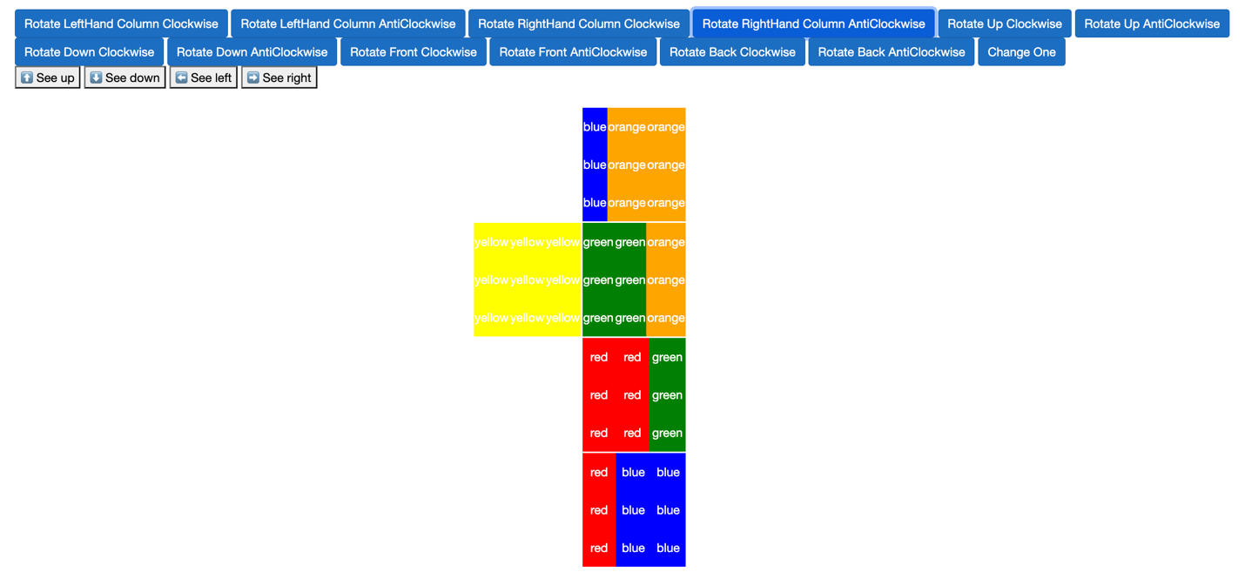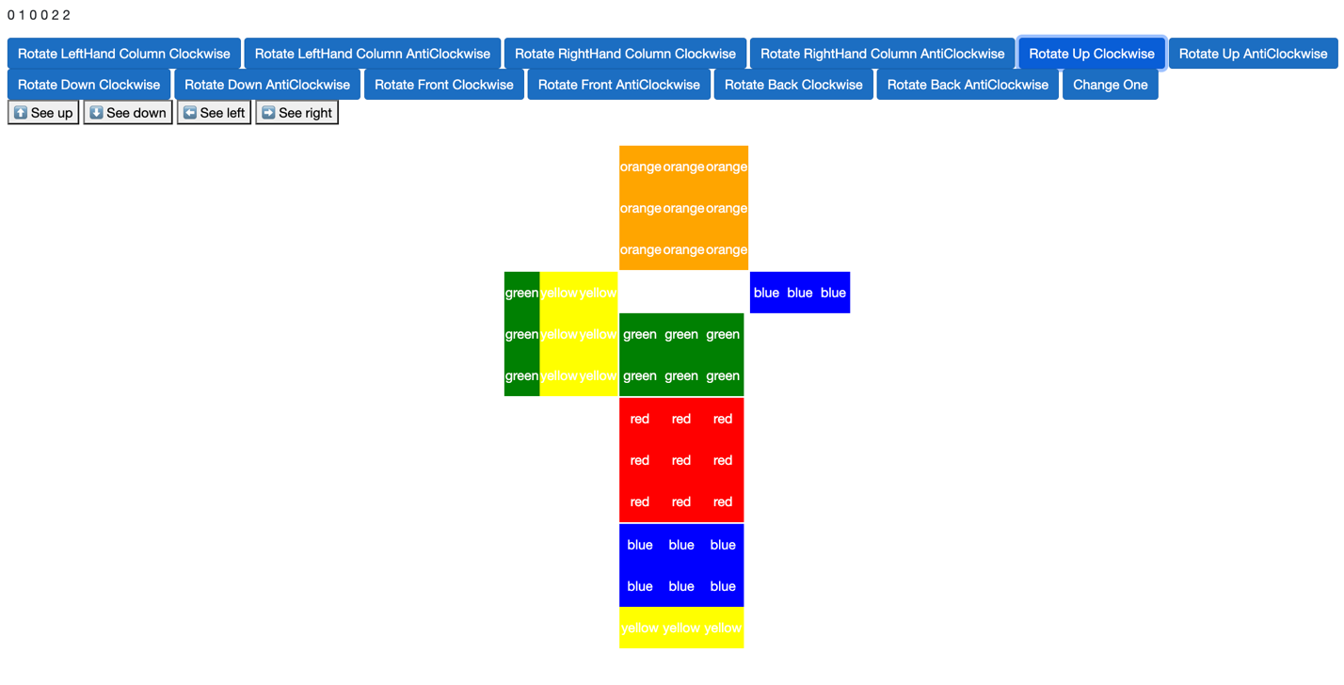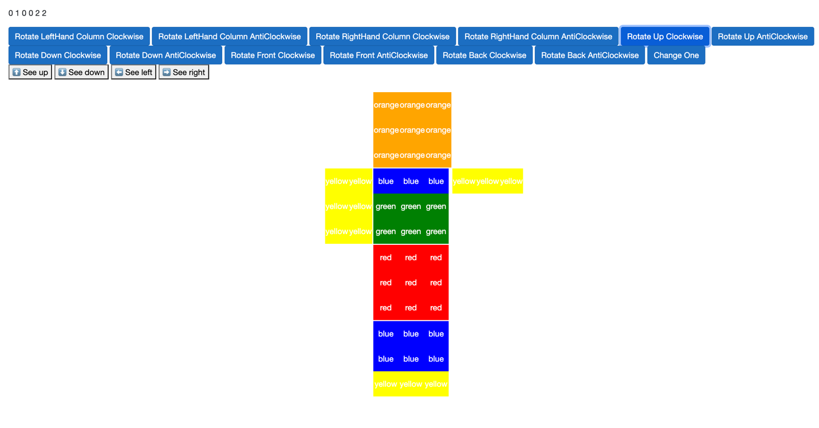

As I started developing and implementing my cube into Blazor, I realised that representing a 3D cube in 2D space was much harder than anticipated. It caused me as a programmer more time to logically analyse each orientation and rotation to ensure that the user was being always displayed the cube in the correct position- i.e., the user could press see left in any orientation and the right matrix transformation would be applied to all faces on the cube so rotations would be performed correctly. Not only did this take a significantly long processing time (as the O(n3) time complexity was used frequently) but also took time away from the actual solver being created. Hence, I decided to research and change the method on how I was going to represent the cube by using CSS. I researched into other new ways to represent a cube, so I attempted to program a 3D cube with CSS using a virtual rotate on hover system using the following code:

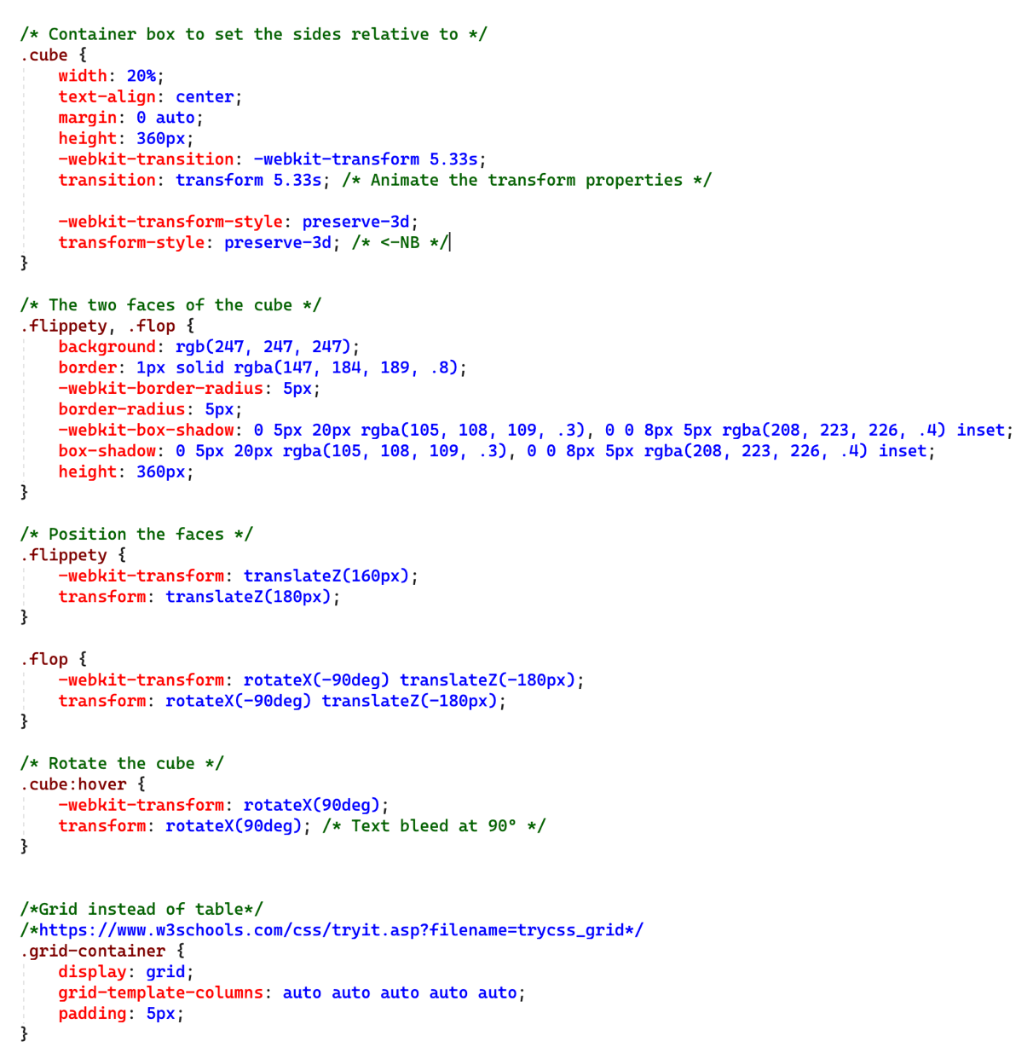

This did work but I felt that the overall look was quite choppy, and the hovering cube idea was good as a concept but didn’t translate well. However I did find that using grid spacing was especially helpful, by having a 5 by 5 table storing buttons to see each side and rotate their corresponding places (rotate right, rotate left etc ) I found the user interface easier to understand and to organise as a programmer.

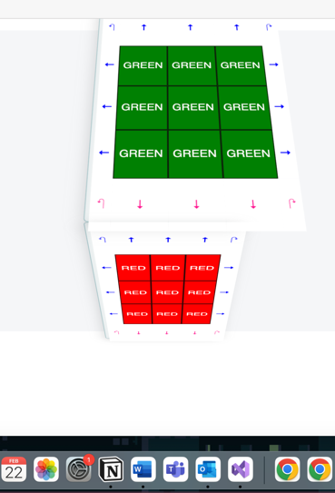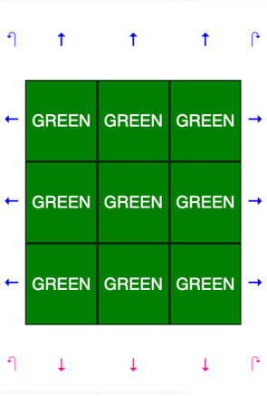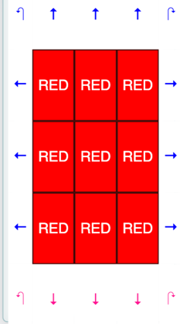

I then investigated into CSS transformations. Using this, the cube can be shifted and rotated however the user pleased whilst making the program more intuitive. To activate 3D space, each face of the cube will need perspective using the transform feature in CSS- I set this at 400 pixels to produce a fairly strong but not extreme 3D effect. Here is some photos of me investigating to find the perfect perspective using the website <https://3dtransforms.desandro.com/> :

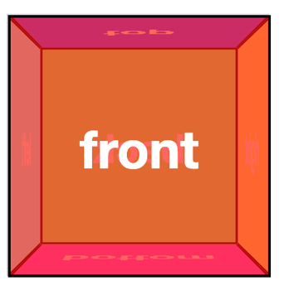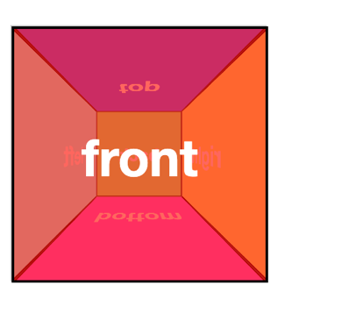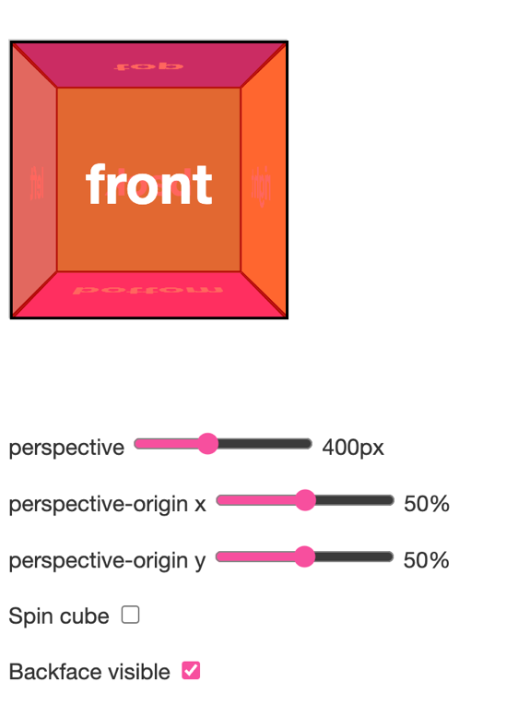

No perspective, essentially 2D but its rotations jolt as it shows the other faces

600 pixels- too much perspective which gives a squished appearance

100 pixels- not very cube like as faces would have different sizes

400 pixels- just right

By using perspective, we introduce a third dimension (along with the X and Y) the Z dimension. To do this I used the following transform functions in my project.

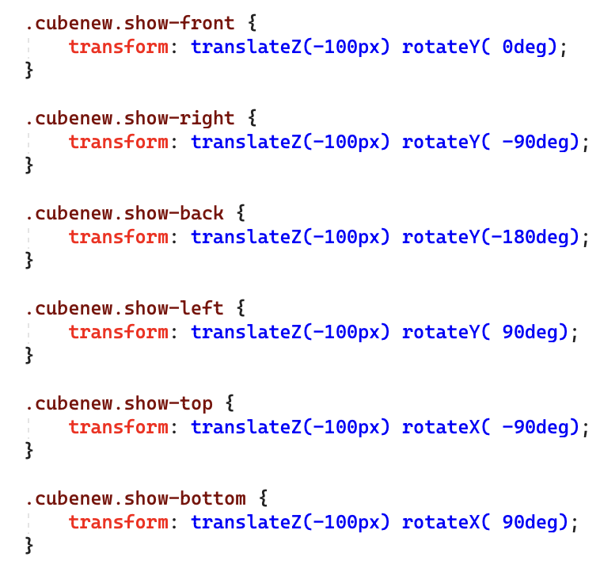

This translates all the functions along the Z axis, positioning positive values closer to the viewer and negative values further away. The show left and right and front should be much closer to the user (hence the 0, 90 and -90) than the show back (hence the -180). I then started to create 6 elements (child elements of the cube) for all 6 faces of the cube and positioned them on top of each other. I did notice however the text ‘front’ became pixelized, after research I found that when applying a 3D transformation, the browser itself takes a screenshot of the element and re-renders the pixels once the 3D transformations are applied. To resolve the distortion, we push back the 3D object so that the front face will be positioned back at the Z origin.

#### The decision

Each display has its own advantages and disadvantages, but I decided to go with the 3D design at the end because of the troubles of trying to represent 3D space in 2D, the logical changes of the cube was too hard to implement, and the current orientation of the cube wasn’t communicating between rotations and the face class to the DisplayFace method. After making these changes, I decided to re-start my project, the following is the testing of my final project.

### Testing for the final CSS 3D cube rendering

In the testing tables below you will find a decomposition of each system into the key aspects of my project and investigates on how successful each subsection was, supplying either photo or video evidence for each. If a section has failed the test, improvements should be trailed to investigate into the matter and a suitable conclusion should be drawn. Some of the evidence may look different to the final program in the video because of its current development stage. All testing uses the cubes face colours green,yellow,white,red,orange,blue.

|  |  |  |  |  |
| --- | --- | --- | --- | --- |
| **Test number** | **Description** | **Test data** | **Expected outcome** | **Pass/Fail (evidence)** |
| Test of user | inputs |  |  |  |
| 1.1 | User should rotate the cube when the corresponding arrow on the screen is pressed | Display all colours of the cube using the relative button | Should output the colours: green, red, yellow, blue, orange and white in any order in a Rubik’s Cube shape with correct animations. | See screenshot 1.1 and test video 1 |
| 1.2 | User should be able to write a list of face colours to enter to see a customisable cube with their suggested colours | Colour the cube red,orange,yellow,  Green,blue and White and rotate the cube to show all the faces | All faces should show the colours red,orange, yellow, orange, blue and white | See screenshot 1.2 |
| 1.3.1 | A start scrambling button drop down list validation | The user should select the difficulty from a drop down list from easy, medium, hard and custom. If custom is pressed, enter “1000”, then enter “thirty two” then enter “20” | Shows suitable error messages for “thirty two” and integer 1000 such as “Invalid input: string has been entered” and “Invalid input: number is too large” | See screenshot 1.3.1 |
| 1.3.2 | A start scrambling button starts scrambling | Select easy and show the scrambling algorithm being dynamically applied to the cube. | Show the before and after of the scrambling button being clicked | See screenshot 1.3.2 |
| 1.4 | A start solving button | Press the button with the mouse | The program should start running | See screenshot 1.4 |
| Basic | Functions |  |  |  |
| 2.1 | Display Cube | Rotate the cube from all sides using buttons | The cube should display all sides | See screenshot  2.1 |
| 2.2 | Perform Rotate Right-hand Column clockwise and anticlockwise | Shift the righthand column like it is on an actual cube, press the relevant testing button, then press the right hand column anticlockwise button. | The righthand column should have shifted, considering the orientation of the face. Once the anticlockwise button is pressed, the cube should return to its original state. | See screenshot 2.2 |
| 2.3 | Perform Rotate Left-Hand Column clockwise and anticlockwise | Shift the lefthand column like it is on an actual cube, press the relevant testing button, then press the left hand column anticlockwise button. | The lefthand column should have shifted, considering the orientation of the face. Once the anticlockwise button is pressed, the cube should return to its original state. | See screenshot 2.3 |
| 2.4 | Perform Rotate Up Row clockwise and anticlockwise | Shift the upper row ilke it is on an actual cube, press the relevant testing button, then press the upper row anticlockwise button. | The upper row should have shifted, considering the orientation of the face. Once the anticlockwise button is pressed, the cube should return to its original state. | See screenshot 2.4 |
| 2.5 | Perform Rotate Down Row clockwise and anticlockwise | Shift the bottom row like it is on an actual cube, press the relevant testing button, then press the bottom row anticlockwise button. | The bottom row should have shifted, considering the orientation of the face. Once the anticlockwise button is pressed, the cube should return to its original state. | See screenshot 2.5 |
| 2.6 | Perform Rotate Front Clockwise and Anticlockwise | Shift the front like it is on an actual cube, press the relevant testing button, then press the front anticlockwise button. | The front should have shifted, considering the orientation of the face. Once the anticlockwise button is pressed, the cube should return to its original state. | See screenshot 2.6 |
| 2.7 | Perform Rotate Back Clockwise and Anticlockwise | Shift the back like it is on an actual cube, press the relevant testing button, then press the back anticlockwise button. | The back should have shifted, considering the orientation of the face. Once the anticlockwise button is pressed, the cube should return to its original state. | See screenshot 2.7 |
| 2.8 | Matrix transformation | A face can be rotated clockwise shifting all the relative cubies – try with the input red,red,red, red, green yellow,yellow,white, blue. Try clockwise, anticlockwise and half rotation. | A cube face should have a clockwise matrix rotation of the cubies (as described in the design section) | See screenshot 2.8 |
| 2.9 | Testing rotations | Perform the algorithm R U R’ U’ 6 times to see if it returns to normal after | Should return to solved after | See screenshot 2.9 |
| Validating | the user input |  |  |  |
| 3.1 | Ensure that the user has inputted 6 of each face colour into the cube | Input the five face colours: “red, white, orange , green, blue” | A suitable error message should be displayed saying that 6 faces has not been entered | See screenshot 3.1 |
| 3.2 | Ensure that no 2 opposite colour stickers are on the same cubie and all the corner cubies are correct | Input the following colours:  Green on front  Orange on left  Red on right  Yellow on back  White on top  Blue on bottom | All corners are invalid, show a suitable error message | See screenshot 3.2 |
| 3.3 | Ensure that all edge cubies are correct | Input the following colours:  Green on front  Orange on left  Red on right  Yellow on back  White on top  Blue on bottom | A suitable error message should be displayed saying that there is an edge which has been inputted incorrectly, saying what colours are in it. | See screenshot 3.3 |
| 3.4 | Ensure that the user entered 6 different face colours to fill in the face. | Enter 7 colours in the list “red,yellow,white,red, orange, white” | Suitable error message should be displayed prompting user to re-enter their faces | See screenshot 3.4 |
| 3.5 | Ensure that the user entered 6 valid colours out of red, yellow, orange, white, green and blue. | Enter the list “red, YelRow, purple, Blue,green,Red” | Suitable error message should be displayed prompting user to re-enter until it is valid | See screenshot 3.5 |
| 3.6 | After inputting a valid cube and pressing ‘start solving’, a message should display saying ‘cube is valid’ | Input a valid cube and press ‘start solving’ | A message should be displayed on the screen saying that the cube is valid | See screenshot 3.6 |
| 3.7 | Is cube solved? | Input a solved cube into the program and press ‘start solving’ | A message should be displayed on the screen saying the cube is (already) solved! | See screenshot 3.7 |
| Scrambling | And solving |  |  |  |
| 4.1 | User inputs their difficulty level | The program generates a scrambling pattern and applies it to the cube | The cube is shown scrambled using the scrambling instructions recursively generated | See screenshot 4.1 |
| 4.2 | Reverse the scrambling instruction list and push the values onto a stack | After pressing ‘start solving’ on a scrambled cube | show that the scrambled cube instruction list is the opposite of the anti instructions list by adding breakpoints into the code | See screenshot 4.2 |
| 4.3 | Popping off values in stack to an instructionSolved list | After pressing ‘start solving’ on a scrambled cube | Screenshot the instructionSolved this and ensure that it is the reversed version of the elements in the stack, also making sure that the instructions are simplified | See screenshot 4.3 |
| 4.4 | Simplify instructions, if two 90-degree turns are used, they should be conjoined into one 180-degree turn. | Input a cube that will eventually use the conjoining feature | The program should not display two 90 degree turns but rather display a 2 in front of the instruction (i.e., 2F) | See screenshot 4.4 |
| 4.5 | Display messages to keep the user motivated | After pressing ‘start solving’ on a scrambled cube | A message which displays “Keep going halfway there” should be announced after the cube is half solved. | See screenshot 4.5 |
| 4.6 | Solve | After pressing ‘start solving’ on a scrambled cube | Cube should unscramble the cube according to the users clicks. | See final screenshots |
| Output |  |  |  |  |
| 5.1 | Display current instruction | Test with adding a right algorithm to the instruction list and display the first instruction U | Displays the current instruction U | See Screenshot 5.1 |
| 5.1.2 | Undo buttons and Redo buttons | Press the next button to see the next two instruction and pressing the undo button to see the previous two instruction | Previous and next instructions are displayed on the screen – starting with U then R then U’ then R then U | See Screenshot 5.1.2 |
| 5.1.3 | Preventing an error with the undo and redo button | After the first instruction is displayed, press undo twice | A suitable error message should be displayed like ‘no more instructions to undo’ | See Screenshot 5.1.3 |

### Testing evidence

#### 1.1

Below are screenshots of the different faces displayed when the relevant button is clicked. These prove the concept of the different faces shown in 3D space.

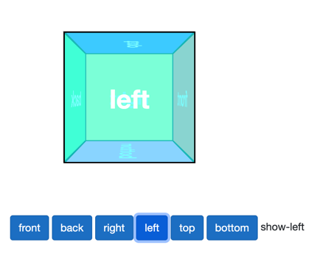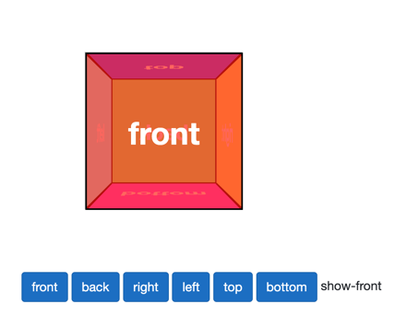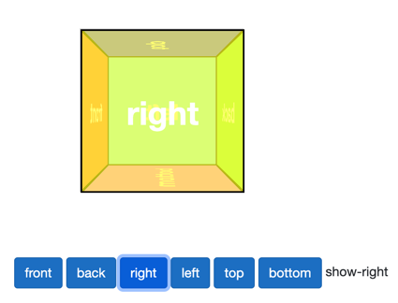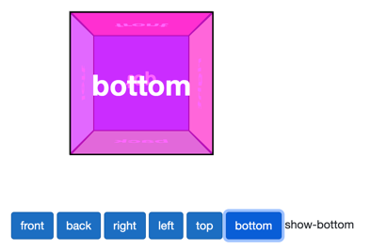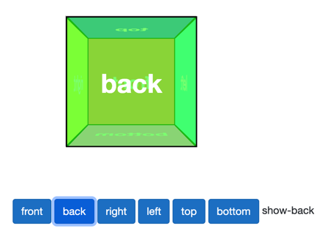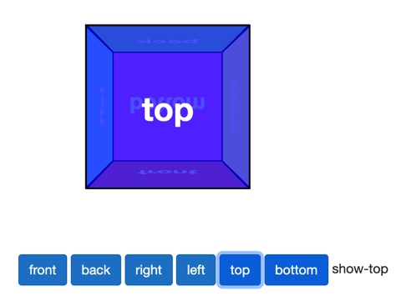

I then added a 3x 3 grid onto of each face to actually represent a Rubiks Cube.

Here I have taken screenshot of all the faces being shown when their relative button is pressed. As this is a screenshot its animations are not shown, please refer to test video 1 to see the CSS 3D rotations.

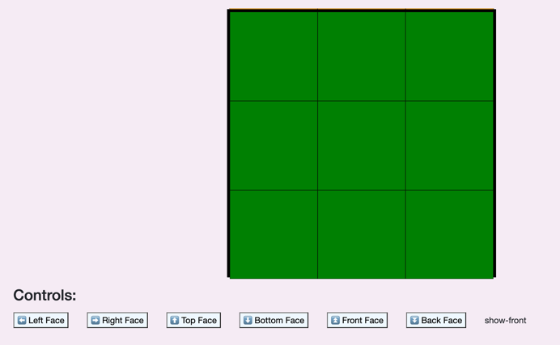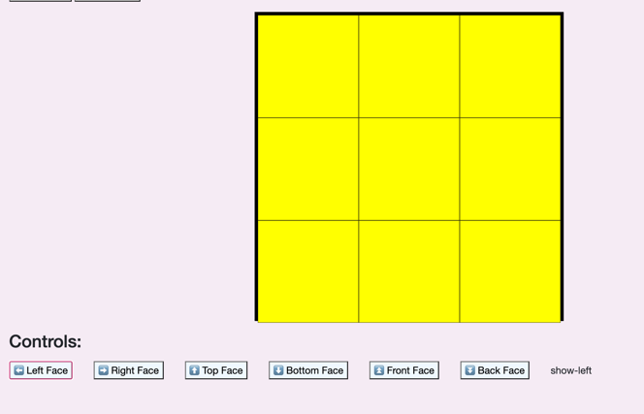

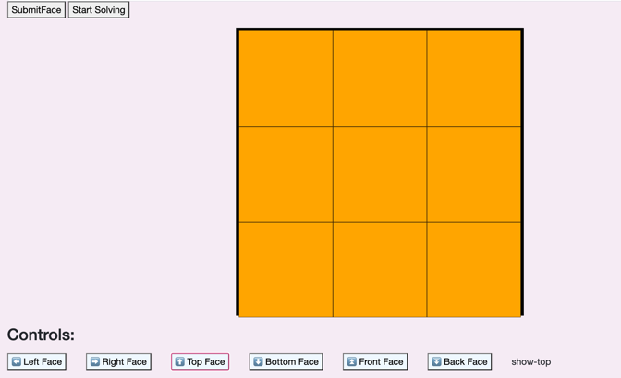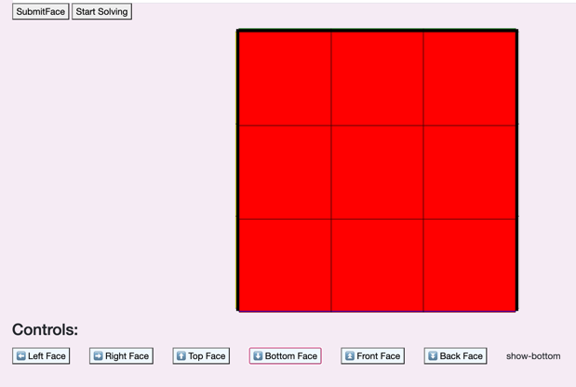

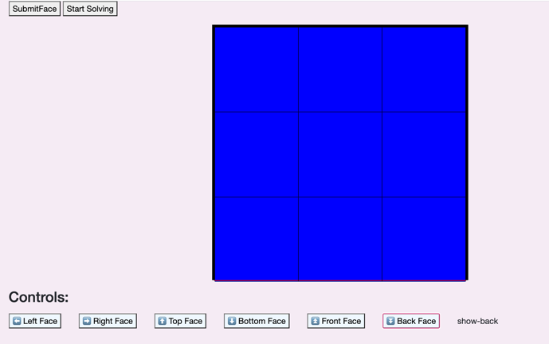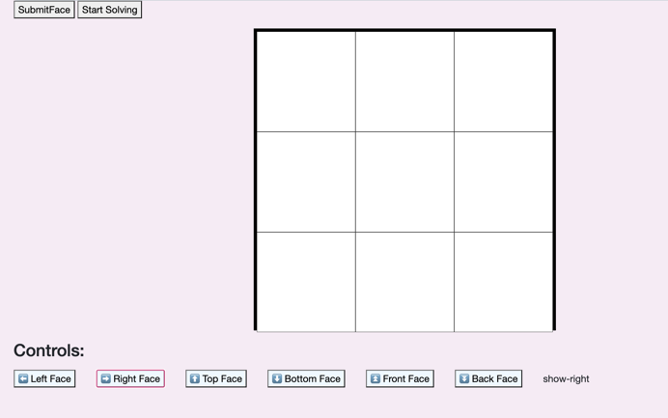

Luckily I was able to use all of the same code as before but slightly alter it to make it link with the 3D cube model. As you will see further down this section, almost all the validation is identical to how it was before, but I now don’t need to worry about the current orientation of the cube while implementing new faces and moves.

#### 1.2

Below is a screenshot of me adding colours to the faces of the cube:

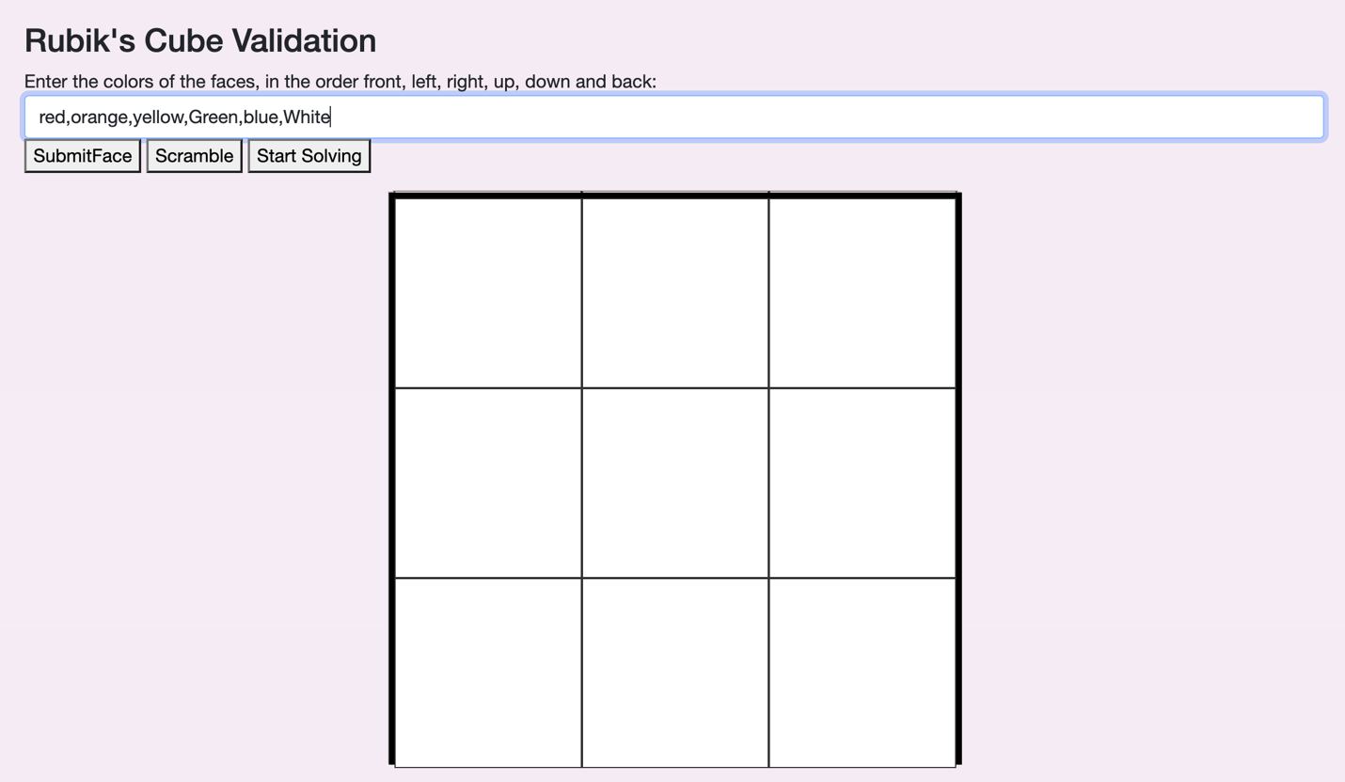

And here are the results:

|  |  |  |  |  |  |
| --- | --- | --- | --- | --- | --- |
| Front Face | Left Face | Right Face | Up Face | Down Face | Back Face |
|  |  |  |  |  |  |

As you can see the correct colours were outputted on the correct face whilst some of the inputs were capitalised and some were not: therefore this test is significant and has passed.

#### 1.3.1

Below is a screenshot of what the scrambling button looks like and the dropdown list which occurs when selecting the scrambling difficulty.

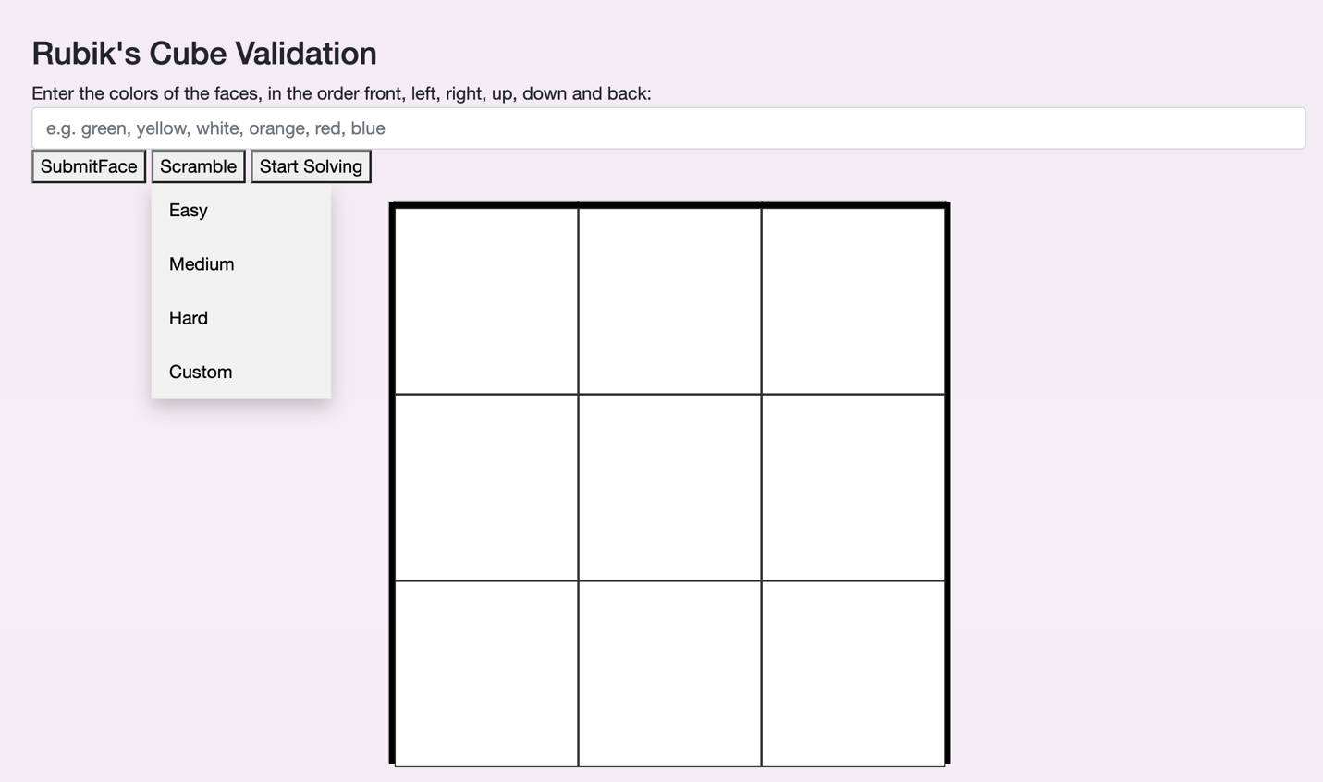

As you can see from the screenshot below, when the custom scrambling button is pressed, a textbox occurs with a place for the user to input how many instructions they want to scramble. This number is limited to 100 to reduce the processing power needed to run the program. An integer must also be entered otherwise an error is producing. Below is an example of each error occurring. 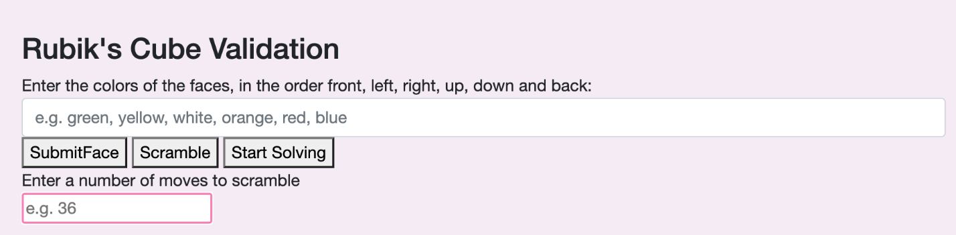

Success message when a valid scrambling number is entered:

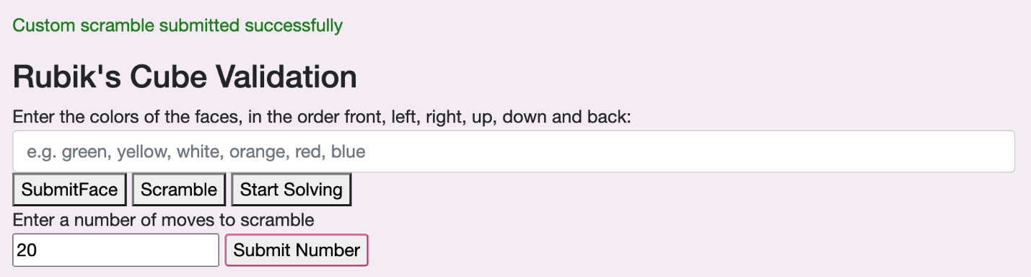

Error message when “thirty two” is entered:

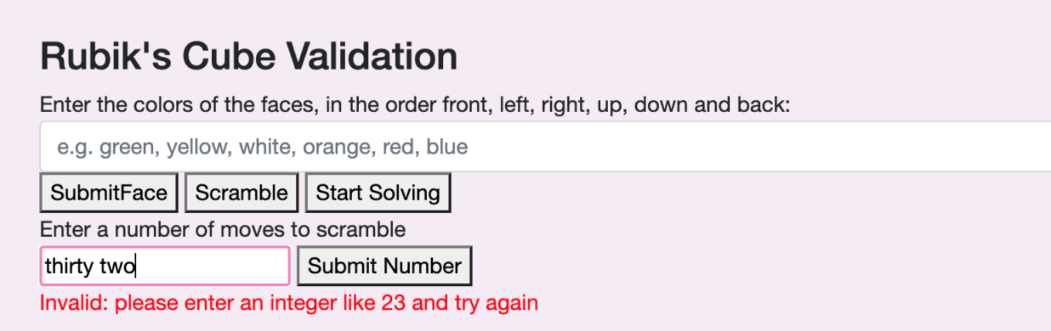

Error message when 1000 is entered: 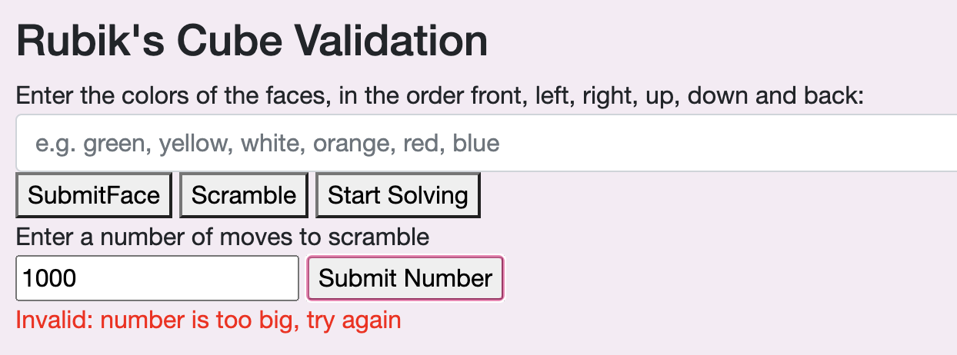

Therefore the validation techniques for the user input has been implemented successfully.

#### 1.3.2

Below is a screenshot of the cube options green,yellow,white,red,orange,blue being inputted for the faces and the easy scrambling button being pressed and its relevant output. This is more of a proof of concept, the rotations did not work well at this point in time, but it just proves that the cube can apply different moves to scramble it.

|  |  |
| --- | --- |
| Before | After |
|  | Shape  Description automatically generated  Face 0 |
| Face 1 |  |
| Face 2 |  |
| Face 3 |  |
| Face 4 |  |
| Face 5 |  |

#### 1.4

Again, this test is more of a proof of concept, the cubes rotations were not fully done at this point- please refer to the result screenshots to see all the components working together.

I implemented the start solving button in the same way as the scrambling instruction method- but I noticed this error coming up on the Blazor page.



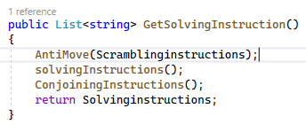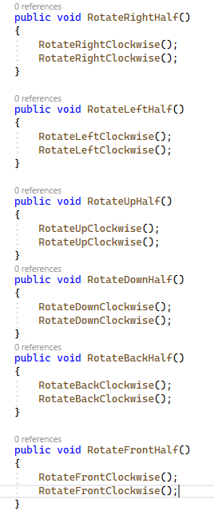I then looked in the code and saw that the program was conjoining the instructions before applying the solver, and it didn’t recognise ‘U 2’. I then went and implemented each of these into the dictionary using the methods I had already created.

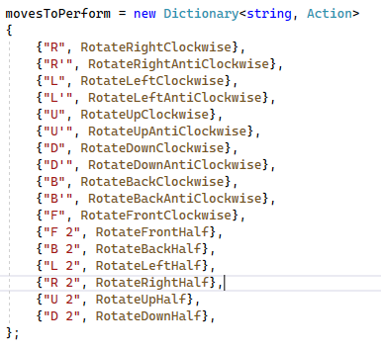

Here are the results of the user pressing start solving once the cube has been scrambled (this is after pressing the next instruction twice to perform the next moves)

|  |  |
| --- | --- |
| Scrambled state |  |
| Pressing start solving and showing the current instruction |  |
| Pressing start solving and pressing the next instruction |  |

Hence, the program can apply the reverse scrambling instructions to eventually solve the cube, deeming this test a success.

#### 2.1

Here are the results after each of the see front, see back ,see up, see down, see right , see left after implementing a control panel on the website.

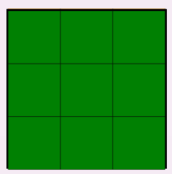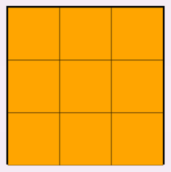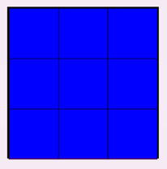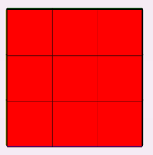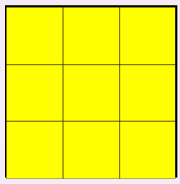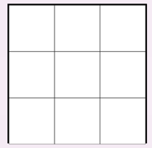

#### 2.2

At first, my cube wasn’t performing correctly, and the rotate right would only work twice before it stopped. Below is a screenshot of what was happening.

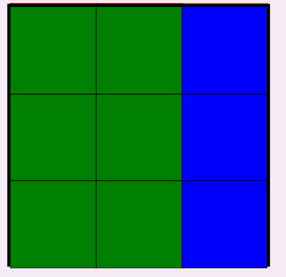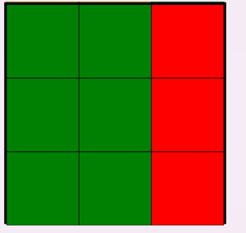

As you can see, this is not working- it is stuck on the blue column. I suspected it was something to do with how I am extracting different columns so I opted to trace through my current algorithms to see what was happening.

|  |  |  |  |
| --- | --- | --- | --- |
| Face Number | Content | Calls to Algorithms |  |
| 0 | “green,green,green  Green,green,green  Green,green,green” |  |  |
| 1 | “yellow,yellow,yellow”  “yellow,yellow,yellow”  “yellow,yellow,yellow” |  |  |
| 2 | “white,white,white”  “white,white,white”  “white,white,white” |  |  |
| 3 | “red,red,red”  “red,red,red”  “red,red,red” |  |  |
| 4 | “orange,orange,orange”  “orange,orange,orange”  “orange,orange,orange” |  |  |
| 5 | “blue,blue,blue”  “blue,blue,blue”  “blue,blue,blue” |  |  |
|  |  | Right Algorithm Called (1) |  |
|  |  | UpdateAllFacesAndTheir Orientation(1) |  |
| 0 | “green,green,red  Green,green,red  Green,green,red” |  |  |
| 1 | “yellow,yellow,yellow”  “yellow,yellow,yellow”  “yellow,yellow,yellow” |  |  |
| 2 | “white,white,white”  “white,white,white”  “white,white,white” |  |  |
| 3 | “red,red,blue”  “red,red,blue”  “red,red,blue” |  |  |
| 4 | “orange,orange,green”  “orange,orange,green”  “orange,orange,green” |  |  |
| 5 | “orange,blue,blue”  “orange,blue,blue”  “orange,blue,blue” |  |  |
|  |  | Right Algorithm Called (2) |  |

|  |  |  |  |
| --- | --- | --- | --- |
| Right Algorithm (1) |  |  |  |
| Sequence Result= 04532 | Sequence key = 00 |  |  |
| Face0 | “green,green,green” |  |  |
| Face1 | “orange,orange,orange” |  |  |
| Face2 | “blue,blue,blue” |  |  |
| Face3 | “red,red,red” |  |  |
| FaceList[0] | “green,green,red”  “green,green,red”  “green,green,red” |  |  |
| FaceList[4] | “orange,orange,green”  “orange,orange,green”  “orange,orange,green” |  |  |
| FaceList[5] | “orange,blue,blue”  “orange,blue,blue”  “orange,blue,blue” | This is correct for the orientation it is in. |  |
| FaceList[3] | “red,red,blue”  “red,red,blue”  “red,red,blue” |  |  |

|  |  |  |  |
| --- | --- | --- | --- |
| Right Algorithm (2) |  |  |  |
| Sequence Result= 04532 | Sequence key = 00 |  |  |
| Face0 | “red,red,red” |  |  |
| Face1 | “green,green,green” |  |  |
| Face2 | “blue,blue,blue” | ERROR! Should take out “orange,orange,orange” |  |
| Face3 | “blue,blue,blue” |  |  |
| FaceList[0] | “green,green,blue”  “green,green,blue”  “green,green,blue” |  |  |
| FaceList[4] | “orange,orange,red”  “orange,orange,red”  “orange,orange,red” |  |  |
| FaceList[5] | “green,blue,blue”  “green,blue,blue”  “green,blue,blue” |  |  |
| FaceList[3] | “red,red,blue”  “red,red,blue”  “red,red,blue” | KNOCK ON ERROR This is now incorrect, it should be orange in the right hand column. |  |

|  |  |  |  |  |  |
| --- | --- | --- | --- | --- | --- |
| UpdateAllFacesAndTheirOrientation (1) | Face Index | Face Orientation | Rotation wanted | Number of Rotations | Matrix Rotations Performed |
| FaceList[0] | 0 | 0 | 0 | 0 | 0 |
| FaceList[1] | 1 | 0 | 0 | 0 | 0 |
| FaceList[2] | 2 | 0 | 0 | 0 | 0 |
| FaceList[3] | 3 | 0 | 0 | 0 | 0 |
| FaceList[4] | 4 | 0 | 0 | 0 | 0 |
| FaceList[5] | 5 | 2 | 2 | 0 | 0 |

After tracing through, my intutition was correct, and the program is not updating and selecting the correct rows, I had a couple ideas of how to deal with this, so I got a piece of paper and a pen and decided I was now going to think of my faces not as a cube but as a *list of faces.* I went back to the drawing board and created a mimic console project and attempted the rotations again. Below is what the cube faces will be set to when the program starts running.

|  |  |  |  |  |  |
| --- | --- | --- | --- | --- | --- |
| Face 0 | Face 1 | Face 2 | Face 3 | Face 4 | Face 5 |
| |  |  |  | | --- | --- | --- | | **1** | **2** | **3** | | **4** | **5** | **6** | | **7** | **8** | **9** | | |  |  |  | | --- | --- | --- | | **1** | **2** | **3** | | **4** | **5** | **6** | | **7** | **8** | **9** | | |  |  |  | | --- | --- | --- | | **1** | **2** | **3** | | **4** | **5** | **6** | | **7** | **8** | **9** | | |  |  |  | | --- | --- | --- | | **1** | **2** | **3** | | **4** | **5** | **6** | | **7** | **8** | **9** | | |  |  |  | | --- | --- | --- | | **1** | **2** | **3** | | **4** | **5** | **6** | | **7** | **8** | **9** | | |  |  |  | | --- | --- | --- | | **1** | **2** | **3** | | **4** | **5** | **6** | | **7** | **8** | **9** | |

After one right clockwise algorithm, the cubes faces should be updated to the following:

|  |  |  |  |  |  |
| --- | --- | --- | --- | --- | --- |
| Face 0 | Face 1 | Face 2 | Face 3 | Face 4 | Face 5 |
| |  |  |  | | --- | --- | --- | | **1** | **2** | **3** | | **4** | **5** | **6** | | **7** | **8** | **9** | | |  |  |  | | --- | --- | --- | | **1** | **2** | **3** | | **4** | **5** | **6** | | **7** | **8** | **9** | | |  |  |  | | --- | --- | --- | | **7** | **4** | **1** | | **8** | **5** | **2** | | **0** | **6** | **3** | | |  |  |  | | --- | --- | --- | | **1** | **2** | **7** | | **4** | **5** | **4** | | **7** | **8** | **1** | | |  |  |  | | --- | --- | --- | | **1** | **2** | **3** | | **4** | **5** | **6** | | **7** | **8** | **9** | | |  |  |  | | --- | --- | --- | | **9** | **2** | **3** | | **6** | **5** | **6** | | **3** | **8** | **9** | |

Changes:

* Face 0 column 2 has been updated with column 2 from face 3 (extracted top to bottom)
* Face 1 is unchanged
* Face 2 has had 1 clockwise matrix rotation applied
* Face 3 column 2 has been updated had column 1 from face 5 (extracted bottom to top)
* Face 4 column 2 has been updated with face 0 column 2 (top to bottom)
* Face 5 column 0 has been updated with column 2 face 4 (bottom to top)

Another right clockwise:

|  |  |  |  |  |  |
| --- | --- | --- | --- | --- | --- |
| Face 0 | Face 1 | Face 2 | Face 3 | Face 4 | Face 5 |
| |  |  |  | | --- | --- | --- | | **1** | **2** | **7** | | **4** | **5** | **4** | | **7** | **8** | **1** | | |  |  |  | | --- | --- | --- | | **1** | **2** | **3** | | **4** | **5** | **6** | | **7** | **8** | **9** | | |  |  |  | | --- | --- | --- | | **9** | **8** | **7** | | **6** | **5** | **4** | | **3** | **2** | **1** | | |  |  |  | | --- | --- | --- | | **1** | **2** | **3** | | **4** | **5** | **6** | | **7** | **8** | **9** | | |  |  |  | | --- | --- | --- | | **1** | **2** | **3** | | **4** | **5** | **6** | | **7** | **8** | **9** | | |  |  |  | | --- | --- | --- | | **9** | **2** | **3** | | **6** | **5** | **6** | | **3** | **8** | **9** | |

Changes:

* Face 0 column 2 has been updated with face 3 column 3 (top to bottom)
* Face 1 is unchanged
* Face 2 has had 1 clockwise matrix rotation applied
* Face 3 column 2 has been updated with face 5 column 1 (bottom to top)
* Face 4 column 2 has been updated with face 0 column 2 (top to bottom)
* Face 5 column 0 has been updated with face 4 column 2 (bottom to top )

Another right clockwise:

|  |  |  |  |  |  |
| --- | --- | --- | --- | --- | --- |
| Face 0 | Face 1 | Face 2 | Face 3 | Face 4 | Face 5 |
| |  |  |  | | --- | --- | --- | | **1** | **2** | **3** | | **4** | **5** | **6** | | **7** | **8** | **9** | | |  |  |  | | --- | --- | --- | | **1** | **2** | **3** | | **4** | **5** | **6** | | **7** | **8** | **9** | | |  |  |  | | --- | --- | --- | | **3** | **6** | **9** | | **2** | **5** | **8** | | **1** | **4** | **7** | | |  |  |  | | --- | --- | --- | | **1** | **2** | **3** | | **4** | **5** | **6** | | **7** | **8** | **9** | | |  |  |  | | --- | --- | --- | | **1** | **2** | **7** | | **4** | **5** | **4** | | **7** | **8** | **1** | | |  |  |  | | --- | --- | --- | | **9** | **2** | **3** | | **6** | **5** | **6** | | **3** | **8** | **9** | |

Changes:

* Face 0 column 2 is updated with face 3 column 2 (top to bottom)
* Face 1 is unchanged
* Face 2 has had 1 clockwise matrix rotation applied
* Face 3 column 2 is updated with face 5 column 0 (bottom to top)
* Face 4 column 2 is updated with face 0 column 2 (top to bottom)
* Face 5 column 0 is updated with face 4 column 2 (bottom to top)

Another right clockwise is applied:

|  |  |  |  |  |  |
| --- | --- | --- | --- | --- | --- |
| Face 0 | Face 1 | Face 2 | Face 3 | Face 4 | Face 5 |
| |  |  |  | | --- | --- | --- | | **1** | **2** | **3** | | **4** | **5** | **6** | | **7** | **8** | **9** | | |  |  |  | | --- | --- | --- | | **1** | **2** | **3** | | **4** | **5** | **6** | | **7** | **8** | **9** | | |  |  |  | | --- | --- | --- | | **1** | **2** | **3** | | **4** | **5** | **6** | | **7** | **8** | **9** | | |  |  |  | | --- | --- | --- | | **1** | **2** | **3** | | **4** | **5** | **6** | | **7** | **8** | **9** | | |  |  |  | | --- | --- | --- | | **1** | **2** | **3** | | **4** | **5** | **6** | | **7** | **8** | **9** | | |  |  |  | | --- | --- | --- | | **1** | **2** | **3** | | **4** | **5** | **6** | | **7** | **8** | **9** | |

Changes:

* Face 0 column 2 is updated with face 3 column 2 (top to bottom)
* Face 1 is unchanged
* Face 2 has had 1 clockwise matrix rotation applied
* Face 3 column 2 is updated with face 5 column 0 (bottom to top)
* Face 4 column 2 is updated with face 0 column 2 (top to bottom)
* Face 5 column 0 is updated with face 4 column 2 (bottom to top)

And the cube is back in the state it started with after 4 right clockwise rotations. As you can see, sometimes the cubies need to be updated top to bottom and sometimes the cubies need to be updated from bottom to top: this is because of the back face being in orientation 2 compared to the orientation 0 the others are in. A way to get around this is to store face 5 in orientation 0 and display it in orientation 2. Below is another attempt to implement a right algorithm with face 5 starting in orientation 0.

|  |  |  |  |  |  |
| --- | --- | --- | --- | --- | --- |
| Face 0 | Face 1 | Face 2 | Face 3 | Face 4 | Face 5 |
| |  |  |  | | --- | --- | --- | | **1** | **2** | **3** | | **4** | **5** | **6** | | **7** | **8** | **9** | | |  |  |  | | --- | --- | --- | | **1** | **2** | **3** | | **4** | **5** | **6** | | **7** | **8** | **9** | | |  |  |  | | --- | --- | --- | | **1** | **2** | **3** | | **4** | **5** | **6** | | **7** | **8** | **9** | | |  |  |  | | --- | --- | --- | | **1** | **2** | **3** | | **4** | **5** | **6** | | **7** | **8** | **9** | | |  |  |  | | --- | --- | --- | | **1** | **2** | **3** | | **4** | **5** | **6** | | **7** | **8** | **9** | | |  |  |  | | --- | --- | --- | | **1** | **2** | **3** | | **4** | **5** | **6** | | **7** | **8** | **9** | |

After a right clockwise algorithm is applied:

|  |  |  |  |  |  |
| --- | --- | --- | --- | --- | --- |
| Face 0 | Face 1 | Face 2 | Face 3 | Face 4 | Face 5 |
| |  |  |  | | --- | --- | --- | | **1** | **2** | **3** | | **4** | **5** | **6** | | **7** | **8** | **9** | | |  |  |  | | --- | --- | --- | | **1** | **2** | **3** | | **4** | **5** | **6** | | **7** | **8** | **9** | | |  |  |  | | --- | --- | --- | | **7** | **4** | **1** | | **8** | **5** | **2** | | **9** | **6** | **3** | | |  |  |  | | --- | --- | --- | | **1** | **2** | **3** | | **4** | **5** | **6** | | **7** | **8** | **9** | | |  |  |  | | --- | --- | --- | | **1** | **2** | **3** | | **4** | **5** | **6** | | **7** | **8** | **9** | | |  |  |  | | --- | --- | --- | | **1** | **2** | **3** | | **4** | **5** | **6** | | **7** | **8** | **9** | |

Changes:

* Face 0 column 2 has been updated with face 3 column 2
* Face 1 is unchanged
* Face 2 has had 1 clockwise matrix rotation applied
* Face 3 column 2 has been updated with face 5 column 2
* Face 4 column 2 has been updated with face 0 column 0
* Face 5 column 2 has been updated with face 4 column 2

All the above are top to bottom which may be easier to deal with then then the previous version

If the user wants to view the blue face, a copy of the face will be stored in a temporary face and 2 clockwise matrix rotations are applied to turn it into orientation 2.

After a right clockwise rotation is applied:

|  |  |  |
| --- | --- | --- |
| **9** | **8** | **7** |
| **6** | **5** | **4** |
| **3** | **2** | **1** |

|  |  |  |  |  |  |
| --- | --- | --- | --- | --- | --- |
| Face 0 | Face 1 | Face 2 | Face 3 | Face 4 | Face 5 |
| |  |  |  | | --- | --- | --- | | **1** | **2** | **3** | | **4** | **5** | **6** | | **7** | **8** | **9** | | |  |  |  | | --- | --- | --- | | **1** | **2** | **3** | | **4** | **5** | **6** | | **7** | **8** | **9** | | |  |  |  | | --- | --- | --- | | **9** | **8** | **7** | | **6** | **5** | **4** | | **3** | **2** | **1** | | |  |  |  | | --- | --- | --- | | **1** | **2** | **3** | | **4** | **5** | **6** | | **7** | **8** | **9** | | |  |  |  | | --- | --- | --- | | **1** | **2** | **3** | | **4** | **5** | **6** | | **7** | **8** | **9** | | |  |  |  | | --- | --- | --- | | **1** | **2** | **3** | | **4** | **5** | **6** | | **7** | **8** | **9** | |

Changes:

* Face 0 column 2 has been updated with face 5 column 2
* Face 1 is unchanged
* Face 2 has had 1 clockwise matrix rotation applied
* Face 3 column 2 has been updated with face 5 column 2
* Face 4 column 2 has been updated with face 0 column 2
* Face 5 column 2 has been updated with face 4 column 2

Temporary face:

|  |  |  |
| --- | --- | --- |
| **9** | **8** | **7** |
| **6** | **5** | **4** |
| **3** | **2** | **1** |

Another right clockwise rotation is performed:

|  |  |  |  |  |  |
| --- | --- | --- | --- | --- | --- |
| Face 0 | Face 1 | Face 2 | Face 3 | Face 4 | Face 5 |
| |  |  |  | | --- | --- | --- | | **1** | **2** | **3** | | **4** | **5** | **6** | | **7** | **8** | **9** | | |  |  |  | | --- | --- | --- | | **1** | **2** | **3** | | **4** | **5** | **6** | | **7** | **8** | **9** | | |  |  |  | | --- | --- | --- | | **3** | **6** | **9** | | **3** | **5** | **8** | | **1** | **4** | **7** | | |  |  |  | | --- | --- | --- | | **1** | **2** | **3** | | **4** | **5** | **6** | | **7** | **8** | **9** | | |  |  |  | | --- | --- | --- | | **1** | **2** | **3** | | **4** | **5** | **6** | | **7** | **8** | **9** | | |  |  |  | | --- | --- | --- | | **1** | **2** | **3** | | **4** | **5** | **6** | | **7** | **8** | **9** | |

Changes:

* Face 0 column 2 has been updated with face 3 column 2
* Face 1 unchanged
* Face 2 has had 1 clockwise matrix rotation applied
* Face 3 column 2 has been updated with face 5 column 2
* Face 4 column 2 has been updated with face 0 column 2
* Face 5 column 2 has been updated with face 4 column 2

Temporary face:

|  |  |  |
| --- | --- | --- |
| **9** | **8** | **7** |
| **6** | **5** | **4** |
| **3** | **2** | **1** |

After a right clockwise rotation is applied:

|  |  |  |  |  |  |
| --- | --- | --- | --- | --- | --- |
| Face 0 | Face 1 | Face 2 | Face 3 | Face 4 | Face 5 |
| |  |  |  | | --- | --- | --- | | **1** | **2** | **3** | | **4** | **5** | **6** | | **7** | **8** | **9** | | |  |  |  | | --- | --- | --- | | **1** | **2** | **3** | | **4** | **5** | **6** | | **7** | **8** | **9** | | |  |  |  | | --- | --- | --- | | **1** | **2** | **3** | | **4** | **5** | **6** | | **7** | **8** | **9** | | |  |  |  | | --- | --- | --- | | **1** | **2** | **3** | | **4** | **5** | **6** | | **7** | **8** | **9** | | |  |  |  | | --- | --- | --- | | **1** | **2** | **3** | | **4** | **5** | **6** | | **7** | **8** | **9** | | |  |  |  | | --- | --- | --- | | **1** | **2** | **3** | | **4** | **5** | **6** | | **7** | **8** | **9** | |

Changes:

* Face 0 column 2 is updated with face 3 column 2
* Face 1 is unchanged
* Face 2 has had 1 clockwise matrix rotation applied
* Face 3 column 2 has been updated with face 5 column 2
* Face 4 column 2 has been updated with face 0 column 2
* Face 5 column 2 has been updated with face 4 column 2

Temporary face:

|  |  |  |
| --- | --- | --- |
| **9** | **8** | **7** |
| **6** | **5** | **4** |
| **3** | **2** | **1** |

For the right anti-clockwise rotation, I did the same as the above to analyse how im going to implement it into the program:

I then implemented this into my project, in each of the following rotation tests, I will show my physical cube vs my programs output.

|  |  |  |
| --- | --- | --- |
| Real-Life | Program After Clockwise | Program After AntiClockwise |
|  |  |  |
|  |  |  |
|  |  |  |
|  |  |  |

#### 2.3

I used the same concept as the right clockwise rotation, but I extracted column 0 instead of column 2 for each rotation. The results are as shown below:

|  |  |  |
| --- | --- | --- |
| Real-Life | Program After Clockwise | Program After Anti Clockwise |
|  |  |  |
|  |  |  |
|  |  |  |
|  |  |  |

#### 2.4

Again , this had a similar problem to the right and left and wasn’t considering the orientation- I opted to trace through the algorithm

|  |  |  |  |
| --- | --- | --- | --- |
| Face Number | Content | Calls to Algorithms |  |
| 0 | “green,green,green  Green,green,green  Green,green,green” |  |  |
| 1 | “yellow,yellow,yellow”  “yellow,yellow,yellow”  “yellow,yellow,yellow” |  |  |
| 2 | “white,white,white”  “white,white,white”  “white,white,white” |  |  |
| 3 | “red,red,red”  “red,red,red”  “red,red,red” |  |  |
| 4 | “orange,orange,orange”  “orange,orange,orange”  “orange,orange,orange” |  |  |
| 5 | “blue,blue,blue”  “blue,blue,blue”  “blue,blue,blue” |  |  |
|  |  | Up Algorithm Called (1) |  |
|  |  | UpdateAllFacesAndTheir Orientation(1) |  |
| 0 | “green,green,red  Green,green,red  Green,green,red” |  |  |
| 1 | “yellow,yellow,yellow”  “yellow,yellow,yellow”  “yellow,yellow,yellow” |  |  |
| 2 | “white,white,white”  “white,white,white”  “white,white,white” |  |  |
| 3 | “red,red,blue”  “red,red,blue”  “red,red,blue” |  |  |
| 4 | “orange,orange,green”  “orange,orange,green”  “orange,orange,green” |  |  |
| 5 | “orange,blue,blue”  “orange,blue,blue”  “orange,blue,blue” |  |  |
|  |  | Right Algorithm Called (2) |  |

|  |  |  |  |
| --- | --- | --- | --- |
| Up Algorithm (1) |  |  |  |
| Sequence Result= 01524 | Sequence key = 00 |  |  |
| Face0 | “green,green,green” |  |  |
| Face1 | “yellow,yellow,yellow” |  |  |
| Face2 | “blue,blue,blue” |  |  |
| Face3 | “white,white,white” |  |  |
| FaceList[0] | “white,white,white”  “green,green,green”  “green,green,green” |  |  |
| FaceList[1] | “green,green,green”  “yellow,yellow,yellow”  “yellow,yellow,yellow” |  |  |
| FaceList[5] | “yellow,yellow,yellow”  “blue,blue,blue”  “blue,blue,blue” | *should maybe be the otherway?* |  |
| FaceList[2] | “blue,blue,blue”  “white,white,white”  “white,white,white” |  |  |

|  |  |  |  |
| --- | --- | --- | --- |
| Up Algorithm (2) |  |  |  |
| Sequence Result= 01524 | Sequence key = 00 |  |  |
| Face0 | “white,white,white” |  |  |
| Face1 | “green,green,green” |  |  |
| Face2 | “blue,blue,blue” | ERROR! Should take out “yellow,yellow,yellow” |  |
| Face3 | “blue,blue,blue” |  |  |
| FaceList[0] | “blue,blue,blue”  “green,green,green”  “green,green,green” |  |  |
| FaceList[1] | “white,white,white”  “yellow,yellow,yellow”  “yellow,yellow,yellow” |  |  |
| FaceList[5] | “green,green,green”  “blue,blue,blue”  “blue,blue,blue” |  |  |
| FaceList[2] | “blue,blue,blue”  “white,white,white”  “white,white,white” | KNOCK ON ERROR This is now incorrect, it should be orange in the right hand column. |  |

|  |  |  |  |  |  |
| --- | --- | --- | --- | --- | --- |
| UpdateAllFacesAndTheirOrientation (1) | Face Index | Face Orientation | Rotation wanted | Number of Rotations | Matrix Rotations Performed |
| FaceList[0] | 0 | 0 | 0 | 0 | 0 |
| FaceList[1] | 1 | 0 | 0 | 0 | 0 |
| FaceList[2] | 2 | 0 | 0 | 0 | 0 |
| FaceList[3] | 3 | 0 | 0 | 0 | 0 |
| FaceList[4] | 4 | 0 | 0 | 0 | 0 |
| FaceList[5] | 5 | 2 | 2 | 0 | 0 |

I then decided to work through each step one by one as I found this helpful for the right and left algorithms. I used the second approach where I would display the back face differently to how I store it.

|  |  |  |  |  |  |
| --- | --- | --- | --- | --- | --- |
| Face 0 | Face 1 | Face 2 | Face 3 | Face 4 | Face 5 |
| |  |  |  | | --- | --- | --- | | **1** | **2** | **3** | | **4** | **5** | **6** | | **7** | **8** | **9** | | |  |  |  | | --- | --- | --- | | **1** | **2** | **3** | | **4** | **5** | **6** | | **7** | **8** | **9** | | |  |  |  | | --- | --- | --- | | **1** | **2** | **3** | | **4** | **5** | **6** | | **7** | **8** | **9** | | |  |  |  | | --- | --- | --- | | **1** | **2** | **3** | | **4** | **5** | **6** | | **7** | **8** | **9** | | |  |  |  | | --- | --- | --- | | **1** | **2** | **3** | | **4** | **5** | **6** | | **7** | **8** | **9** | | |  |  |  | | --- | --- | --- | | **1** | **2** | **3** | | **4** | **5** | **6** | | **7** | **8** | **9** | |

After an up clockwise algorithm is applied:

|  |  |  |  |  |  |
| --- | --- | --- | --- | --- | --- |
| Face 0 | Face 1 | Face 2 | Face 3 | Face 4 | Face 5 |
| |  |  |  | | --- | --- | --- | | **1** | **2** | **3** | | **4** | **5** | **6** | | **7** | **8** | **9** | | |  |  |  | | --- | --- | --- | | **1** | **2** | **3** | | **4** | **5** | **6** | | **7** | **8** | **9** | | |  |  |  | | --- | --- | --- | | **9** | **8** | **7** | | **4** | **5** | **6** | | **7** | **8** | **9** | | |  |  |  | | --- | --- | --- | | **1** | **2** | **3** | | **4** | **5** | **6** | | **7** | **8** | **9** | | |  |  |  | | --- | --- | --- | | **7** | **4** | **1** | | **8** | **5** | **2** | | **9** | **6** | **3** | | |  |  |  | | --- | --- | --- | | **1** | **2** | **3** | | **4** | **5** | **6** | | **3** | **2** | **1** | |

Changes:

* Face 0 row 0 has been updated with face 2 row 0
* Face 1 row 0 has been updated with face 0 row 0
* Face 2 row 0 has been updated with face 5 row 2 (backwards)
* Face 3 has been unchanged
* Face 4 has had 1 clockwise matrix rotation applied
* Face 5 row 2 has been updated with face 1 row 0 (backwards)

Temporary face updated:

|  |  |  |
| --- | --- | --- |
| **1** | **2** | **3** |
| **6** | **5** | **4** |
| **3** | **2** | **1** |

*To undo the pattern:* (ignore step this is to work out the anit-clockwise rotation)

|  |  |  |  |  |  |
| --- | --- | --- | --- | --- | --- |
| Face 0 | Face 1 | Face 2 | Face 3 | Face 4 | Face 5 |
| |  |  |  | | --- | --- | --- | | **1** | **2** | **3** | | **4** | **5** | **6** | | **7** | **8** | **9** | | |  |  |  | | --- | --- | --- | | **1** | **2** | **3** | | **4** | **5** | **6** | | **7** | **8** | **9** | | |  |  |  | | --- | --- | --- | | **1** | **2** | **3** | | **4** | **5** | **6** | | **7** | **8** | **9** | | |  |  |  | | --- | --- | --- | | **1** | **2** | **3** | | **4** | **5** | **6** | | **7** | **8** | **9** | | |  |  |  | | --- | --- | --- | | **1** | **2** | **3** | | **4** | **5** | **6** | | **7** | **8** | **9** | | |  |  |  | | --- | --- | --- | | **1** | **2** | **3** | | **4** | **5** | **6** | | **7** | **8** | **9** | |

Change:

* Face 0 row 0 has been updated with face 1 row 0
* Face 1 row 0 is updated with face 5 row 2 (backwards)
* Face 2 row 0 is updated with face 0 row 0
* Face 3 remains unchanged
* Face 4 has had an anti-clockwise matrix rotation applied
* Face 5 row 2 has been updated with face 2 row 0 (backwards)

After another up clockwise rotation is applied:

|  |  |  |  |  |  |
| --- | --- | --- | --- | --- | --- |
| Face 0 | Face 1 | Face 2 | Face 3 | Face 4 | Face 5 |
| |  |  |  | | --- | --- | --- | | **9** | **8** | **7** | | **4** | **5** | **6** | | **7** | **8** | **9** | | |  |  |  | | --- | --- | --- | | **1** | **2** | **3** | | **4** | **5** | **6** | | **7** | **8** | **9** | | |  |  |  | | --- | --- | --- | | **1** | **2** | **3** | | **6** | **5** | **4** | | **3** | **2** | **1** | | |  |  |  | | --- | --- | --- | | **1** | **2** | **3** | | **4** | **5** | **6** | | **7** | **8** | **9** | | |  |  |  | | --- | --- | --- | | **9** | **8** | **7** | | **6** | **5** | **4** | | **3** | **2** | **1** | | |  |  |  | | --- | --- | --- | | **1** | **2** | **3** | | **4** | **5** | **6** | | **3** | **2** | **1** | |

Changes:

* Face 0 row 0 has been updated with face 2 row 0
* Face 1 row 0 has been updated with face 0 row 0
* Face 2 row 0 has been updated with face 5 row 2 (backwards)
* Face 3 is unchanged
* Face 4 has had 1 clockwise matrix rotation applied
* Face 5 row 2 has been updated with face 1 row 0 (backwards)

Temporary face:

|  |  |  |
| --- | --- | --- |
| **1** | **2** | **3** |
| **6** | **5** | **4** |
| **3** | **2** | **1** |

Another up clockwise rotation is performed:

|  |  |  |  |  |  |
| --- | --- | --- | --- | --- | --- |
| Face 0 | Face 1 | Face 2 | Face 3 | Face 4 | Face 5 |
| |  |  |  | | --- | --- | --- | | **1** | **2** | **3** | | **4** | **5** | **6** | | **7** | **8** | **9** | | |  |  |  | | --- | --- | --- | | **9** | **8** | **7** | | **4** | **5** | **6** | | **7** | **8** | **9** | | |  |  |  | | --- | --- | --- | | **1** | **2** | **3** | | **4** | **5** | **6** | | **7** | **8** | **9** | | |  |  |  | | --- | --- | --- | | **1** | **2** | **3** | | **4** | **5** | **6** | | **7** | **8** | **9** | | |  |  |  | | --- | --- | --- | | **3** | **6** | **9** | | **2** | **5** | **8** | | **1** | **4** | **7** | | |  |  |  | | --- | --- | --- | | **1** | **2** | **3** | | **4** | **5** | **6** | | **3** | **2** | **1** | |

Changes:

* Face 0 row 0 has been updated with face 2 row 0
* Face 1 row 0 has been updated with face 0 row 0
* Face 2 row 0 has been updated with face 5 row 2 (backwards)
* Face 3 is unchanged
* Face 4 has had 1 clockwise matrix rotation applied
* Face 5 row 2 has been updated with face 1 row 0 (backwards)

Temporary face:

|  |  |  |
| --- | --- | --- |
| **1** | **2** | **3** |
| **6** | **5** | **4** |
| **3** | **2** | **1** |

After an up clockwise rotation is applied:

|  |  |  |  |  |  |
| --- | --- | --- | --- | --- | --- |
| Face 0 | Face 1 | Face 2 | Face 3 | Face 4 | Face 5 |
| |  |  |  | | --- | --- | --- | | **1** | **2** | **3** | | **4** | **5** | **6** | | **7** | **8** | **9** | | |  |  |  | | --- | --- | --- | | **1** | **2** | **3** | | **4** | **5** | **6** | | **7** | **8** | **9** | | |  |  |  | | --- | --- | --- | | **1** | **2** | **3** | | **4** | **5** | **6** | | **7** | **8** | **9** | | |  |  |  | | --- | --- | --- | | **1** | **2** | **3** | | **4** | **5** | **6** | | **7** | **8** | **9** | | |  |  |  | | --- | --- | --- | | **1** | **2** | **3** | | **4** | **5** | **6** | | **7** | **8** | **9** | | |  |  |  | | --- | --- | --- | | **1** | **2** | **3** | | **4** | **5** | **6** | | **7** | **8** | **9** | |

Changes:

* Face 0 row 0 is updated with face 2 row 0
* Face 1 row 0 is updated with face 0 row 0
* Face 2 row 0 is updated with face 5 row 2 (backwards)
* Face 3 remains unchanged
* Face 4 has had 1 clockwise matrix rotation applied
* Face 5 row 2 has been updated with face 1 row 0 (backwards)

Temporary face:

|  |  |  |
| --- | --- | --- |
| **9** | **8** | **7** |
| **6** | **5** | **4** |
| **3** | **2** | **1** |

Even though this is a little messier then the first version (this is due to the nature of a cube and the folding point around the bottom of the red face and the top of the blue face), a pattern has emerged where the 3rd and 6th instruction is updated in reversed order.

I then thought about an anticlockwise rotation for the up and went through an example:

|  |  |  |  |  |  |  |  |  |  |  |  |  |  |  |  |  |  |  |  |  |  |  |  |  |  |  |  |  |  |  |  |  |  |  |  |  |  |  |  |  |  |  |  |  |  |  |  |  |  |  |  |  |  |  |  |  |  |  |  |
| --- | --- | --- | --- | --- | --- | --- | --- | --- | --- | --- | --- | --- | --- | --- | --- | --- | --- | --- | --- | --- | --- | --- | --- | --- | --- | --- | --- | --- | --- | --- | --- | --- | --- | --- | --- | --- | --- | --- | --- | --- | --- | --- | --- | --- | --- | --- | --- | --- | --- | --- | --- | --- | --- | --- | --- | --- | --- | --- | --- |
| |  |  |  | | --- | --- | --- | | **1** | **2** | **3** | | **4** | **5** | **6** | | **7** | **8** | **9** | | |  |  |  | | --- | --- | --- | | **1** | **2** | **3** | | **4** | **5** | **6** | | **7** | **8** | **9** | | |  |  |  | | --- | --- | --- | | **9** | **8** | **7** | | **4** | **5** | **6** | | **7** | **8** | **9** | | |  |  |  | | --- | --- | --- | | **1** | **2** | **3** | | **4** | **5** | **6** | | **7** | **8** | **9** | | |  |  |  | | --- | --- | --- | | **7** | **4** | **1** | | **8** | **5** | **2** | | **9** | **6** | **3** | | |  |  |  | | --- | --- | --- | | **1** | **2** | **3** | | **4** | **5** | **6** | | **3** | **2** | **1** | |

After one anticlockwise rotation:

|  |  |  |  |  |  |
| --- | --- | --- | --- | --- | --- |
| Face 0 | Face 1 | Face 2 | Face 3 | Face 4 | Face 5 |
| |  |  |  | | --- | --- | --- | | **1** | **2** | **3** | | **4** | **5** | **6** | | **7** | **8** | **9** | | |  |  |  | | --- | --- | --- | | **1** | **2** | **3** | | **4** | **5** | **6** | | **7** | **8** | **9** | | |  |  |  | | --- | --- | --- | | **1** | **2** | **3** | | **4** | **5** | **6** | | **7** | **8** | **9** | | |  |  |  | | --- | --- | --- | | **1** | **2** | **3** | | **4** | **5** | **6** | | **7** | **8** | **9** | | |  |  |  | | --- | --- | --- | | **1** | **2** | **3** | | **4** | **5** | **6** | | **7** | **8** | **9** | | |  |  |  | | --- | --- | --- | | **1** | **2** | **3** | | **4** | **5** | **6** | | **7** | **8** | **9** | |

Changes:

* Face 0 row 0 is updated. With face 1 row 0
* Face 1 row 0 is updated with face 5 row 2 (backwards)
* Face 2 row 0 is updated with face 0 row 0
* Face 3 remains unchanged
* Face 4 has had 1 anticlockwise rotation applied
* Face 5 row 2 is updated with face 2 row 0 (backwards)

I then implemented the above and the results were as followed:

|  |  |  |
| --- | --- | --- |
| Real-Life | Program After Clockwise | Program After Anticlockwise |
|  |  |  |
|  |  |  |
|  |  |  |
|  |  |  |

#### 2.5

Below is an example of what the down algorithm would be performed with each face change:

|  |  |  |  |  |  |
| --- | --- | --- | --- | --- | --- |
| Face 0 | Face 1 | Face 2 | Face 3 | Face 4 | Face 5 |
| |  |  |  | | --- | --- | --- | | **1** | **2** | **3** | | **4** | **5** | **6** | | **7** | **8** | **9** | | |  |  |  | | --- | --- | --- | | **1** | **2** | **3** | | **4** | **5** | **6** | | **7** | **8** | **9** | | |  |  |  | | --- | --- | --- | | **1** | **2** | **3** | | **4** | **5** | **6** | | **7** | **8** | **9** | | |  |  |  | | --- | --- | --- | | **1** | **2** | **3** | | **4** | **5** | **6** | | **7** | **8** | **9** | | |  |  |  | | --- | --- | --- | | **1** | **2** | **3** | | **4** | **5** | **6** | | **7** | **8** | **9** | | |  |  |  | | --- | --- | --- | | **1** | **2** | **3** | | **4** | **5** | **6** | | **7** | **8** | **9** | |

After one clockwise down algorithm:

|  |  |  |  |  |  |
| --- | --- | --- | --- | --- | --- |
| Face 0 | Face 1 | Face 2 | Face 3 | Face 4 | Face 5 |
| |  |  |  | | --- | --- | --- | | **1** | **2** | **3** | | **4** | **5** | **6** | | **7** | **8** | **9** | | |  |  |  | | --- | --- | --- | | **1** | **2** | **3** | | **4** | **5** | **6** | | **7** | **8** | **9** | | |  |  |  | | --- | --- | --- | | **1** | **2** | **3** | | **4** | **5** | **6** | | **3** | **2** | **1** | | |  |  |  | | --- | --- | --- | | **3** | **6** | **9** | | **2** | **5** | **8** | | **1** | **4** | **7** | | |  |  |  | | --- | --- | --- | | **1** | **2** | **3** | | **4** | **5** | **6** | | **7** | **8** | **9** | | |  |  |  | | --- | --- | --- | | **9** | **8** | **7** | | **4** | **5** | **6** | | **7** | **8** | **9** | |

Changes:

* Face 0 row 2 is updated with face 2 row 2
* Face 1 row 2 is updated with face 0 row 2
* Face 2 row 2 is updated with face 5 row 0 (backwards)
* Face 3 has 1 clockwise matrix rotation applied
* Face 4 remains unchanged
* Face 5 row 0 is updated with face 1 row 2 (backwards)

Temporary face:

|  |  |  |
| --- | --- | --- |
| **9** | **8** | **7** |
| **6** | **5** | **4** |
| **7** | **8** | **9** |

One anti-clockwise down algorithm is applied:

|  |  |  |  |  |  |
| --- | --- | --- | --- | --- | --- |
| Face 0 | Face 1 | Face 2 | Face 3 | Face 4 | Face 5 |
| |  |  |  | | --- | --- | --- | | **1** | **2** | **3** | | **4** | **5** | **6** | | **7** | **8** | **9** | | |  |  |  | | --- | --- | --- | | **1** | **2** | **3** | | **4** | **5** | **6** | | **7** | **8** | **9** | | |  |  |  | | --- | --- | --- | | **1** | **2** | **3** | | **4** | **5** | **6** | | **7** | **8** | **9** | | |  |  |  | | --- | --- | --- | | **1** | **2** | **3** | | **4** | **5** | **6** | | **7** | **8** | **9** | | |  |  |  | | --- | --- | --- | | **1** | **2** | **3** | | **4** | **5** | **6** | | **7** | **8** | **9** | | |  |  |  | | --- | --- | --- | | **1** | **2** | **3** | | **4** | **5** | **6** | | **7** | **8** | **9** | |

Temporary face:

|  |  |  |
| --- | --- | --- |
| **9** | **8** | **7** |
| **6** | **5** | **4** |
| **3** | **2** | **1** |

Changes:

* Face 0 row 2 is updated with face 1 row 2
* Face 1 row 2 is updated with face 5 row 0 (backwards)
* Face 2 row 2 is updated with face 0 row 2
* Face 3 has had 1 anti-clockwise rotation applied
* Face 4 remains unchanged
* Face 5 row 0 is updated with face 2 row 2 (backwards)

|  |  |  |
| --- | --- | --- |
| Real-Life | Program After Clockwise | Program After Anticlockwise |
|  |  |  |
|  |  |  |
|  |  |  |
|  |  |  |

#### 2.6

As we have done before, lets cycle through the moves on how to do a front algorithm:

|  |  |  |  |  |  |
| --- | --- | --- | --- | --- | --- |
| Face 0 | Face 1 | Face 2 | Face 3 | Face 4 | Face 5 |
| |  |  |  | | --- | --- | --- | | **1** | **2** | **3** | | **4** | **5** | **6** | | **7** | **8** | **9** | | |  |  |  | | --- | --- | --- | | **1** | **2** | **3** | | **4** | **5** | **6** | | **7** | **8** | **9** | | |  |  |  | | --- | --- | --- | | **1** | **2** | **3** | | **4** | **5** | **6** | | **7** | **8** | **9** | | |  |  |  | | --- | --- | --- | | **1** | **2** | **3** | | **4** | **5** | **6** | | **7** | **8** | **9** | | |  |  |  | | --- | --- | --- | | **1** | **2** | **3** | | **4** | **5** | **6** | | **7** | **8** | **9** | | |  |  |  | | --- | --- | --- | | **1** | **2** | **3** | | **4** | **5** | **6** | | **7** | **8** | **9** | |

After an up clockwise algorithm is applied:

|  |  |  |  |  |  |
| --- | --- | --- | --- | --- | --- |
| Face 0 | Face 1 | Face 2 | Face 3 | Face 4 | Face 5 |
| |  |  |  | | --- | --- | --- | | **7** | **4** | **1** | | **8** | **5** | **2** | | **9** | **6** | **3** | | |  |  |  | | --- | --- | --- | | **1** | **2** | **1** | | **4** | **5** | **2** | | **7** | **8** | **3** | | |  |  |  | | --- | --- | --- | | **7** | **2** | **3** | | **8** | **5** | **6** | | **9** | **8** | **9** | | |  |  |  | | --- | --- | --- | | **7** | **4** | **1** | | **4** | **5** | **6** | | **7** | **8** | **9** | | |  |  |  | | --- | --- | --- | | **1** | **2** | **3** | | **4** | **5** | **6** | | **9** | **6** | **3** | | |  |  |  | | --- | --- | --- | | **1** | **2** | **3** | | **4** | **5** | **6** | | **7** | **8** | **9** | |

Changes:

* Face 0 has had 1 clockwise matrix rotation applied
* Face 1 column 2 has been updated with face 3 row 0
* Face 2 column 0 has been updated with face 4 row 2
* Face 3 row 0 has been updated with face 2 column 0 (backwards)
* Face 4 row 2 has been updated with face 1 column 2 (backwards)
* Face 5 remains unchanged

After another up clockwise rotation is applied:

|  |  |  |  |  |  |
| --- | --- | --- | --- | --- | --- |
| Face 0 | Face 1 | Face 2 | Face 3 | Face 4 | Face 5 |
| |  |  |  | | --- | --- | --- | | **9** | **8** | **7** | | **6** | **5** | **4** | | **3** | **2** | **1** | | |  |  |  | | --- | --- | --- | | **1** | **2** | **7** | | **4** | **5** | **4** | | **7** | **8** | **1** | | |  |  |  | | --- | --- | --- | | **9** | **2** | **3** | | **6** | **5** | **6** | | **3** | **8** | **9** | | |  |  |  | | --- | --- | --- | | **9** | **8** | **7** | | **4** | **5** | **6** | | **7** | **8** | **9** | | |  |  |  | | --- | --- | --- | | **1** | **2** | **3** | | **4** | **5** | **6** | | **3** | **2** | **1** | | |  |  |  | | --- | --- | --- | | **1** | **2** | **3** | | **4** | **5** | **6** | | **7** | **8** | **9** | |

Changes:

* Face 0 has had 1 clockwise matrix rotation applied
* Face 1 column 2 has been updated with face 3 row 0
* Face 2 column 0 has been updated with face 4 row 2
* Face 3 row 0 has been updated with face 2 column 0 (backwards)
* Face 4 row 2 has been updated with face 1 column 2 (backwards)
* Face 5 remains unchanged

Another up clockwise rotation is performed:

|  |  |  |  |  |  |
| --- | --- | --- | --- | --- | --- |
| Face 0 | Face 1 | Face 2 | Face 3 | Face 4 | Face 5 |
| |  |  |  | | --- | --- | --- | | **3** | **6** | **9** | | **2** | **5** | **8** | | **1** | **4** | **7** | | |  |  |  | | --- | --- | --- | | **1** | **2** | **9** | | **4** | **5** | **8** | | **7** | **8** | **7** | | |  |  |  | | --- | --- | --- | | **3** | **2** | **3** | | **2** | **5** | **6** | | **1** | **8** | **9** | | |  |  |  | | --- | --- | --- | | **3** | **6** | **9** | | **4** | **5** | **6** | | **7** | **8** | **9** | | |  |  |  | | --- | --- | --- | | **1** | **2** | **3** | | **4** | **5** | **6** | | **1** | **4** | **7** | | |  |  |  | | --- | --- | --- | | **1** | **2** | **3** | | **4** | **5** | **6** | | **3** | **2** | **1** | |

Changes:

* Face 0 has had 1 clockwise matrix rotation applied
* Face 1 column 2 has been updated with face 3 row 0
* Face 2 column 0 has been updated with face 4 row 2
* Face 3 row 0 has been updated with face 2 column 0 (backwards)
* Face 4 row 2 has been updated with face 1 column 2 (backwards)
* Face 5 remains unchanged

After an up clockwise rotation is applied:

|  |  |  |  |  |  |
| --- | --- | --- | --- | --- | --- |
| Face 0 | Face 1 | Face 2 | Face 3 | Face 4 | Face 5 |
| |  |  |  | | --- | --- | --- | | **1** | **2** | **3** | | **4** | **5** | **6** | | **7** | **8** | **9** | | |  |  |  | | --- | --- | --- | | **1** | **2** | **3** | | **4** | **5** | **6** | | **7** | **8** | **9** | | |  |  |  | | --- | --- | --- | | **1** | **2** | **3** | | **4** | **5** | **6** | | **7** | **8** | **9** | | |  |  |  | | --- | --- | --- | | **1** | **2** | **3** | | **4** | **5** | **6** | | **7** | **8** | **9** | | |  |  |  | | --- | --- | --- | | **1** | **2** | **3** | | **4** | **5** | **6** | | **7** | **8** | **9** | | |  |  |  | | --- | --- | --- | | **1** | **2** | **3** | | **4** | **5** | **6** | | **7** | **8** | **9** | |

Changes:

* Face 0 has had 1 clockwise matrix rotation applied
* Face 1 column 2 has been updated with face 3 row 0
* Face 2 column 0 has been updated with face 4 row 2
* Face 3 row 0 has been updated with face 2 column 0 (backwards)
* Face 4 row 2 has been updated with face 1 column 2 (backwards)
* Face 5 remains unchanged

I then did the same thing for the anti-clockwise but just looked at the first rotation to see the backwards pattern:

|  |  |  |  |  |  |
| --- | --- | --- | --- | --- | --- |
| Face 0 | Face 1 | Face 2 | Face 3 | Face 4 | Face 5 |
| |  |  |  | | --- | --- | --- | | **1** | **2** | **3** | | **4** | **5** | **6** | | **7** | **8** | **9** | | |  |  |  | | --- | --- | --- | | **1** | **2** | **3** | | **4** | **5** | **6** | | **7** | **8** | **9** | | |  |  |  | | --- | --- | --- | | **1** | **2** | **3** | | **4** | **5** | **6** | | **7** | **8** | **9** | | |  |  |  | | --- | --- | --- | | **1** | **2** | **3** | | **4** | **5** | **6** | | **7** | **8** | **9** | | |  |  |  | | --- | --- | --- | | **1** | **2** | **3** | | **4** | **5** | **6** | | **7** | **8** | **9** | | |  |  |  | | --- | --- | --- | | **1** | **2** | **3** | | **4** | **5** | **6** | | **7** | **8** | **9** | |

One anticlockwise front rotation

|  |  |  |  |  |  |
| --- | --- | --- | --- | --- | --- |
| Face 0 | Face 1 | Face 2 | Face 3 | Face 4 | Face 5 |
| |  |  |  | | --- | --- | --- | | **3** | **6** | **9** | | **2** | **5** | **8** | | **1** | **4** | **7** | | |  |  |  | | --- | --- | --- | | **1** | **2** | **9** | | **4** | **5** | **8** | | **7** | **8** | **7** | | |  |  |  | | --- | --- | --- | | **3** | **2** | **3** | | **2** | **5** | **6** | | **1** | **8** | **9** | | |  |  |  | | --- | --- | --- | | **3** | **6** | **9** | | **4** | **5** | **6** | | **7** | **8** | **9** | | |  |  |  | | --- | --- | --- | | **1** | **2** | **3** | | **4** | **5** | **6** | | **1** | **4** | **7** | | |  |  |  | | --- | --- | --- | | **1** | **2** | **3** | | **4** | **5** | **6** | | **7** | **8** | **9** | |

Changes:

* Face 0 has had 1 anti-clockwise rotation
* Face 1 column 2 has been updated with face 4 row 2 (backwards)
* Face 2 column 1 has been updated with face 3 row 0 (backwards)
* Face 3 row 0 has been updated with face 1 column 2
* Face 4 row 2 has been updated with face 2 column 0
* Face 5 remains unchanged

I then hardcoded this into the program and below is the results:

|  |  |  |
| --- | --- | --- |
| Real-Life | Program After Clockwise | Program After Anticlockwise |
|  |  |  |
|  |  |  |
|  |  |  |
|  |  |  |
|  |  |  |

#### 2.7

I did one more test to investigate the pattern for the back rotation:

|  |  |  |  |  |  |
| --- | --- | --- | --- | --- | --- |
| Face 0 | Face 1 | Face 2 | Face 3 | Face 4 | Face 5 |
| |  |  |  | | --- | --- | --- | | **1** | **2** | **3** | | **4** | **5** | **6** | | **7** | **8** | **9** | | |  |  |  | | --- | --- | --- | | **1** | **2** | **3** | | **4** | **5** | **6** | | **7** | **8** | **9** | | |  |  |  | | --- | --- | --- | | **1** | **2** | **3** | | **4** | **5** | **6** | | **7** | **8** | **9** | | |  |  |  | | --- | --- | --- | | **1** | **2** | **3** | | **4** | **5** | **6** | | **7** | **8** | **9** | | |  |  |  | | --- | --- | --- | | **1** | **2** | **3** | | **4** | **5** | **6** | | **7** | **8** | **9** | | |  |  |  | | --- | --- | --- | | **1** | **2** | **3** | | **4** | **5** | **6** | | **7** | **8** | **9** | |

After 1 back clockwise rotation:

|  |  |  |  |  |  |
| --- | --- | --- | --- | --- | --- |
| Face 0 | Face 1 | Face 2 | Face 3 | Face 4 | Face 5 |
| |  |  |  | | --- | --- | --- | | **1** | **2** | **3** | | **4** | **5** | **6** | | **7** | **8** | **9** | | |  |  |  | | --- | --- | --- | | **7** | **2** | **3** | | **8** | **5** | **6** | | **9** | **8** | **9** | | |  |  |  | | --- | --- | --- | | **1** | **2** | **1** | | **4** | **5** | **2** | | **7** | **8** | **3** | | |  |  |  | | --- | --- | --- | | **1** | **2** | **3** | | **4** | **5** | **6** | | **9** | **6** | **3** | | |  |  |  | | --- | --- | --- | | **7** | **4** | **1** | | **4** | **5** | **6** | | **7** | **8** | **9** | | |  |  |  | | --- | --- | --- | | **7** | **4** | **1** | | **8** | **5** | **2** | | **9** | **6** | **3** | |

Temporary face:

|  |  |  |
| --- | --- | --- |
| **3** | **6** | **9** |
| **2** | **5** | **8** |
| **1** | **4** | **7** |

Changes:

* Face 0 is unchanged
* Face 1 column 0 is updated with face 3 row 2;
* Face 2 column 2 is updated with face 4 row 0
* Face 3 row 2 is updated with face 2 column 2 (backwards)
* Face 4 row 0 is updated with face 1 column 0 (backwards)
* Face 5 has had 1 clockwise matrix rotation applied

And a backwards back rotation:

|  |  |  |  |  |  |
| --- | --- | --- | --- | --- | --- |
| Face 0 | Face 1 | Face 2 | Face 3 | Face 4 | Face 5 |
| |  |  |  | | --- | --- | --- | | **1** | **2** | **3** | | **4** | **5** | **6** | | **7** | **8** | **9** | | |  |  |  | | --- | --- | --- | | **1** | **2** | **3** | | **4** | **5** | **6** | | **7** | **8** | **9** | | |  |  |  | | --- | --- | --- | | **1** | **2** | **3** | | **4** | **5** | **6** | | **7** | **8** | **9** | | |  |  |  | | --- | --- | --- | | **1** | **2** | **3** | | **4** | **5** | **6** | | **7** | **8** | **9** | | |  |  |  | | --- | --- | --- | | **1** | **2** | **3** | | **4** | **5** | **6** | | **7** | **8** | **9** | | |  |  |  | | --- | --- | --- | | **1** | **2** | **3** | | **4** | **5** | **6** | | **7** | **8** | **9** | |

Temporary face:

|  |  |  |
| --- | --- | --- |
| **9** | **8** | **7** |
| **6** | **5** | **4** |
| **3** | **2** | **1** |

Changes:

* Face 0 is unchanged
* Face 1 column 0 is updated with face 4 row 0 (backwards)
* Face 2 column 2 is updated with face 3 row 2 (backwards)
* Face 3 row 2 is updated with face 1 column 0
* Face 4 row 0 is updated with face 2 column 2
* Face 2 has had 1 anticlockwise rotation applied

|  |  |  |
| --- | --- | --- |
| Real-Life | Program After Clockwise | Program After Anticlockwise |
|  |  |  |
|  |  |  |
|  |  |  |
|  |  |  |
|  |  |  |
|  |  |  |

#### 2.8

|  |  |  |  |
| --- | --- | --- | --- |
| Original | Clockwise Matrix Rotation | Anticlockwise Matrix Rotation | Half turn matrix rotation |
|  |  |  |  |

#### 2.9

|  |  |
| --- | --- |
| Passes | Result |
| 0 |  |
| 1 |  |
| 2 |  |
| 3 |  |
| 4 |  |
| 5 |  |
| 6 |  |

#### 3.1

Below is a screenshot of the user trying to submit 5 face colours instead of 6, a suitable error message has been displayed.

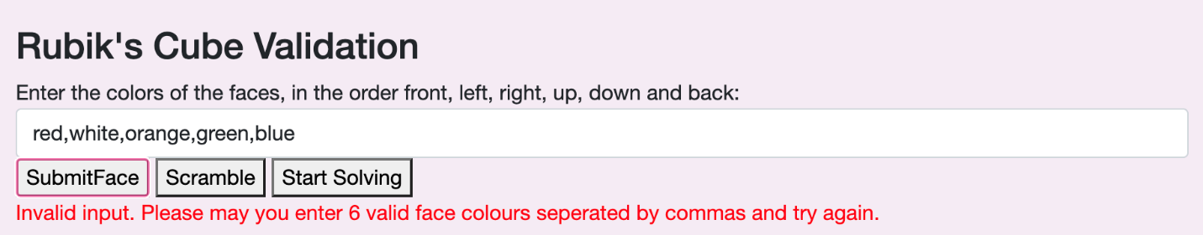

However, I did notice a lexical error in the buttons naming (should say Submit Faces) , so I edited the HTML and tested again.

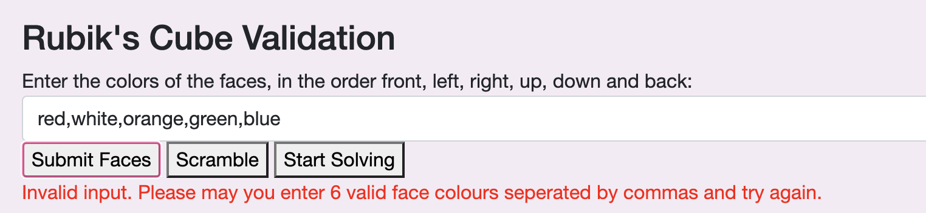

And I was much happier with this!

#### 3.2

Below you can see screenshots of the faces I inputted to test the error

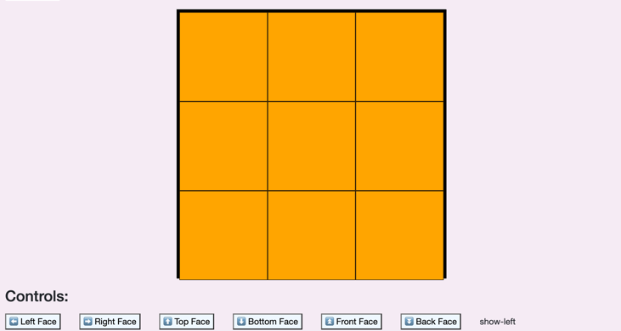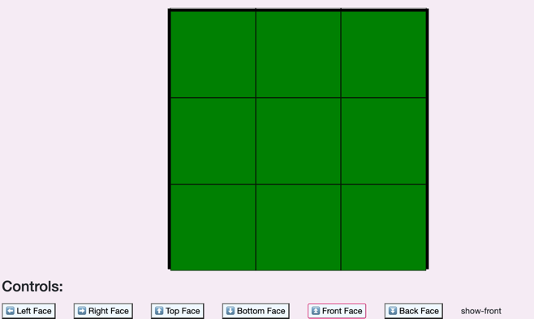

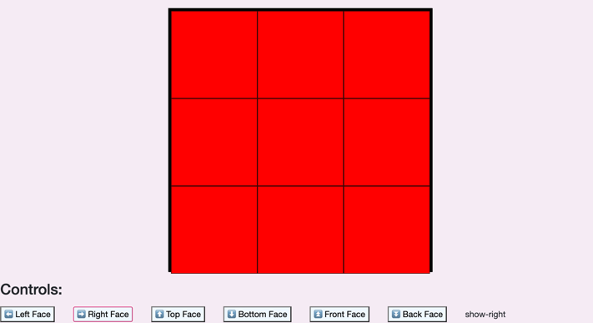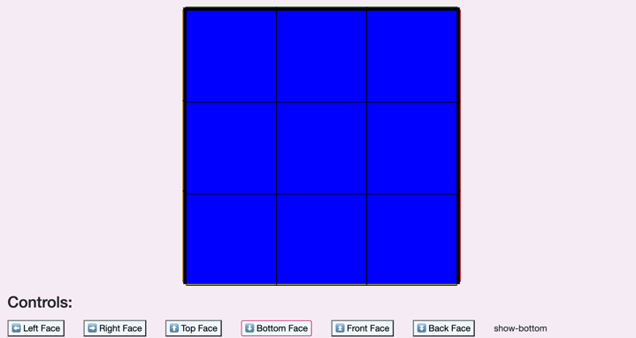

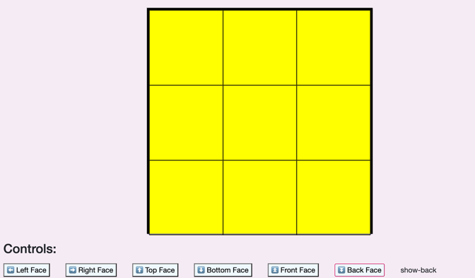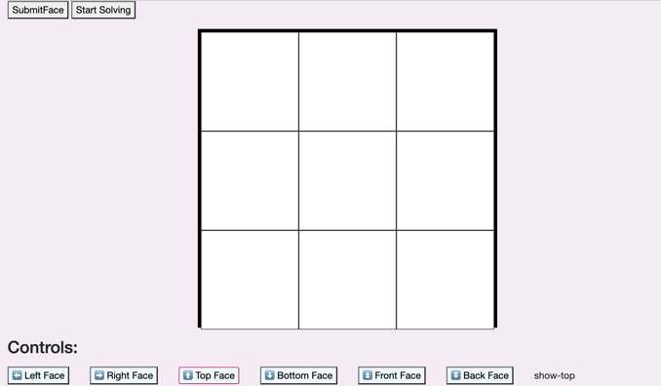

And here is the error message displayed:

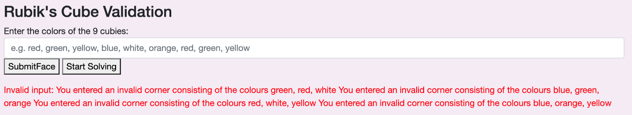

However, I didn’t really like the formatting so I changed the code to include spaces and fullstops to make it easier for the end user to understand.

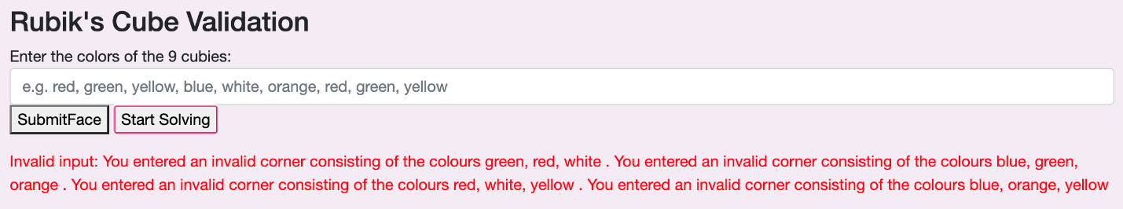

#### 3.3

Here is the test for the edges after inputting the face:

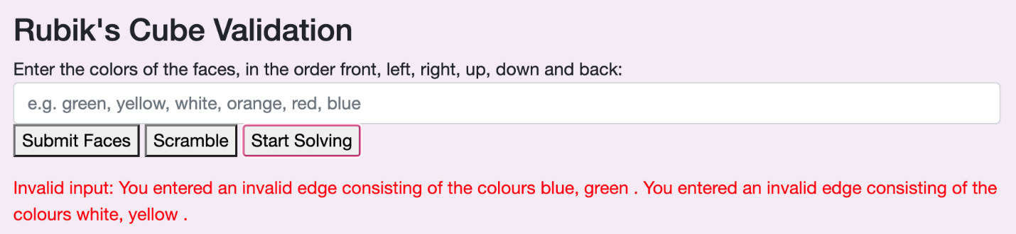

As you can see, this is a successful test as the program has identified the incorrect edges.

#### 3.4

Below is the test user input and its result.

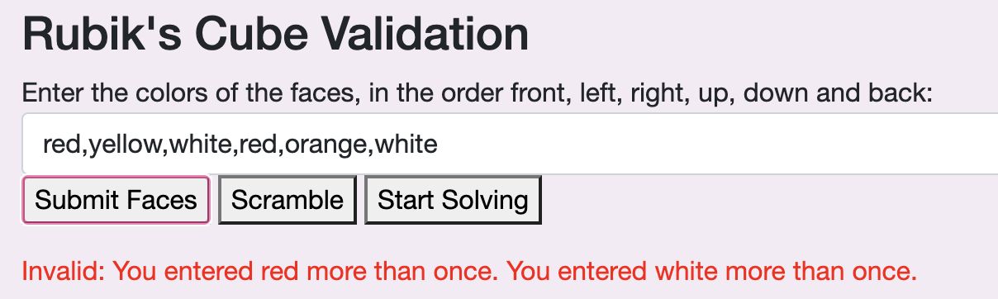

The program has successfully recognised that red and white has been entered more than once .

#### 3.5

Here is the evidence which shows that the faces can only be one of the selected colours out of red, yellow, green, orange, blue and white:



#### 3.6

Using the valid cube which is loaded automatically when the program starts, if I press start solving the button outputs the following message:

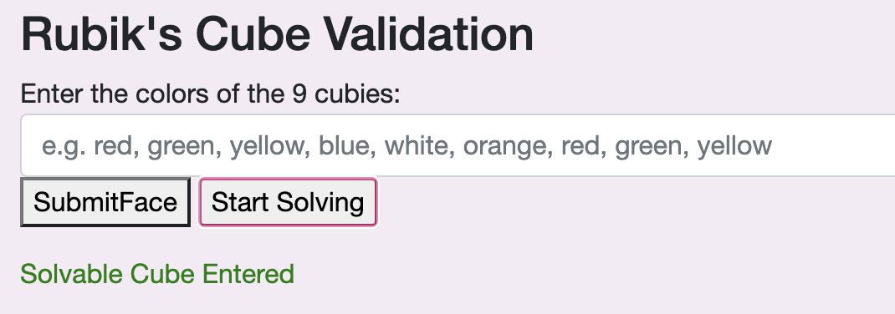

#### 3.7

After instantiating the cube to already be solved when the program once starts, I entered Start Solving and it outputted the appropriate error message:

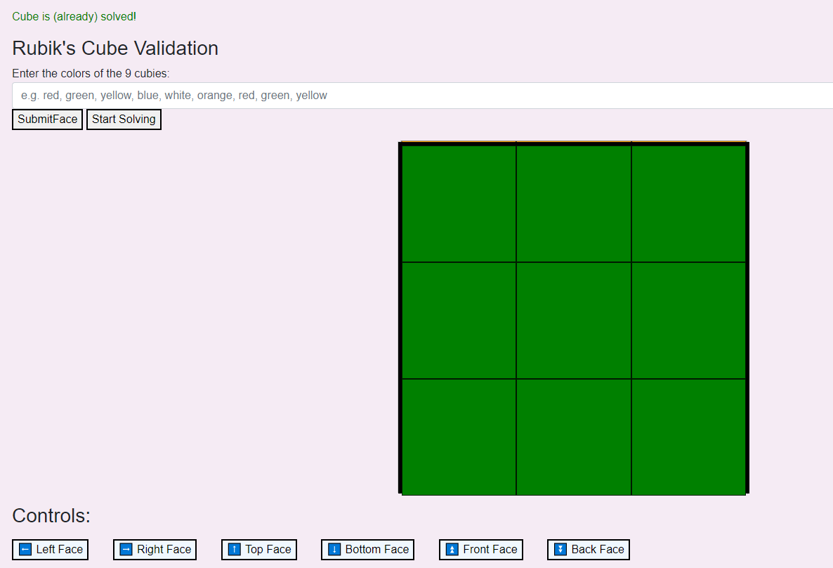

#### 4.1

Here is the list of scrambling instructions based on difficulty level and the user input of a custom instruction 42- please note that in the video slightly different instruction lengths and another randomly generated sequence will be generated- this is just for testing purposes. The following screenshots is after I added breakpoints in the code to see the generated instructions for each scramble:

|  |  |
| --- | --- |
| Easy Scramble | Medium Scramble |
|  |  |
| Hard Scramble | Custom Scramble (42) |
|  | I was unable to get all of the randomly generated instructions but here Is a screenshot showing that the count is 42. |

Custom scramble input:

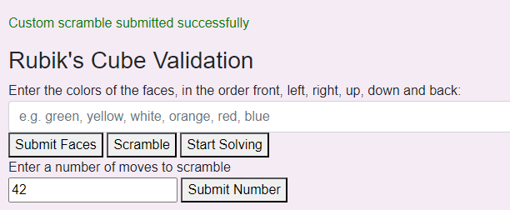

#### 4.2

Here is a screenshot of the scrambling instructions:

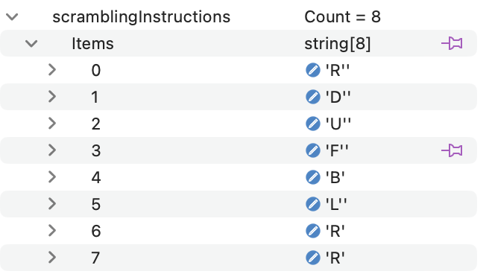

Here is a screenshot of the relevant ‘Anti-instructions’:

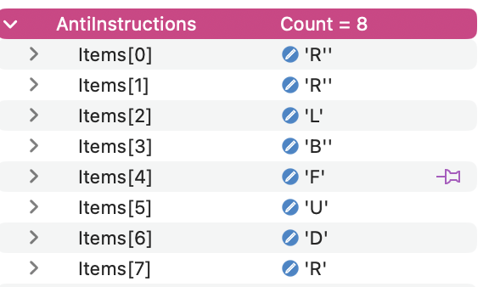

As you can see, the Anti-instructions is in the reverse order of the scrambling instructions and are the relevant anti-move.

#### 4.3

Below is a screenshot of the scrambling instructions and the fully simplified instructions (note that in this case, the program did not conjoin any instructions, see 4.4 for evidence of simplification of instructions)

Scrambling instruction list-

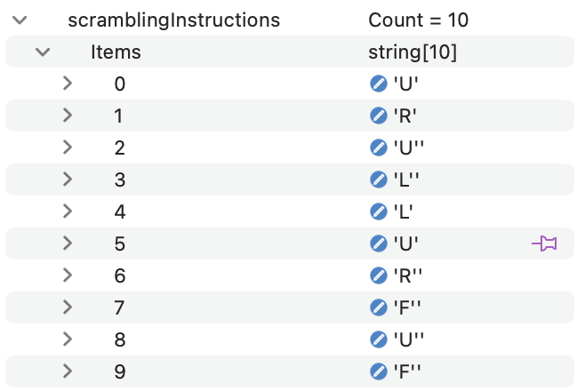

Solving instruction list-

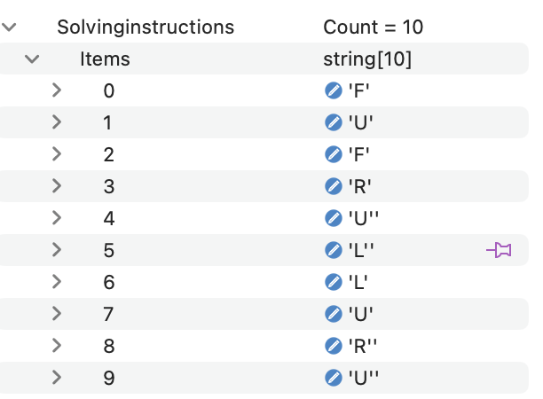

#### 4.4

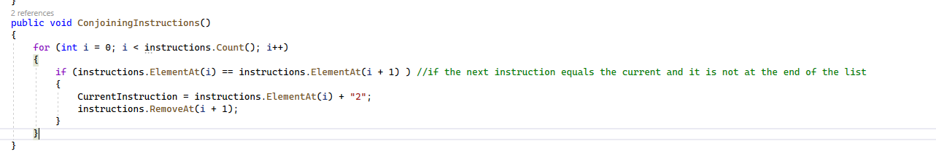To conjoin the instructions I implemented a run-length encoding style compression. Initially, I kept getting index out of range errors by adding one to I and comparing it to the current value. See the screenshot below for the old code:

But I kept getting index out of range errors. I opted for starting at 1 and comparing the previous position to prevent this. See the code below:

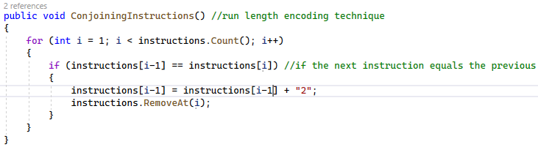

Here are the results:

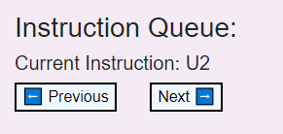

#### 4.5

Below is a screenshot of an example of a user inputting a custom scramble of 10 moves (an even number of moves) and a motivational message popping up when they are half way there

|  |  |
| --- | --- |
| Entering custom scrambling instructions |  |
| Oth instruction |  |
| 1st |  |
| 2nd |  |
| 3rd |  |
| 4th |  |
| 5TH |  |

]

As you can see, after 5 instructions, a motivational message pops up on the screen.

The next test is with an odd number of moves:

|  |  |
| --- | --- |
| User input |  |
| 0th |  |
| 1st |  |
| 2nd |  |
| 3rd |  |
| 4th |  |

As you can see, this works with both odd and even numbers- hence this is a successful test. Below is also a screenshot of how the cube will display a message when it is solved:



#### 5.1

Below are screenshots of the current instructions to click through:

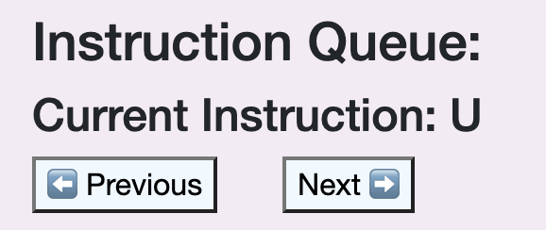

Although I decided I didn’t like the bold title, so I researched into different HTML headings and decided to use <h6> for the current instruction.

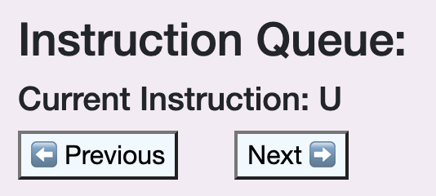

Finally, below is a photo of the solving state of the user input:

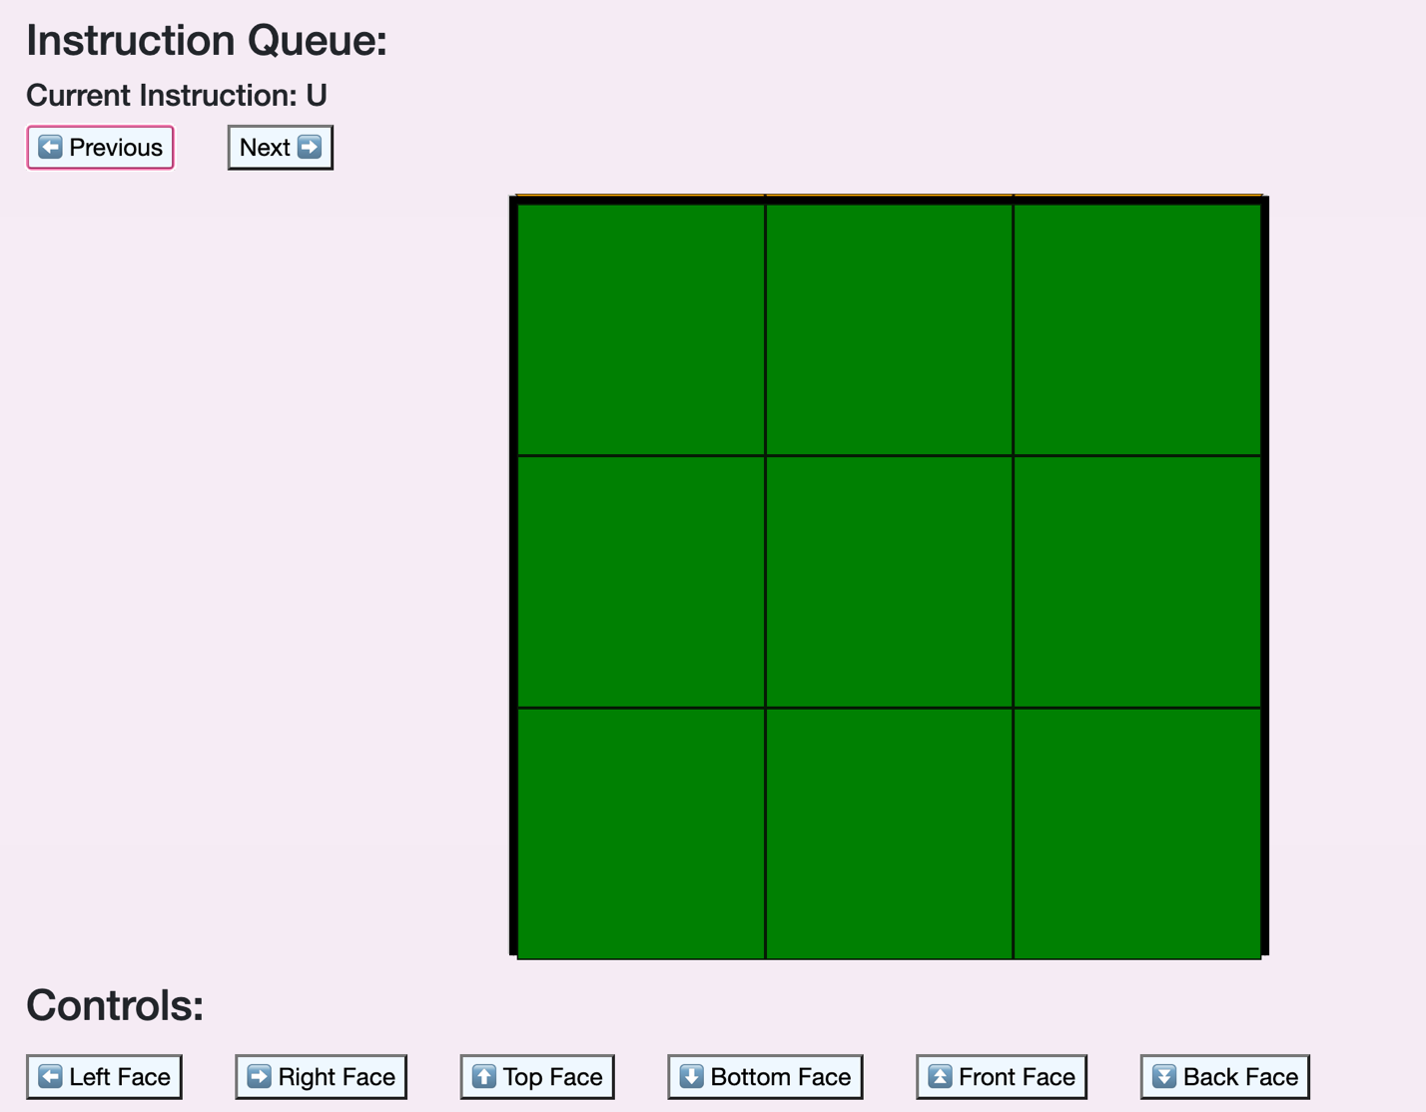

#### 5.1.2

Here are the is snippets of the user clicking through a sample right algorithm.

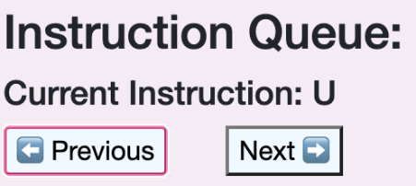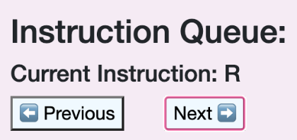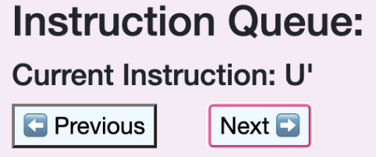

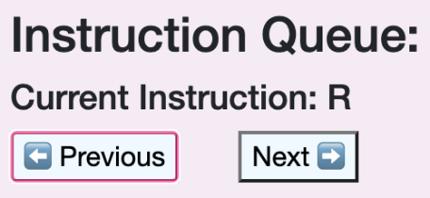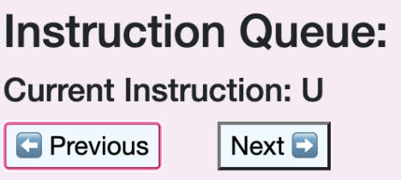

#### 5.1.3

I tried to create an error by clicking next at the last instruction of the right algorithm (U R U’ R’ U’ F’ U F) and trying to click previous at the start of the next instruction. As you can see appropriate error messages displayed for both cases. However when testing I realised that if I had got an error it would and moved on clicking to the next instruction, it would not clear the message; therefore I added a line of code in both error cases to clear it.

Before:

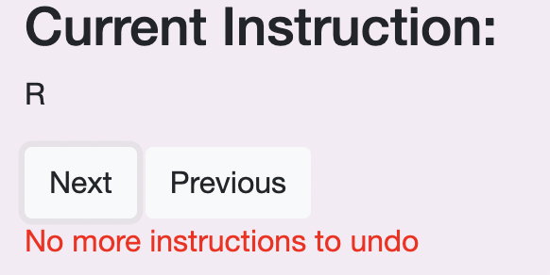

After:

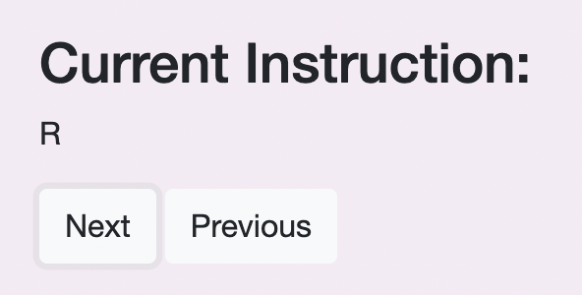

Fixed code:

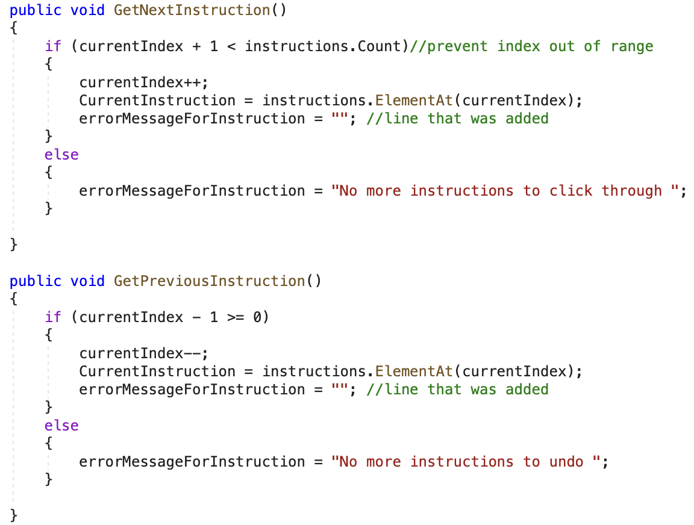

And below are screenshots of error messages when the user tries to click outside the bounds of the queue of instructions:

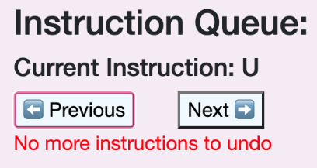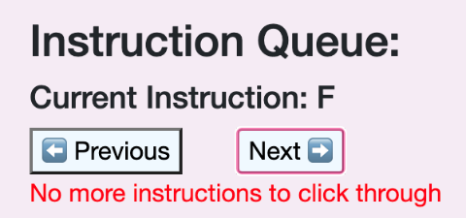

Below are further instructions of the actual cube having instructions being undone and redone to prove the actual moves are undone:

|  |  |  |
| --- | --- | --- |
| Current state | Action Performed | State after |
|  | Next |  |
|  | Previous |  |

Thus proving this works.

## Final Project Screenshots:

Below shows screenshots of my final project, please also refer to the test video to see the cube rotating animations.

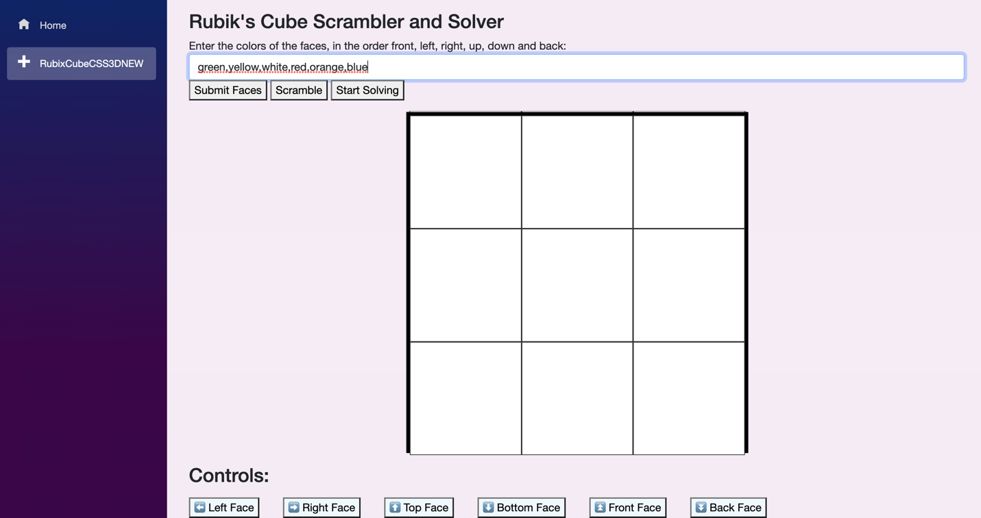

Faces:

|  |  |  |  |  |  |
| --- | --- | --- | --- | --- | --- |
| Face 0 | Face 1 | Face 2 | Face 3 | Face 4 | Face 5 |
|  |  |  |  |  |  |

Choosing the easy scramble:

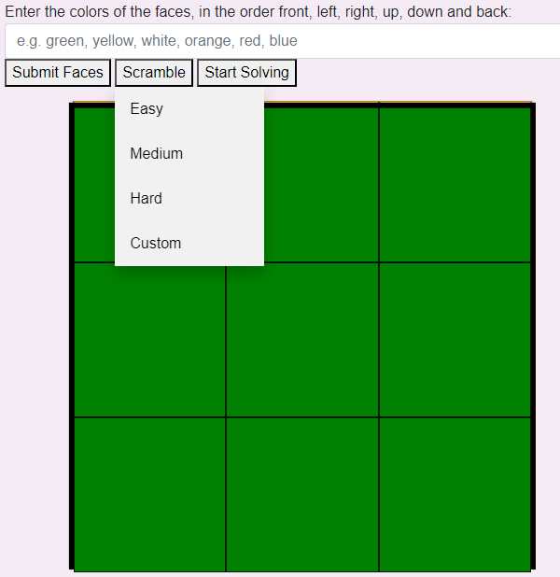

Cube scrambled:

|  |  |  |  |  |  |
| --- | --- | --- | --- | --- | --- |
| Face 0 | Face 1 | Face 2 | Face 3 | Face 4 | Face 5 |
|  |  |  |  |  |  |

|  |  |
| --- | --- |
| Move | Front face state |
| 1 |  |
| 2 |  |
| 3 |  |
| 4 |  |
| 5 |  |
| 6 |  |
| 7 |  |
| 8 |  |
| 9 |  |
| 10 |  |
| 11 |  |

Cubes ending state (each face):

|  |  |  |  |  |  |
| --- | --- | --- | --- | --- | --- |
| Face 0 | Face 1 | Face 2 | Face 3 | Face 4 | Face 5 |
|  |  |  |  |  |  |

# Evaluation

### Comparison of project against original objectives

The following is a copy of the objectives list earlier, if the objective is highlighted in green it has been completed successfully, and if it is in red it has been unsuccessful. Please see the possible improvements column for potential changes to what I could do or an explanation on why the task was not met up to a suitable standard.

|  |  |  |
| --- | --- | --- |
| Task | Objectives | Possible improvements? |
| Input | * A suitable user interface should be designed to allow the user to input their cube options. * User should be able to interact with different buttons on the screen, being triggered by a mouse click- the user should enter the colours of the cube they have and be able to dynamically view each side of the cube. * There should be an input and start solving button, as well as a drop down list to select the scrambling difficulty * User should be able to view all sides of the cube, rotating it how they please | In the future I would like to be able to implement a more dynamic user interface where mouse clicks are used to loop through selected colours and being able to input your cube and the program solves it. However, In the time I had to do this project I think that this was successfully implemented. Furthermore, If I were to do this project again I would use another editing studio like monogame, unity or Roblox creator to have a prerendered cube so I wouldn’t need to work out each individual current orientation and rotation pathway (although I did learn a lot by the use of dictionaries to store sequences to make more elegant code instead of loads of IF statements). I wish I had started with the CSS method however I think that I did a good job considering the time I had. |
| Validation | * Check if there are 9 of each colour inputted * Check that no 2 opposite colour stickers are on the same cubie * Check there are no same-coloured stickers on a cubie * Check user has actually entered valid colours spelt correctly | My validation checks were successful, I found this much easier to implement when using the 3D model of my cube. In the future I would like to go with my original design for inputting cubies and getting the program to solve it, however in the time I had (and in the a level scope) I think I did a good job. |
| Scrambling | * After the selected difficulty is selected by the user, the program should display the steps of scrambling for the user and then prompt the user to solve the cube themselves * The program should randomly generate cube scrambling at the difficulty level selected by the user and use recursive techniques to produce this. | Recursively creating a scrambling list using the dictionaries and lists I had set up was not as hard as anticipated; I found that my program worked much more efficiently and having an instruction queue class did really help with this. Overall I think that this is a better method than having the user input their cube options as it allows the user to actually learn how to solve a cube and get used to the Rubik’s cube operations rather than just getting a program to solve it. |
| Solving | * The program must store a list of instructions to solve this cube position after scrambling * The instructions should be fully simplified in terms of consecutive rotations on the same face * 2 90 degree turns in a row should be replaced with one 180-degree turn * 2 180 degrees in a row should be removed * Program must incorporate * An object-oriented approach * Matrix operations * Stacks and queues * Arrays * If the user wants to view the instructions on how to solve the cube, they should be able to view the step by step solution using buttons on the screen | As I started implementing the solver I quickly found that the algorithm I wrote would take me far too long to implement so I opted for the scrambling method instead. Although this is a compromise, I feel that I have successfully implemented this method. When simplifying instructions, I decided to use run length encoding as it is a programming concept, I am quite familiar with through my A-Level computer science and dequeue instructions from the queue list. I found creating recursive techniques challenging but rewarding, the cube naturally lends itself recursively (as well as the instruction being generated). |
| Output | * Displays a cube * Program must display a set of instructions * It must have the choice to ‘undo’ an instruction via interactable buttons * Could display a motivational message once solved | Investigating into HTML and CSS to create the optimum web browser for human computer interaction was again quite challenging (as was most of the project!) but I gained so much experience and confidence with learning two new markup languages to structure my ideas. Furthermore, incorporating 3D operations and complex matrix transformations using the three axis x,y,z introduced me to the idea of vector graphics and will give me great insight when developing in the future. |

### User feedback

I conducted another interview with Miss Collins and Mr Cowlard to see how the project turned out and what they thought about the final product.

Questions:

What do you like about the system?

Mr Cowlard: I think that it is very easy to understand, the 3D rendering makes it especially helpful and straightforward to visualise. The prompts to ensure the I entered in the cubes colours in the correct format were much more helpful than any other cube solving sites I have used, and the motivational messages displayed throughout solving it is fantastic. I think that the choosing difficulty levels for the solving was helpful as it helps the user gain confidence in solving, and I felt that the difficulty levels increased in difficulty well.

What could I improve?

Miss Collins: I would love to see this work for any cube size and show how to make patterns on the cube. I think a timer feature would be interesting to see how fast the cube could be solved and having the user implement their own cube options would be a nice edition, but you have done a remarkable job.

I then invited some of my classmates to test out my project and give me their feedback:

Zuza: I am not familiar with solving the Rubik’s cube, however, I thought that the system was very well done; it was very intuitive, and I found it easy to navigate. The validation was also very effective, it did stop me from entering 900 moves. I think clearer instructions on the webpage would further make this more accessible; other than that, it is a very fun, easy and impressive project to test.

Charlie: I thought that the animations were very smooth and the solving algorithm was very skilful. The validation worked particularly well when I entered the colour purple. Not only did the program pick up on this mistake but also identified the specific error and gave me useful error messages. I think that it was very cool.

Minnie: The 3D rendering of the cube on the screen was very good; I even got to test some of the individual rotations that make up a cube and saw how they worked. I particularly liked the conjoined instructions; I feel that it effectively solved the cube given the scramble and the custom scramble was a lovely feature. Overall, I think that this project was great!

The overwhelmingly positive feedback from my classmates and Miss Collins and Mr Cowlard was very gratifying, everyone seemed to like the program and the project created. The overall response was that I fulfilled my objectives and that the only improvements mentioned were generally lexical errors which could easily be edited, or other features.

### Possible extensions to my project

Unfortunately, I did not have time to implement the human method of solving a Rubik’s cube to a satisfactory standard, but I did enjoy researching, prototyping and writing the pseudocodes on how I would attempt this in the design section. I would love to develop the skills to include this but with the lack of time it seemed unreasonable. If I were to completely restart and take on a more electrical approach, I think it would be intellectually stimulating to use Arduinos, motors, and logic circuits to create a physical solver; incorporating aspects of machine learning would be incredibly interesting, so the cube could be more efficiently solved. In the ‘cubing’ subreddit I have joined since embarking on this project, I have discovered that the existence of 2x2, 4x4, triangular and even 30x30 cubes exist. Adapting my program to have the choice to solve any of these would make it easier for cube collectors to solve all their cubes in one software (instead of downloading many different programs for each cube; hence saving space on their computers). I think it would be very interesting to come back to this project and implement some AI to reduce the number of steps it takes to solve the problem and add more features as Mr Cowlard discussed in the interview I conducted.

### Improvements that could be made

Other than the previous changes I have mentioned, I could have decided to use a 3D array and linked lists to store my cube rather than a list of 2D faces, but I may have encountered more problems this way as I am not too comfortable with the use of those abstract data types and would much rather be confident in my ability as a programmer. Throughout my project I also should have improved the protection of my classes via more private and public methods- I became more conscious of this by the end but if I had the time I would go through all of my project and change their protection levels to a more appropriate type. Overall, I think the project is a success and the improvements, changes and extensions which could have been met are outweighed by the Rubik’s Cube Solvers use of complex OOP, matrices, complex algorithms, recursion, and various other computational techniques which I have learnt and implemented during this project.

### Project Log

|  |  |  |
| --- | --- | --- |
| Month | Task | Notes |
| Summer Holidays | Initial investigation of possible objectives, project ideas and research | I learnt the human way of how to solve a Rubik’s cube, basic history about it and researched into possible hardware to use in my project |
| September | Project objectives agreed | Finalise my ideas and plan of action on how the Rubik’s cube solver should work and what techniques will be used to make it |
| October | Project analysis completed | I finished off my research and my proposed idea was decided on |
| November | Designing project and the user interface | I started creating how I wanted the human computer interaction to look like and gave initial thoughts to how I wanted the project to be structured |
| December | Pseudocode of main algorithms | I completed writing all the key pseudocodes which were vital for the project to succeed |
|  | Initial Prototyping | Investigated different methods to represent a 3D cube in Blazor including matrix and vector operations |
| January | Programming the user inputs and setting up classes | Programming the user inputs so that the cube can interact with the human it is solving the cube for. I also set up classes and began implementing the design the end user sees. |
| February | Get validation completed | Validation for my project should be fully completed and the testing stage should begin. |
| March | Restarting display using 3D CSS | All validation rotations should be working seamlessly, and the relevant testing section should be complete. |
| April | Solver and scrambler should be fully implemented | The scrambling algorithm should be applied successfully and the solver should solve the cube to its original state once more. |
| May | Evaluation | Finish up write up and meet up with Mrs Collins and Mr Cowlard to discuss if my project meets the ideal requirements. |